Financial Contagion and Volatility Spillover: an exploration into Bitcoin Future and FOREX Future Markets
ISSN 1857-9973 UDC 336.746:004.91.056.55]:336.76}:303.725.3(100)”2017/2019”

Konstantinos Tsiaras¹
¹University of Ioannina, University Campus, Ioannina, Greece, konstantinos.tsiaras1988@gmail.com
Abstract. This paper examines the time-varying conditional correlations between Bitcoin future market and five FOREX future markets. A sixvariate dynamic conditional correlation (DCC) GARCH model is applied in order to capture potential contagion effects between the markets for the period 2017-2019. Empirical results reveal contagion during the under investigation period regarding the one sixvariate model, showing potential volatility transmission channels among the future markets. Findings have crucial implications for policymakers who provide regulations for the above derivative markets.
Keywords: Bitcoin future market, DCC-GARCH model, dynamic conditional correlations, financial contagion, FOREX future markets

1. Introduction
Τhis paper investigates the potential volatility spillover and contagion effects of Bitcoin [1] future market and five FOREX future markets [2]. By employing a sixvariate DCC-GARCH model, results reveal show significant volatility spillover effects. Moreover, the definition of contagion suggested by Forbes and Rigobon [3] is used. They defined contagion as a significant increase in cross-market linkages after a shock. Dynamic conditional correlations reveal contagion effects in sub-periods between Bitcoin future market and the five FOREX future markets.
The motivation for this paper is analyzed as follows. Firstly, there is no other empirical research investigating the conditional second moments of the distribution between Bitcoin future market [1,4-5] and five FOREX future markets. Secondly, the potential existence of contagion between Bitcoin future market and five FOREX future markets is new evidence to financial theory. Thirdly, the under investigation period is of great importance, since it entails major economic crises.
In the literature, there are empirical studies investigating volatility of Bitcoin market [6-13] and other empirical studies investigating Bitcoin as a speculative investment [1,6,14-15]. Additionally, many researchers have studied the impact of Bitcoin on many financial markets [13,16-22]. There is no previous empirical evidence providing evidence of spillover effects between the under investigation market.
The paper of the paper is organized as follows. Section 2 describes data characteristics. Section 3 provides methodology. Section 4 discusses the empirical results. The last section concludes the paper.

2. Data Characteristics
The paper uses daily data for Bitcoin future market (CME-BITCOIN) and five FOREX future markets (DGCX-INR/USD CONTINUOUS AVG. - SETT. PRICE, DGCX-JPY/USD CONTINUOUS AVG. - SETT. PRICE, SGX-KRW/USD CONT.AVG - SETT. PRICE, DGCX-GBP/USD CONTINUOUS AVG. - SETT. PRICE, DGCX-EUR/USD CONTINUOUS AVG. - SETT. PRICE). We downloaded data from datastream database. The period is set from December 18, 2017 to May 20, 2019 (371 observations). The market returns are generated by the equation $r_{t}=ln⁡(p_{t})⁡-ln(p_{t-1})$, where $p_{t}$ the price of future market on day t and $p_{t-1}$ is the price of future market on day t-1.
Tables 1 and 2 present the summary statistics for the market returns. DGCX-JPY/USD CONTINUOUS AVG. - SETT. PRICE exhibits the highest mean value (3,1526e-005). Based on the highest maximum (0,096253), the minimum (-0,096635) and the highest std. deviation (0,02091) values, CME-BITCOIN presents the largest fluctuations among all the markets.
Additionally, all market returns are negatively skewed, except the cases of DGCX-INR/USD CONTINUOUS AVG. - SETT. PRICE, DGCX-JPY/USD CONTINUOUS AVG. - SETT. PRICE and DGCX-GBP/USD CONTINUOUS AVG. - SETT. PRICE. Furthermore, all market returns show excess kurtosis. In addition, Jarque-Bera statistic results indicate the rejection of the null hypothesis of normality for all market returns except the cases of SGX-KRW/USD CONT.AVG - SETT. PRICE and DGCX-EUR/USD CONTINUOUS AVG. - SETT. PRICE. ADF test results reject the null hypotheses of unit root at 1% level, showing that the daily market returns appropriate for further testing.

Table 1 Summary statistics of the daily market logarithmic returns.
 | DGCX-INR/USD CONTINUOUS AVG. - SETT. PRICE | DGCX-JPY/USD CONTINUOUS AVG. - SETT. PRICE | SGX-KRW/USD CONT.AVG - SETT. PRICE
Mean | -0,00010171 | 3,1526e-005 | -2,1977e-005
Minimum | -0,0073411 | -0,0063788 | -0,0058781
Maximum | 0,0083642 | 0,0057922 | 0,0057491
Std. Deviation | 0,0018869 | 0,0017014 | 0,0018764
Skewness | 0,099447 | 0,17915* | -0,12998*
t-Statistic | 0,78409 | 1,4125 | 1,0248
p-Value | 0,43299 | 0,15779 | 0,30544
Excess Kyrtosis | 1,6007*** | 0,62512** | 0,020701
t-Statistic | 6,3271 | 2,4709 | 0,081827
p-Value | 2,4987e-010 | 0,013477 | 0,93478
Jarque-Bera | 40,111*** | 8,0037*** | 1,0485
p-Value | 1,9501e-009 | 0,018281 | 0,59200
ADF Test | -12,1578*** | -10,9745*** | -11,8421***

Table 2 Summary statistics of the daily market logarithmic returns.
 | DGCX-GBP/USD CONTINUOUS AVG. - SETT. PRICE | DGCX-EUR/USD CONTINUOUS AVG. - SETT. PRICE | CME-BITCOIN
Mean | -5,6885e-005 | -5,8857e-005 | -0,0010379
Minimum | -0,007279 | -0,0074177 | -0,096635
Maximum | 0,0080418 | 0,0050249 | 0,096253
Std. Deviation | 0,0022084 | 0,0018539 | 0,02091
Skewness | 0,13322* | -0,11453 | -0,12056
t-Statistic | 1,0504 | 0,90305 | 0,95053
p-Value | 0,29354 | 0,36650 | 0,34184
Excess Kyrtosis | 0,69575** | 0,36510* | 3,3128***
t-Statistic | 2,7501 | 1,4431 | 13,094
p-Value | 0,0059581 | 0,14898 | 3,5455e-039
Jarque-Bera | 8,5571*** | 2,8640 | 170,09***
p-Value | 0,013863 | 0,23883 | 1,1653e-037
ADF Test | -11,1731*** | -11,2936*** | -10,3406***
Figure 1, graphs the logarithmic returns for CME-BITCOIN, DGCX-INR/USD CONTINUOUS AVG. - SETT. PRICE, DGCX-JPY/USD CONTINUOUS AVG. - SETT. PRICE, SGX-KRW/USD CONT.AVG - SETT. PRICE, DGCX-GBP/USD CONTINUOUS AVG. - SETT. PRICE and DGCX-EUR/USD CONTINUOUS AVG. - SETT. PRICE. Based on the virtual observation of the graph, the time varying levels of fluctuations indicate the presence of heteroskedasticity and appropriate the use of DCC-GARCH model.
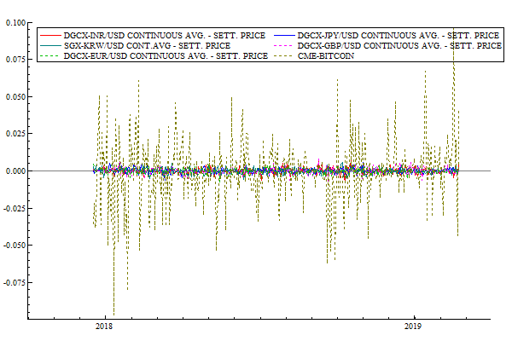
Figure 1 Actual series of the logarithmic returns of the markets

3. Methodology
Sections Conditional mean equation for the basic GARCH model:
$y_{t}=μ+ε_{t}$, with t = 1,…,T (1)
where μ is constant and $ε_{t}$ is standardized residuals described as:
$ε_{t}=\sqrt{h_{t}}u_{t}$, where $ε_{t}\sim N(0,H_{t})$ and $u_{t} are i.i.d.$ (2)
where $u_{t}$ is standardized errors and $h_{t}$ is conditional variance depending on $h_{t}$ and $ε_{t}^{}$ for each market lagged one period, generated by the univariate GARCH(1,1) model [23]:
$h_{t}=ω+aε_{t-1}^{2}+bh_{t-1}$ (3)
where ω is constant, a and b are ARCH and GARCH effects.
Apart from the basic GARCH model, the Engle [24] representation of the sixvariate GARCH model is employed in order to estimate the sixvariate conditional variance matrix ($Η_{t}$ is N x N matrix, with N the number of markets, i = 1,…,N) as follows:
$Η_{t}=D_{t}R_{t}D_{t}$ (4)
$D_{t}$ is the conditional variance matrix given by:
$D_{t}=diag\left(h_{11t}^{\frac{1}{2}}…h_{NNt}^{\frac{1}{2}}\right)$ (5)
$R_{t}$ is the condition correlation matrix of N x N dimension, and is defined as follows:
$R_{t}=(ρ_{iit})=diag(q_{11,t}^{-\frac{1}{2}}…q_{NN,t}^{-\frac{1}{2}})Q_{t}diag(q_{11,t}^{-\frac{1}{2}}…q_{NN,t}^{-\frac{1}{2}})$ (6)
where the N x N symmetric positive definite matrix $Q_{t}=(q_{ii,t})$ is given by:
$Q_{t}=\left(1-α-β\right)\overline{Q}+αu_{t-1}u_{t-1}^{'}+βQ_{t-1}$, (7)
$\overline{Q}$ is the N x N unconditional variance matrix of $u_{t}$, and α and β are nonnegative scalar parameters, satisfying α + β < 1..
4. Empirical Results
This section describes the empirical results generated by the sixvariate DCC-GARCH model. Sub-section 4.1 shows the results of the univariate GARCH model while in sub-section 4.2, we analyze the results of the sixvariate DCC-GARCH model. In sub-section 4.3, we report an analysis of the generated Dynamic Conditional Correlations (DCCs).
.
4.1 Results of the univariate GARCH(1,1) model
Tables 3 and 4 show the estimated values for univariate GARCH(1,1) model. Empirical results report statistically significant ω for SGX-KRW/USD CONT.AVG - SETT. PRICE, DGCX-EUR/USD CONTINUOUS AVG. - SETT. PRICE and CME-BITCOIN. Moreover, ARCH (a) and GARCH (b) terms are highly significant for all the markets returns except the ARCH effects of DGCX-EUR/USD CONTINUOUS AVG. - SETT. PRICE.

Table 3 Estimates of univariate GARCH (1,1) model.
 | DGCX-INR/USD CONTINUOUS AVG. - SETT. PRICE | DGCX-JPY/USD CONTINUOUS AVG. - SETT. PRICE | SGX-KRW/USD CONT.AVG - SETT. PRICE
constant (ω) | 0,046619 | 0,109084 | 0,851510*
t-Statistic | 0,9132 | 0,7797 | 1,040
p-Value | 0,3618 | 0,4361 | 0,2990
ARCH ($a$) | 0,040822* | 0,040206* | 0,090389*
t-Statistic | 1,876 | 1,531 | 1,942
p-Value | 0,0615 | 0,1267 | 0,0529
GARCH (b) | 0,948906*** | 0,924674*** | 0,695465***
t-Statistic | 34,36 | 14,55 | 3,082
p-Value | 0,0000 | 0,0000 | 0,0022

Table 4 Estimates of univariate GARCH (1,1) model.
 | DGCX-GBP/USD CONTINUOUS AVG. - SETT. PRICE | DGCX-EUR/USD CONTINUOUS AVG. - SETT. PRICE | CME-BITCOIN
constant (ω) | 0,029257 | 6,582295*** | 0,100971*
t-Statistic | 0,4343 | 11,00 | 1,090
p-Value | 0,6644 | 0,0000 | 0,2766
ARCH ($a$) | 0,024102* | 0,037071 | 0,062745**
t-Statistic | 1,613 | 0,9992 | 2,821
p-Value | 0,1077 | 0,3184 | 0,0051
GARCH (b) | 0,971243*** | -0,860920*** | 0,906923***
t-Statistic | 47,25 | -13,09 | 32,94
p-Value | 0,0000 | 0,0000 | 0,0000

In figure 2, the behavior of conditional variances are presented for CME-BITCOIN, DGCX-INR/USD CONTINUOUS AVG. - SETT. PRICE, DGCX-JPY/USD CONTINUOUS AVG. - SETT. PRICE, SGX-KRW/USD CONT.AVG - SETT. PRICE, DGCX-GBP/USD CONTINUOUS AVG. - SETT. PRICE and DGCX-EUR/USD CONTINUOUS AVG. - SETT. PRICE. Empirical results show strongly volatile conditional variances for all the market returns over time. Additionally, results indicate a common movement of conditional volatilities.
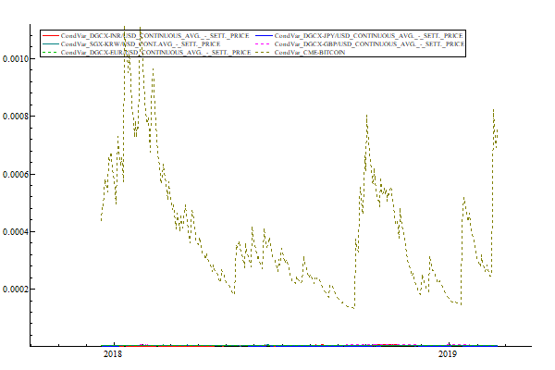
Figure 2 Conditional variances of the univariate GARCH (1,1) model

4.2 Results of the sixvariate DCC-GARCH(1,1) model, Diagnostic Tests and Selected Information Criteria
Tables 5 shows the estimated average correlations of the sixvariate DCC-GARCH(1,1) model. Results indicate the most average correlations statistically significant. Additionally, the strongest average correlation is observed for the pair of markets CORR_DGCX-GBP/USD CONTINUOUS AVG. - SETT. PRICE_DGCX-EUR/USD CON.
Table 6 presents the results of the sixvariate DCC model estimations. The α and β parameters are statistically significant, indicating strong ARCH and GARCH effects. Additionally, the estimates of the degrees of freedom (v) and of the log-likelihood are provided.
Table 7 report the estimates of diagnostic tests and information criteria. $x^{2}$(12) statistic results suggest that the null hypothesis of no spillovers is rejected at 1% significance level. Ljuing-Box test results [25-26] provide evidence of no serial autocorrelation, suggesting the absence of misspecification errors of the estimated multivariate GARCH model. Moreover, the estimated AIC and SIC information criteria are presented.
Figures 3 plots the conditional covariances for all the pairs of market returns during the whole period. All the conditional covariances have tremble trend. Additionally, conditional covariances seem to be extreme volatile.

Table 5 Estimates for the average correlations of the sixvariate DCC-GARCH (1,1) model.

 | Coefficient | t-Statistic | p-Value
CORR_DGCX-INR/USD CONTINUOUS AVG. - SETT. PRICE_DGCX-JPY/USD CON | 0,115366* | 1,966 | 0,0500
CORR_DGCX-INR/USD CONTINUOUS AVG. - SETT. PRICE_SGX-KRW/USD CONT | 0,044281 | 0,8555 | 0,3928
CORR_DGCX-INR/USD CONTINUOUS AVG. - SETT. PRICE_DGCX-GBP/USD CON | 0,327631*** | 6,027 | 0,0000
CORR_DGCX-INR/USD CONTINUOUS AVG. - SETT. PRICE_DGCX-EUR/USD CON | 0,363903*** | 8,118 | 0,0000
CORR_DGCX-INR/USD CONTINUOUS AVG. - SETT. PRICE_CME-BITCOIN | 0,101184* | 1,804 | 0,0721
CORR_DGCX-JPY/USD CONTINUOUS AVG. - SETT. PRICE_SGX-KRW/USD CONT | -0,010161 | -0,1765 | 0,8600
CORR_DGCX-JPY/USD CONTINUOUS AVG. - SETT. PRICE_DGCX-GBP/USD CON | 0,242814*** | 4,452 | 0,0000
CORR_DGCX-JPY/USD CONTINUOUS AVG. - SETT. PRICE_DGCX-EUR/USD CON | 0,354953*** | 7,210 | 0,0000
CORR_DGCX-JPY/USD CONTINUOUS AVG. - SETT. PRICE_CME-BITCOIN | 0,061601* | 1,163 | 0,2458
CORR_SGX-KRW/USD CONT.AVG - SETT. PRICE_DGCX-GBP/USD CONTINUOUS | -0,012957 | -0,2582 | 0,7964
CORR_SGX-KRW/USD CONT.AVG - SETT. PRICE_DGCX-EUR/USD CONTINUOUS | 0,016747 | 0,3218 | 0,7478
CORR_SGX-KRW/USD CONT.AVG - SETT. PRICE_CME-BITCOIN | -0,018811 | -0,3446 | 0,7306
CORR_DGCX-GBP/USD CONTINUOUS AVG. - SETT. PRICE_DGCX-EUR/USD CON | 0,640969*** | 20,54 | 0,0000
CORR_DGCX-GBP/USD CONTINUOUS AVG. - SETT. PRICE_CME-BITCOIN | 0,038499 | 0,7667 | 0,4438
CORR_DGCX-EUR/USD CONTINUOUS AVG. - SETT. PRICE_CME-BITCOIN | -0,002225 | -0,04132 | 0,9671

Table 6 Estimates of the sixvariate DCC-GARCH (1,1) model, degrees of freedom, log-likelihood.
 | Coefficient
alpha (α) | 0,008110*
t-Statistic | 1,016
p-Value | 0,3105
beta (β) | 0,840878***
t-Statistic | 7,115
p-Value | 0,0000
degrees of freedom (df) | 14,424106***
t-Statistic | 4,301
p-Value | 0,0000
log-likelihood | 10082,519

Table 7 Diagnostic tests and information criteria.
 | Coefficient
$x^{2}$(12) | 272,54
p-Value | 0,0000
Hosking (50) | 1836,22
p-Value | 0,2707055
Hosking² (50) | 1690,83
p-Value | 0,9650689
Li-McLeod (50) | 1834,51
p-Value | 0,2800593
Li-McLeod² (50) | 1696,19
p-Value | 0,9572637
Akaike | 0,047182
Schwarz | 0,427955

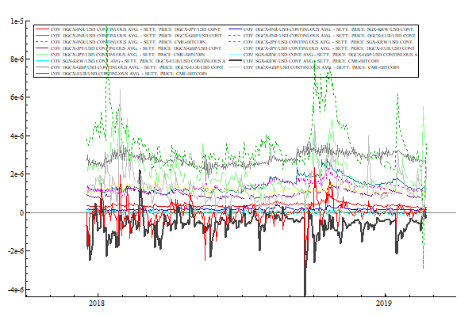

Figure 3 Conditional covariances of the bivariate DCC-GARCH (1,1) model
4.2 Analysis of the Dynamic Conditional Correlations (DCCs)
Tables 8, 9, 10, 11 and 12 show the descriptive statistics of the dynamic conditional correlations (DCCs) of the fifteen pairs of markets generated by Equation 5. Results reveal the highest mean value (0,65938) is for the pair of markets CORR_DGCX-GBP/USD CONTINUOUS AVG. - SETT. PRICE_DGCX-EUR/USD CON. The highest std. deviation value for the pair of markets CORR_DGCX-INR/USD CONTINUOUS AVG. - SETT. PRICE_CME-BITCOIN indicates that the specific DCC experiences larger flunctuations. The statistical significant Skewness, Excess Kyrtosis and the Jarque-Bera test statistics indicate that the DCCs for all the pairs of markets are not normally distributed.

Table 8 Statistical properties of the Multivariate GARCH-DCC’s.
 | CORR_DGCX-INR/USD CONTINUOUS AVG. - SETT. PRICE_DGCX-JPY/USD CON | CORR_DGCX-INR/USD CONTINUOUS AVG. - SETT. PRICE_SGX-KRW/USD CONT | CORR_DGCX-INR/USD CONTINUOUS AVG. - SETT. PRICE_DGCX-GBP/USD CON
Mean | 0,11932 | 0,048576 | 0,32915
Minimum | 0,066438 | -0,00026145 | 0,28521
Maximum | 0,18999 | 0,083063 | 0,38751
Std. Deviation | 0,014118 | 0,01093 | 0,0122
Skewness | 0,24655 | -0,55415*** | -0,0067045
p-Value | 1,9439 | 1,2470e-005 | 0,95784
Excess Kyrtosis | 3,0572*** | 2,7278*** | 3,2858***
p-Value | 1,2810e-033 | 4,1839e-027 | 1,4363e-038
Jarque-Bera | 147,84*** | 133,65*** | 166,45***
p-Value | 7,8937e-033 | 9,5219e-030 | 7,1862e-037

Table 9 Statistical properties of the Multivariate GARCH-DCC’s.
 | CORR_DGCX-INR/USD CONTINUOUS AVG. - SETT. PRICE_DGCX-EUR/USD CON | CORR_DGCX-INR/USD CONTINUOUS AVG. - SETT. PRICE_CME-BITCOIN | CORR_DGCX-JPY/USD CONTINUOUS AVG. - SETT. PRICE_SGX-KRW/USD CONT
Mean | 0,37137 | 0,095888 | -0,010362
Minimum | 0,33014 | -0,056078 | -0,057123
Maximum | 0,41487 | 0,17122 | 0,045473
Std. Deviation | 0,010021 | 0,015792 | 0,01252
Skewness | -0,0026446 | -3,2174*** | 0,28853***
p-Value | 0,98336 | 5,7661e-142 | 0,022909
Excess Kyrtosis | 2,4693*** | 29,233*** | 2,4508***
p-Value | 1,6656e-022 | 0,00000 | 3,4108e-022
Jarque-Bera | 94,002*** | 13813,0*** | 97,735***
p-Value | 3,8705e-021 | 0,0000 | 5,9852e-022

Table 10 Statistical properties of the Multivariate GARCH-DCC’s.
 | CORR_DGCX-JPY/USD CONTINUOUS AVG. - SETT. PRICE_DGCX-GBP/USD CON | CORR_DGCX-JPY/USD CONTINUOUS AVG. - SETT. PRICE_DGCX-EUR/USD CON | CORR_DGCX-JPY/USD CONTINUOUS AVG. - SETT. PRICE_CME-BITCOIN
Mean | 0,24998 | 0,36527 | 0,060547
Minimum | 0,21134 | 0,31266 | 0,0065338
Maximum | 0,30335 | 0,40635 | 0,1267
Std. Deviation | 0,011734 | 0,011629 | 0,012789
Skewness | 0,29972*** | -0,084127 | 0,56144***
p-Value | 0,018120 | 0,50714 | 9,5690e-006
Excess Kyrtosis | 2,0360*** | 2,4576*** | 4,1605***
p-Value | 8,4235e-016 | 2,6202e-022 | 9,0485e-061
Jarque-Bera | 69,449*** | 93,553*** | 286,30***
p-Value | 8,3040e-016 | 4,8447e-021 | 6,7625e-063

Table 11 Statistical properties of the Multivariate GARCH-DCC’s.
 | CORR_SGX-KRW/USD CONT.AVG - SETT. PRICE_DGCX-GBP/USD CONTINUOUS | CORR_SGX-KRW/USD CONT.AVG - SETT. PRICE_DGCX-EUR/USD CONTINUOUS | CORR_SGX-KRW/USD CONT.AVG - SETT. PRICE_CME-BITCOIN
Mean | -0,014663 | 0,015418 | -0,017329
Minimum | -0,054699 | -0,018875 | -0,10494
Maximum | 0,020286 | 0,048706 | 0,036029
Std. Deviation | 0,011093 | 0,010782 | 0,012981
Skewness | -0,18274 | 0,057943 | -1,1280***
p-Value | 0,14963 | 0,64778 | 5,9196e-019
Excess Kyrtosis | 1,1101*** | 0,83365*** | 7,4337***
p-Value | 1,1454e-005 | 0,00098366 | 9,0037e-190
Jarque-Bera | 21,056*** | 10,921*** | 930,38***
p-Value | 2,6772e-005 | 0,0042512 | 9,3309e-203

Table 12 Statistical properties of the Multivariate GARCH-DCC’s.
 | CORR_DGCX-GBP/USD CONTINUOUS AVG. - SETT. PRICE_DGCX-EUR/USD CON | CORR_DGCX-GBP/USD CONTINUOUS AVG. - SETT. PRICE_CME-BITCOIN | CORR_DGCX-EUR/USD CONTINUOUS AVG. - SETT. PRICE_CME-BITCOIN
Mean | 0,65938 | 0,029016 | -0,00085378
Minimum | 0,627 | -0,019916 | -0,072351
Maximum | 0,68246 | 0,092826 | 0,041564
Std. Deviation | 0,0071167 | 0,012144 | 0,012657
Skewness | -0,70494*** | 0,062411 | -0,89534***
p-Value | 2,7272e-008 | 0,62266 | 1,6731e-012
Excess Kyrtosis | 2,4540*** | 4,1676*** | 4,7906***
p-Value | 3,0146e-022 | 5,6914e-061 | 5,7879e-080
Jarque-Bera | 123,49*** | 268,02*** | 403,24***
p-Value | 1,5315e-027 | 6,3234e-059 | 2,7362e-088

Figure 4 presents the pair-wise Dynamic Conditional Correlations (DCCs). Strong co-movements are noticeable for all DCCs. DCCs have positive values in sub-periods, indicating the existence of contagion, implying the specific correlations risky for any investor. Furthermore, the effects of major economic events are presented on the DCC graphs as the lines are bouncing above and beyond.
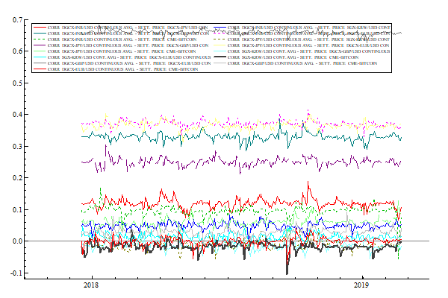
Figure 4 Dynamic conditional correlations of the bivariate DCC-GARCH (1,1) model

5. Conclusions
This paper investigates the potential volatility spillovers effects and the existence of contagion effects among Bitcoin future market and five FOREX future markets by employing a sixvariate DCC-GARCH model. The under investigation period is set from 2017 until 2019. This is the first empirical study, investigating volatility spillovers between Bitcoin future market and five FOREX future markets.
The main empirical results are summarized as follows. Based on the descriptive statistics, CME-BITCOIN returns presents the largest fluctuations compared to the rest markets. Furthermore, results of sixvariate DCC-GARCH model indicate strong evidence of volatility spillover effects. DCCs analysis shows evidence of strong co-movements for all the pairs of markets. Additionally, DCCs reveal contagion for all the pairs of markets in sub-periods. The empirical results are of interest to policymakers, who provide regulations for the under investigation derivative markets as well as to market-makers.
References
1 Corbet S, Brian L, Maurice P, Samuel V. Bitcoin futures—What use are they? Economics Letters 2018; 172; 23–27.
2 Tsiaras K. Dynamic relationship between future FOREX markets in the post Global Financial Crisis. Journal of Quantitative Methods 2020; 4(1); 30-52.
3 Forbes K, Rigobon R. No contagion, Only Interdependence: Measuring Stock Market CoMovements. Journal of Finance 2002; 57; 2223-2261.
4 Liu R, Shanfeng W, Zili Z, Xuejun Z. Is the introduction of futures responsible for the crash of bitcoin? Finance Research Letters 2019; 34.
5 Kim W J L, Kyungwon K. The effects of the introduction of bitcoin futures on the volatility of bitcoin returns. Finance Research Letters 2019; 33; 101204.
6 Aalborg H Aarhus P M, de Vries, J E. What can explain the price, volatility and trading volume of bitcoin? Finance Research Letters 2019; 29; 255–65.
7 Ardia D, Keven B, Maxime R. Regime changes in bitcoin garch volatility dynamics. Finance Research Letters 2019; 29; 266–71.
8 Bouoiyour J, Refk S. What does bitcoin look like? Annals of Economics and Finance 2015; 16; 449–92.
9 Bouri E, Peter M, Georges A, David R, Hagfors L I. On the hedge and safe haven properties of bitcoin: Is it really more than a diversifier? Finance Research Letters 2017; 20; 192–98.
10 Darné C, Darné A, Darné Ο. Volatility estimation for bitcoin: Replication and robustness. International Economics 2019; 157; 23–32.
11 Dyhrberg A H. Bitcoin, gold and the dollar—A garch volatility analysis. Finance Research Letters 2016; 16; 85–92.
12 Katsiampa P. Volatility estimation for bitcoin: A comparison of garch models. Economics Letters 2017; 158; 3–6.
13 Wu S, Mu T, Zhongyi Y, Abdelkader D. Does gold or bitcoin hedge economic policy uncertainty? Finance Research Letters 2019; 31; 171–78.
14 Bouoiyour J, Refk S. Bitcoin: A beginning of a new phase. Economics Bulletin 2016; 36; 1430–40.
15 Yermack D. Is bitcoin a real currency? An economic appraisal. Handbook of Digital Currency 2015; 31–43.
16 Dastgir S, Ender D, Gareth D, Giray G, Chi, K M L. The causal relationship between bitcoin attention and bitcoin returns: Evidence from the copula-based granger causality test. Finance Research Letters 2019; 28; 160–64.
17 Kristoufek L. Bitcoin meets google trends and wikipedia: Quantifying the relationship between phenomena of the internet era. Scientific Reports 2013; 3; 3415.
18 Panagiotidis T, Thanasis S, Orestis V. The effects of markets, uncertainty and search intensity on bitcoin returns. International Review of Financial Analysis 2019; 63; 220–42.
19 Dyhrberg A H. Hedging capabilities of bitcoin. Is it the virtual gold? Finance Research Letters 2016; 16; 139–44.
20 Bouri E, Rangan G, Aviral K T, David R. Does bitcoin hedge global uncertainty? Evidence from wavelet-based quantile-in-quantile regressions. Finance Research Letters 2017; 23; 87–95.
21 Demir E, Giray G, Chi K M L, Samuel, A V. Does economic policy uncertainty predict the bitcoin returns? an empirical investigation. Finance Research Letters 2018; 26; 145–49.
22 H, Pedro G. Bitcoin futures: An effective tool for hedging cryptocurrencies. Finance Research Letters 2019; 33.
23 Bollerslev T. Generalized autoregressive conditional heteroskedasticity. Journal of Econometrics 1986; 31(3); 307-327.
24 Engle R F. Dynamic conditional correlation-a simple class of multivariate GARCH models. Journal of Business & Economic Statistics 2002; 20; 339-350.
25 Hosking J R M. The Multivariate Portmanteau Statistic. Journal of the American Statistical Association 1980; 75(371); 602-608.
26.McLeod A I, Li W K. Diagnostic checking ARMA time series models using squared-residuals autocorrelations. Journal of Time Series Analysis 1983; 4(4); 269-273.

