Spc technigues in the non – manufacturing areas
ISSN 1857-9973 UDC 005.6:303.71]:658.5/.7

Elenica Sofijanova,¹ Goran Mitev²
¹University,,Goce Delcev“- Faculty of Economics – Stip, elenica.sofijanova@ugd.edu.mk
² University,,Goce Delcev“- Faculty of Economics – Stip, mitev.goran@gmail.com,

Abstract: In order for the company to maintain optimal process stability to make continuous improvements in order to survive and thrive, management needs to know and use certain tools and methods in quality management. Organizations which embrace the TQM concepts should recognize the value of SPC techniques in areas such as sales, purchasing, invoicing, finance, distribution, training, etc., which are outside production or operations – the traditional area for SPC use. A Pareto analysis, a histogram, a flow chart, or a control chart is a vehicle for communication. Statistical Quality Control (SPC) is a term used to describe the set of statistical tools used by quality professionals. Before start a new business (start-up) should be the right study for feasibility and profitability (feasibility study) and business plan for banks or potential investors in order to secure financing. Statistics can be used to come up with a practical business plan with which will be of interest to potential partners or financial institutions. Ways of using statistical data are: control, storage-archiving and retrieval. When using it is necessary to take into account the wide range of needs such as: the need for users, data quality, complete data inventory when entering documents, data protection and security, comparability of data over a period of time, timeliness of final data, financial implication, public understanding and acceptance.
Keywords: Statistical Quality Control - SPC, TQM concepts, new business - start-up, business plan, control, storage-archiving

1. INTRODUCTION

Statistical process control (SPC) is a method of quality control which employs statistical methods to monitor and control a process. This helps to ensure that the process operates efficiently, producing more specification-conforming products with less waste, rework or scrap. SPC can be applied to any process where the "conforming product" product meeting specifications output can be measured.
Key tools used in SPC include run charts, control charts, a focus on continuous improvement, and the design of experiments. An example of a process where SPC is applied is manufacturing lines.
SPC must be practiced in 2 phases: The first phase is the initial establishment of the process, and the second phase is the regular production use of the process. In the second phase, a decision of the period to be examined must be made, depending upon the change in 5M&E conditions (Man, Machine, Material, Method, Movement, Environment) and wear rate of parts used in the manufacturing process (machine parts, jigs, and fixtures).
An advantage of SPC over other methods of quality control, such as ,,inspection,, is that it emphasizes early detection and prevention of problems, rather than the correction of problems after they have occurred.
In addition to reducing waste, SPC can lead to a reduction in the time required to produce the product. SPC makes it less likely the finished product will need to be reworked or scrapped.
Statistical quality control can be divided into three broad categories:
1. Descriptive statistics - used to describe characteristics and quality links.
2. Statistical Process Control (SPC) - includes inspection of random sample selection from the process and deciding whether the process of producing products with characteristics that belong in the predetermined range answers the question of whether the process works properly or not.
3. Acceptance of sampling is a random process inspection, depending on whether to accept the decision on based on the results.
Therefore, when choosing which statistical methods and techniques (with appropriate software support) will be used in business research, it is necessary fulfillment of the following assumptions:

- Full knowledge of the theoretical concept of statistical methods and techniques applied;
- Knowledge of software packages, tools for statistical analysis, on-line statistical applications, etc .;
- Knowledge of the structure of statistical databases, etc. and
- Use of appropriate statistical terminology and development of statistical reports, as well as their interpretation.
In a narrower sense, SPS methods mean implementation of the control process by means of statistical control maps and process capability indices. An important element of quality control is the recognition of the displacement of measures that probably do not reflect the natural variability but signal some structural reason it requires additional examination. The total variation of the process is equal to the sum of the special ones (systematic) and random (unsystematic) causes of variation. Thanks to various control techniques there are many ways to conduct statistical control of processes and products. The basic tools for quality monitoring and control are:
- Histogram;
- Pareto diagram;
- Ishikawa diagram / Cause and effect diagram;
- Scatter diagram
- Control charts

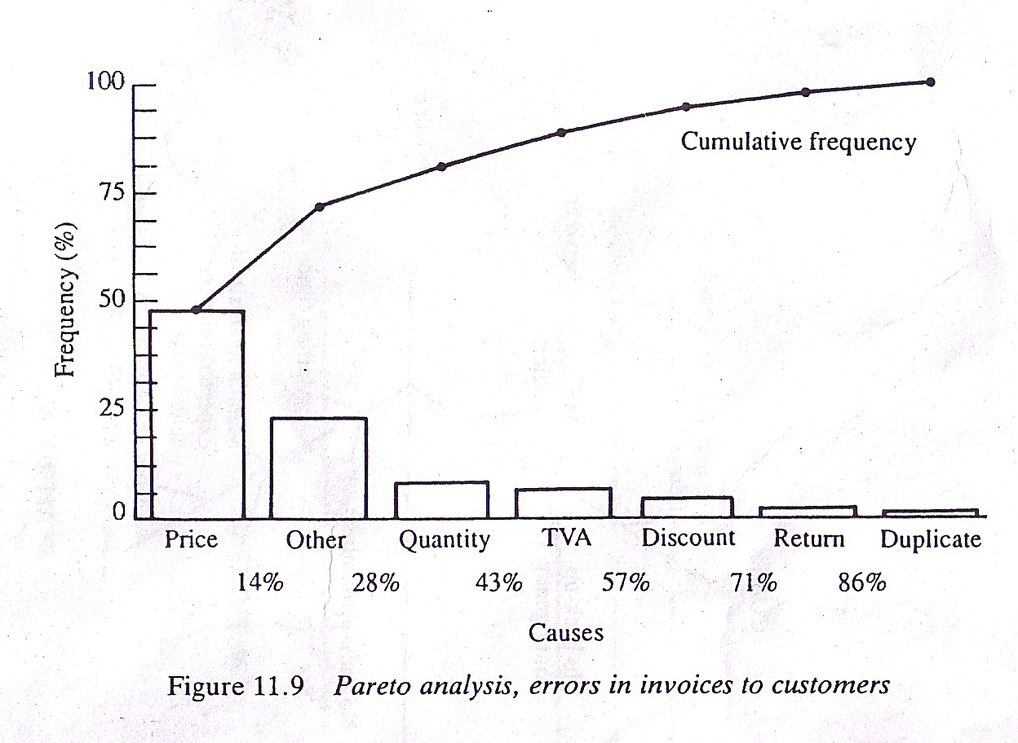
Figure 1. Pareto analysis, errors in invoices to customers
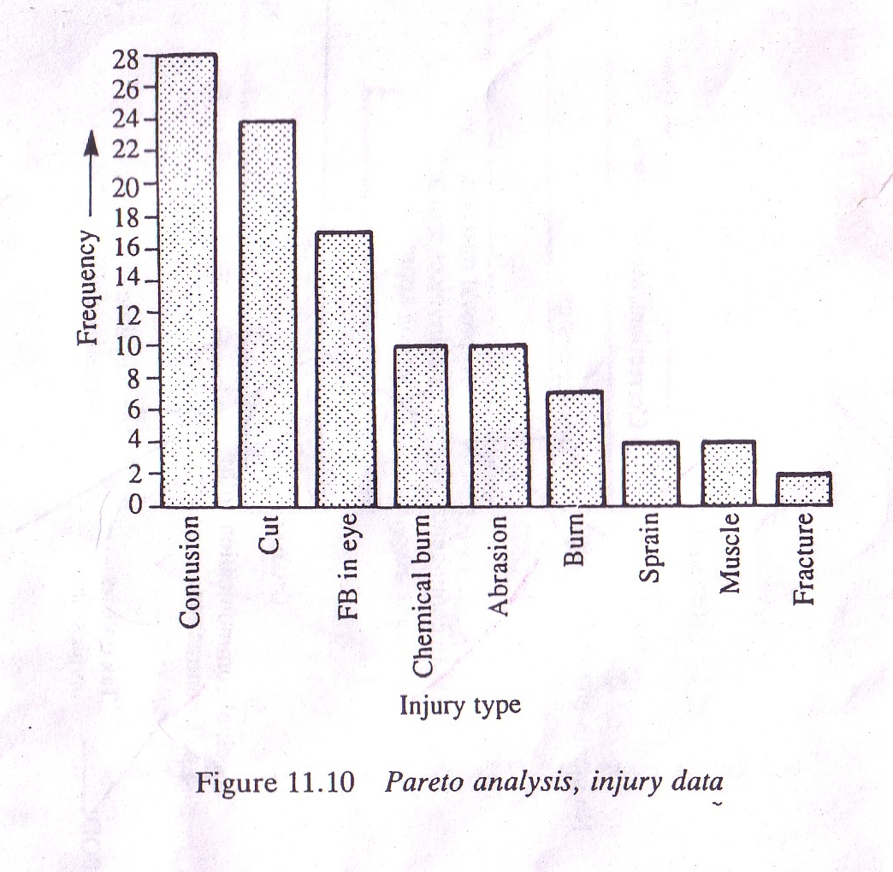

Figure 2. Pareto analysis, injury data
Statistical thinking is based on three basic principles :[1]
1. in the company the business consists of related processes,
2. there are variations in all processes and
3. Understanding and reducing are key to business success variations. Those who "think statistically" also understand that there are variations all around us and those variations are the main ones "Enemies" of quality

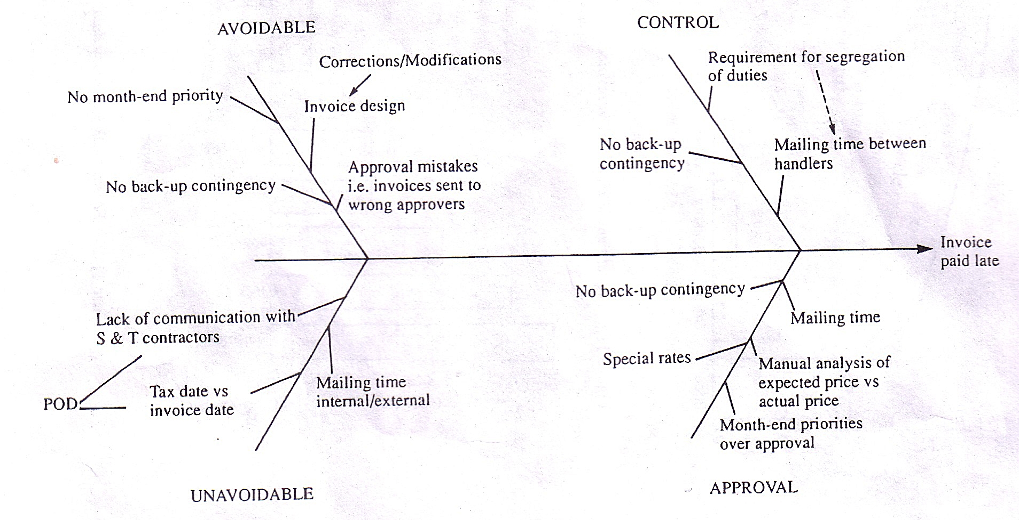

Figure 3. Basic cause and effect analysis, reasons for late payment
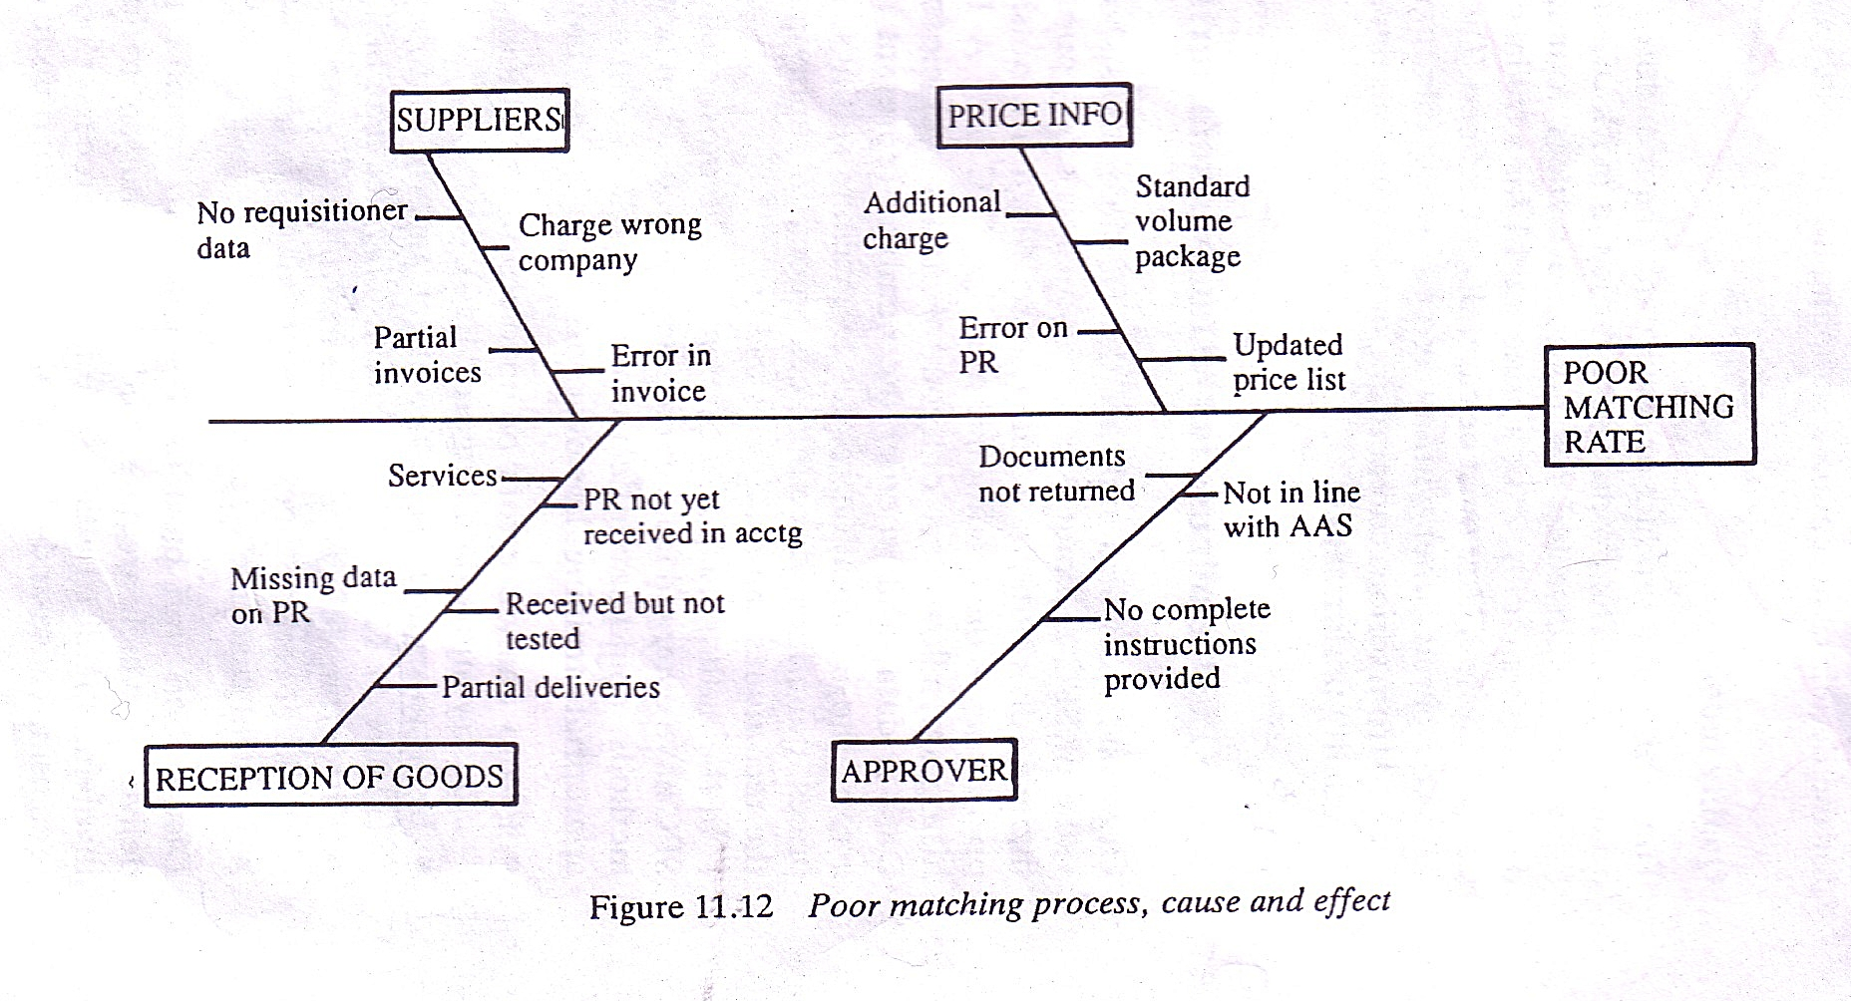

Figure 4. Poor matching process, cause and effect

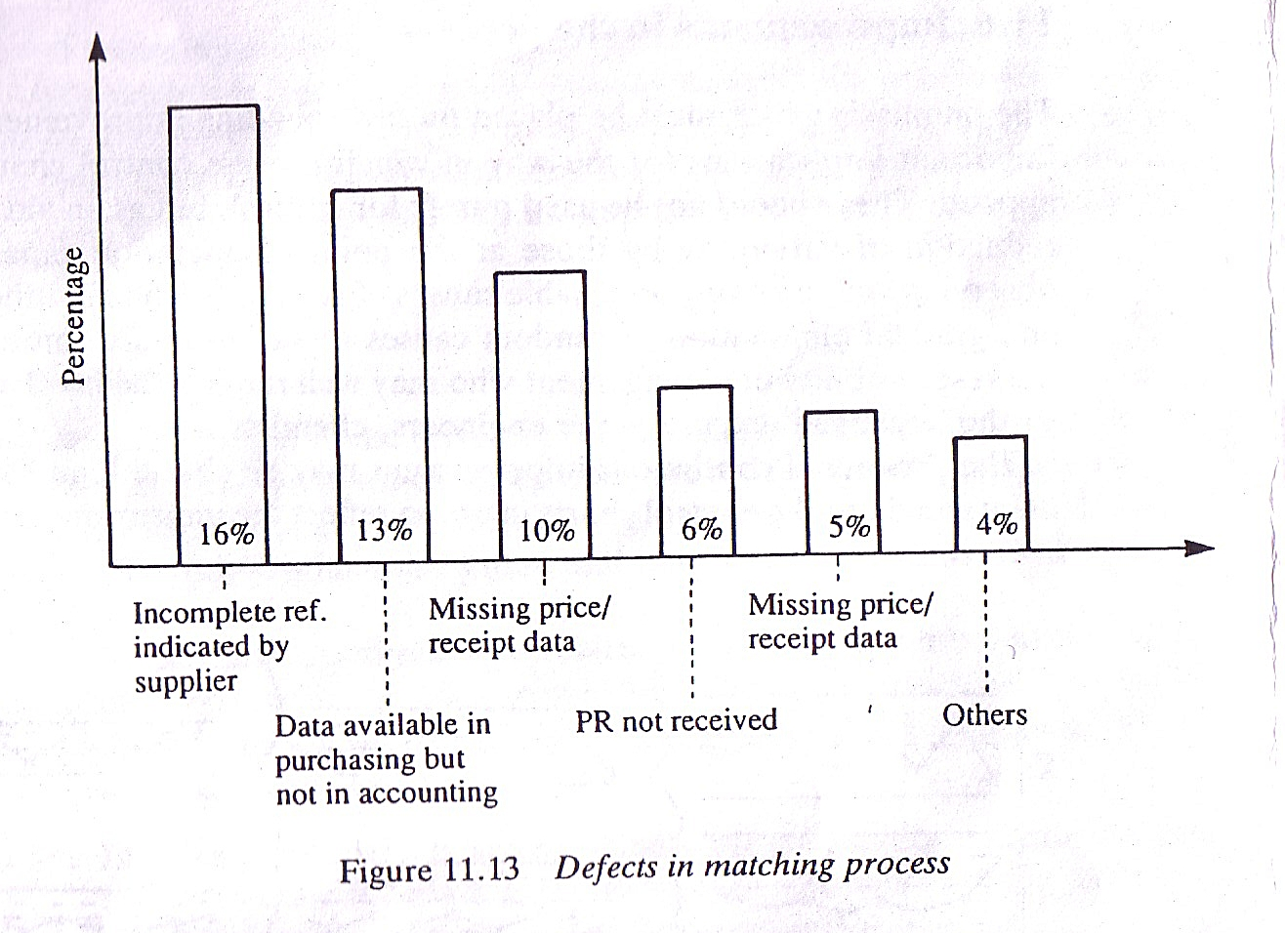
Figure 5. Defects in matching process

Those organizations which have made most progress in implementing TQM have recognized at an early stage SPC is for the whole organization. Restricting it to traditional manufacturing or operations activities means that a window of opportunity for improvement has been closed. Applying the methods and techniques outside manufacturing will make it easier, not harder, to gain maximum benefit from an SPC programme.
Sales and marketing is one area which often resists training in SPC on the basis that it is difficult to apply. Personnel in this vital function need to be educated in SPC methods for two reasons:

- They need to understand the way the manufacturing or service-producing processes in their organizations work. This will enable them to have more meaningful and involved dialogues with customers about the whole product service system capability and control. It will also enable them to influence customers` thinking about specifications and create a competitive advantage from improving process capabilities.
- They will be able to improve the marketing processes and activities. A significant part of the sales and marketing effort is clearly associated with building relationships, which are best built on facts (data) and not opinions. There are also opportunities to use SPC techniques directly in such areas as forecasting demand levels and market requirements, monitoring market penetration, marketing control, and product development, all of which must be viewed as processes.

SPC has considerable applications for non-manufacturing organizations, including universities![2]
Data and information on patients hospitals, students in universities, polytechnics, colleges and schools, people who pay (and do not pay) tax, draw social security benefit, shop at a systematic way, and all operations treated as processes, far better decisions could be made concerning past, present, and future performances of non-manufacturing parts of industry.[3]
Standards are an instrument of complete economic and industrial integration required to manage complex systems and providing quality products or services. Depending on acceptance standards can be internal, industrial, regional, national and international, shown in Table 1.

Table 1. Types of Standards
Hierarchical  level | Occurrence / application | Examples of  competent  organizations
Internal | In individual organizations from  national and multinational type
Industrial | One or more industrial  branches in one country | VDI, VDMA, ASTM, etc.
National | Area of individual countries | DIN, GB, HRN, BAS and others.
Regional | Individual Regions in Europe, America and others. | For example. European  organization
International | International Practically valid for the whole world | ISO etc.

In 1988, the Software Engineering Institute in America suggested that SPC could be applied to non-manufacturing processes, such as software engineering processes, in the Capability Maturity Model CMM). The Level 4 and Level 5 practices of the Capability Maturity Model Integration (CMMI) use this concept.
The application of SPC to non-repetitive, knowledge-intensive processes, such as research and development or systems engineering, has encountered skepticism and remains controversial.
SPC is less effective in the domain of software development than in, e.g., manufacturing.

In manufacturing, quality is defined as conformance to specification. However, no two products or characteristics are ever exactly the same, because any process contains many sources of variability. In mass-manufacturing, traditionally, the quality of a finished article is ensured by post-manufacturing inspection of the product. Each article (or a sample of articles from a production lot) may be accepted or rejected according to how well it meets its design specifications, SPC uses statistical tools to observe the performance of the production process in order to detect significant variations before they result in the production of a sub-standard article. Any source of variation at any point of time in a process will fall into one of two classes.[4]
(1) Common causes
'Common' causes are sometimes referred to as ,,non-assignable,,, or ,,normal,, sources of variation. It refers to any source of variation that consistently acts on process, of which there are typically many. This type of causes collectively produce a statistically stable and repeatable distribution over time.
(2) Special causes
'Special' causes are sometimes referred to as ,,assignable,, sources of variation. The term refers to any factor causing variation that affects only some of the process output. They are often intermittent and unpredictable.
Most processes have many sources of variation; most of them are minor and may be ignored. If the dominant assignable sources of variation are detected, potentially they can be identified and removed. When they are removed, the process is said to be ,,stable,,. When a process is stable, its variation should remain within a known set of limits. That is, at least, until another assignable source of variation occurs.
For example, a breakfast cereal packaging line may be designed to fill each cereal box with 500 grams of cereal. Some boxes will have slightly more than 500 grams, and some will have slightly less. When the package weights are measured, the data will demonstrate a distribution of net weights.
If the production process, its inputs, or its environment (for example, the machine on the line) change, the distribution of the data will change. For example, as the cams and pulleys of the machinery wear, the cereal filling machine may put more than the specified amount of cereal into each box. Although this might benefit the customer, from the manufacturer's point of view it is wasteful, and increases the cost of production. If the manufacturer finds the change and its source in a timely manner, the change can be corrected for example, the cams and pulleys replaced.[5]
The application of SPC involves three main phases of activity:
- Understanding the process and the specification limits.
- Eliminating assignable (special) sources of variation, so that the process is stable.
- Monitoring the ongoing production process, assisted by the use of control charts, to detect significant changes of mean or variation.
Control charts
The data from measurements of variations at points on the process map is monitored using control charts. Control charts attempt to differentiate "assignable" or "special" sources of variation from "common" sources. "Common" sources, because they are an expected part of the process, are of much less concern to the manufacturer than "assignable" sources. Using control charts is a continuous activity, ongoing over time.
Stable process
When the process does not trigger any of the control chart "detection rules" for the control chart, it is said to be "stable". A process capability analysis may be performed on a stable process to predict the ability of the process to produce "conforming product" in the future.
A stable process can be demonstrated by a process signature that is free of variances outside of the capability index. A process signature is the plotted points compared with the capability index.
Excessive variations
When the process triggers any of the control chart "detection rules", (or alternatively, the process capability is low), other activities may be performed to identify the source of the excessive variation. The tools used in these extra activities include: Ishikawa diagram, designed experiments and Pareto charts.. Designed experiments are a means of objectively quantifying the relative importance (strength) of sources of variation. Once the sources of (special cause) variation are identified, they can be minimized or eliminated. Steps to eliminating a source of variation might include: development of standards, staff training, error-proofing, and changes to the process itself or its inputs.
Process stability metrics
When monitoring many processes with control charts, it is sometimes useful to calculate quantitative measures of the stability of the processes. These metrics can then be used to identify/prioritize the processes that are most in need of corrective actions. These metrics can also be viewed as supplementing the traditional process capability metrics. Several metrics have been proposed, as described in Ramirez and Runger. [6]
WThey are (1) a Stability Ratio which compares the long-term variability to the short-term variability, (2) an ANOVA Test which compares the within-subgroup variation to the between-subgroup variation, and (3) an Instability Ratio which compares the number of subgroups that have one or more violations of the Western Electric rules to the total number of subgroups.

- IMPROVMENTS IN THE PROCESS

The emphasis which must be placed on never-ending improvement has important implications for the way in which process control charts are applied. They should not be used purely for control, but as an aid in the reduction of variability by those at the point of operation capable of observing and removing assignable causes of variation.[7]
The identification and gradual elimination of random causes of variation are, moreover, the responsibility of management who may well require the involvement of the ‘technical’ experts-the engineers, chemists, etc.
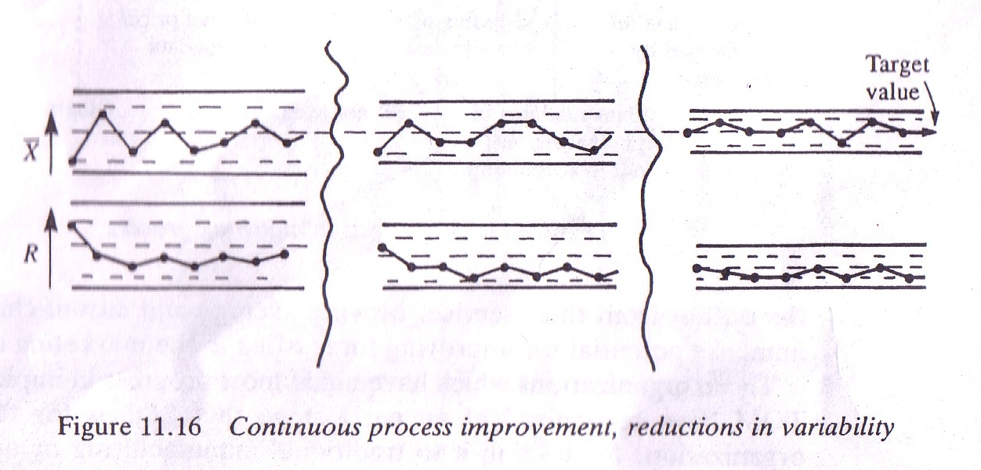

Figure 6. Continuous process improvement, reductions in variability

The process of continuous improvement may be charted, and adjustment made to the control charts in use to reflect the improvements. This is shown in Figure 6. where progressive reductions in the variability of piston diameters has led to decreasing sample range values.[8]
If the control limits on the mean and range charts are recalculated periodically or after a step change, their positions will indicate the improvements which have been made over a period of time, and ensure that the new level of process capability is maintained. Similarly attribute or cusum chart may be used, to show a decreasing level of number of errors, or proportion of defects and to indicate improvements an capability.[9]

3. POKA – YOKE

Shigeo Shingo is the inventor of the single-minute exchange of die (SMED) system in which set-up times are reduced from hours to minutes, and poka-yoke (mistake proofing) system. He was a key developer of the Toyota Production System and likes to be known as ‘Dr Improvement’.[10]
Shingo teaches three interrelated aspects of quality control. Zero quality control is the ideal production system in which no defects or errors are produces. To achieve this two things are required: ’poka-yoke’ and source inspections.

1. In poka-yoke, defects are examined, the production system stopped and immediate feedback given so that the root causes of the problems may be identified and prevented from occurring again.
Poka-yoke recognizes that people are human, fallible and will, on occasions, inadvertently forget things. To counter this characteristic of the human being, Shingo suggests the incorporation of ‘checklists’ (i.e. a poka-yoke) into the operation, so that if a worker forgets something, the device will signal that fact, thereby preventing errors or defects from occurring. This is similar to the author uses to make sure he has all the equipment necessary when leaving for the golf-course![11]
The poka-yoke concept is based on the same idea as ‘foolproofing’, an approach often used for preserving the safety of operations and in which assembly, manufacture, or operation can be performed in only one way – the correct way. This clearly has large implications for product and process design.
2. In source inspections, errors are looked at before they become defects and the system is either stopped for correction or the error condition automatically adjusted to prevent it from becoming a defect.[12]

Ordinary inspection systems stimulate feedback and action in response ti defects which have been produced. Source inspections are based on discovering errors in conditions that can give rise to defects, feeding back, and taking action at the error stage to prevent the errors from turning into defects. This requires the clear distinction between errors and defects. Defects arise because errors are made and there is a cause-and effect relationship between the two. If this is so then clearly errors will not turn into defects if feedback and action take place at the error stage.[13]

4.SOME TYPES OF STATISTICAL SOFTWERE UESD TODAY

Today the use of statistical methods is unthinkable without use on the computer, which contributed to their development and widespread use. Software support for statistical process control helps to meet the requirements of standards for management systems (e.g. ISO 9001) and the model of excellence, on the way to achieving the level of
quality. Most statistical software applications are developed to facilitate data entry, data presentation, view the alarm by entering comments and explanations for certain reasons that eliminated him from the process out of control. That's to him allows the executor to answer questions such as: “How does it work the process? "" Should the process be adjusted or left without corrections? " [14].
The executor needs very little knowledge of the SPC (Statistical Process Control). In general, a representative of application development must specify SPC data to create SPC objects, the executor only needs to know how to enter the data (input of data can be automated with DCS or base process data) and how to respond to alarms. For production and process engineers SPC application is useful for the implementation of the methodology of the total quality that requires continuous reduction / improvement of variations of process. The specific reasons are described in each case when the process is under control so the engineer / manager can concentrate on elimination of the most common special causes.
Also, small changes in process conditions can be analyzed objectively. SPC can be installed and activated very quickly and can be use all available information such as current and historical data. There are three graphics in almost all SPC software packages applications: SPC control charts, histograms, Pareto diagram.
The statistical software used can be: professional applications, spreadsheet calculators and web applications.

5. CONCLUSION

The methods of statistical quality control are increasing impose on companies as assistance and support in the management of quality. To be competitive in the market, companies will have to start use statistical quality control methods to a greater extent in their operation. The use of statistical methods, if performed with understanding, assists managers in making the right business decisions.
Often in process control situations, action signals are given when the assignable cause results in a desirable event, such as the reduction of an impurity level, a decrease in error rate, or an increase in demand or sales.
Clearly assignable or special causes which result in deterioration of the process must be investigated and eliminated, but those that result in improvements must also be sought out and managed so that they become part of the process operation. Significant variation between batches of material, operators, or differences between suppliers is frequent causes of action signals on control charts. [15]
The continuous improvement philosophy demands that these are all investigated and the results used to take another step on the long ladder to perfection. Action signals and assignable or special causes of variation should stimulate enthusiasm for solving a problem or understanding an improvement, rather that gloom and despondency. Zero QC system are set up by combining source inspections with 100 per cent inspections and providing immediate feedback and action. According to Shingo, a zero quality control system is based on the following basic ideas:

a) use source inspections to prevent defects, by applying control functions at the error stage where defects originate, and eliminate them completely;
b) use 100 per cent inspections rather than sampling inspections;
c) minimize the time it takes to carry out corrective action when abnormalities appear;
d) recognize than human workers are not infallible and set up poka-yoke devices accordingly

Using poka-yoke and source inspection systems has enabled companies such as Toyota to virtually eliminate the need for acceptance sampling methods.
Sectors in which statistical methods are mostly used in companies are the planning and analysis sector, the manufacturing and to a lesser extent the service sector and procurement and control sector. As a key factor for the successful introduction of statistical methods more managers consider training needed as well software for statistical processing of the obtained data.
The opinion of most of the managers is that with the introduction of statistical methods will increase production quality as well as process control work, increase the efficiency of the process, and it will all help in making the right decisions in the operation.[16]
Decision making is a process by which managers respond to opportunities and the threats they face, through analysis and decision making, or decisions.
Good decisions result in the selection of adequate goals and directions of action, which increase organizational execution, while bad decisions result in poorer execution. Managers always look for ways to make better decisions to improve organizational execution.
Modern management methods, managers can not apply without knowledge of statistical thinking. Statistical thinking helps managers do better in business and thus to achieve the best results for the company as well as for a personal career.
Statistical thinking is based on three basic principles: that in the company, the business consists of related processes, in all processes there are variations and how key to business success are understanding and reduction of variations. Those who "think statistically" also understand that there are variations all around us and those variations are the main ones "Enemies" of quality.
The challenge for corporate management is to improve in enrichment of knowledge from statistics and their application in the process of making decisions that will not be intuitive but based on rules, analyses and experiences.

5. REFERENCES

- Gustavsen, B., B.Hofmaier, M.Ekman Philips&Wikman, Concept – driven development and the organization of the process of change; an evaluation of the process of change, Vol.3 John Benjamins Publishing Company, Amsterdam\ Philadelphia, 2006, p. 118 – 123
- Dransfield, S.B., Fisher, N.I., Vogel, N.J. (1999), “Using Statistics and Statistical Thinking to Improve Organizational Performance.” International Statistical Review, 67 (2), 99-122.
- Richart L.Daft, Bureaucratic vs. Nonbureaucratic Structure in the Process of Innovation and Change, in Perspectives in Organizational Sociology: Theory and Research, ed.Samuel B.Bacharach(Greenwich,CT:JAI Press, 1982), 129 – 166
- Glenn Rifkin, Competing Through Innovation: The case of Borderbund, Strategy + Business11 (Second Quarter 1998), 48 – 58
- Duncan, A. J., (1986), Quality Control and Industrial Statistics – 5th edition,Homewood, IL: Irwin
- Salacinski, T (2015) SPC - Statistical Process Control. The Warsaw University of Technology Publishing House.
- Adapted from Patrick Reinmoeller and Nicole van Baardwijk, The Link Between Diversity and Resillence, MIT Sloan Management Review (Summer 2005), 61 – 65
- Evans, J.R.; Lindsay, W. M., (2005), The Management and Control of Quality –6 th edition, Cincinnati - Ohio, United States.
- Paul Hersez, Kennet H. Blanchard, Management of Organizational Behavior-Utilrring Human Resources, Fifth Edition, Prentice Hall, Englenjood Cliffs, Nenj Jersez, 1988
- Hoerl, R.; Snee, R., (2012), Statistical Thinking: Improving Business Performance – 2 th edition, New Jersey.
- Klarić, S.; Pobrić, S., (2009), “Importance of tools and methods for improvement of quality.” Naučno-stručni skup sa sa međunarodnim učešćem ”KVALITET 2009”, Univerzitet „Dţemal Bijedić“, Mašinski fakultet Mostar, Neum, B&H.
- Oakland, S.J., (2004), Quality Management, Oxford.
- Peter, M.; Oakland, S.J., (2011),Total Quality Management: A pictorial guide for managers, Oxford.
- Basu, Ron, Implementing Quality: A practical guide to tools and techniques, Thomson Learning, 2004
- Bhatt, G.D. (2001), “Knowledge menadţement in organizations: Examing the interaction between technologies, techniques and people.” Journal of Knowledge Menadžement, 5(1)
- Douglas, C. M., (2008), Statistical Quality Control: A Modern Introduction – 6 th edition, United States of America

