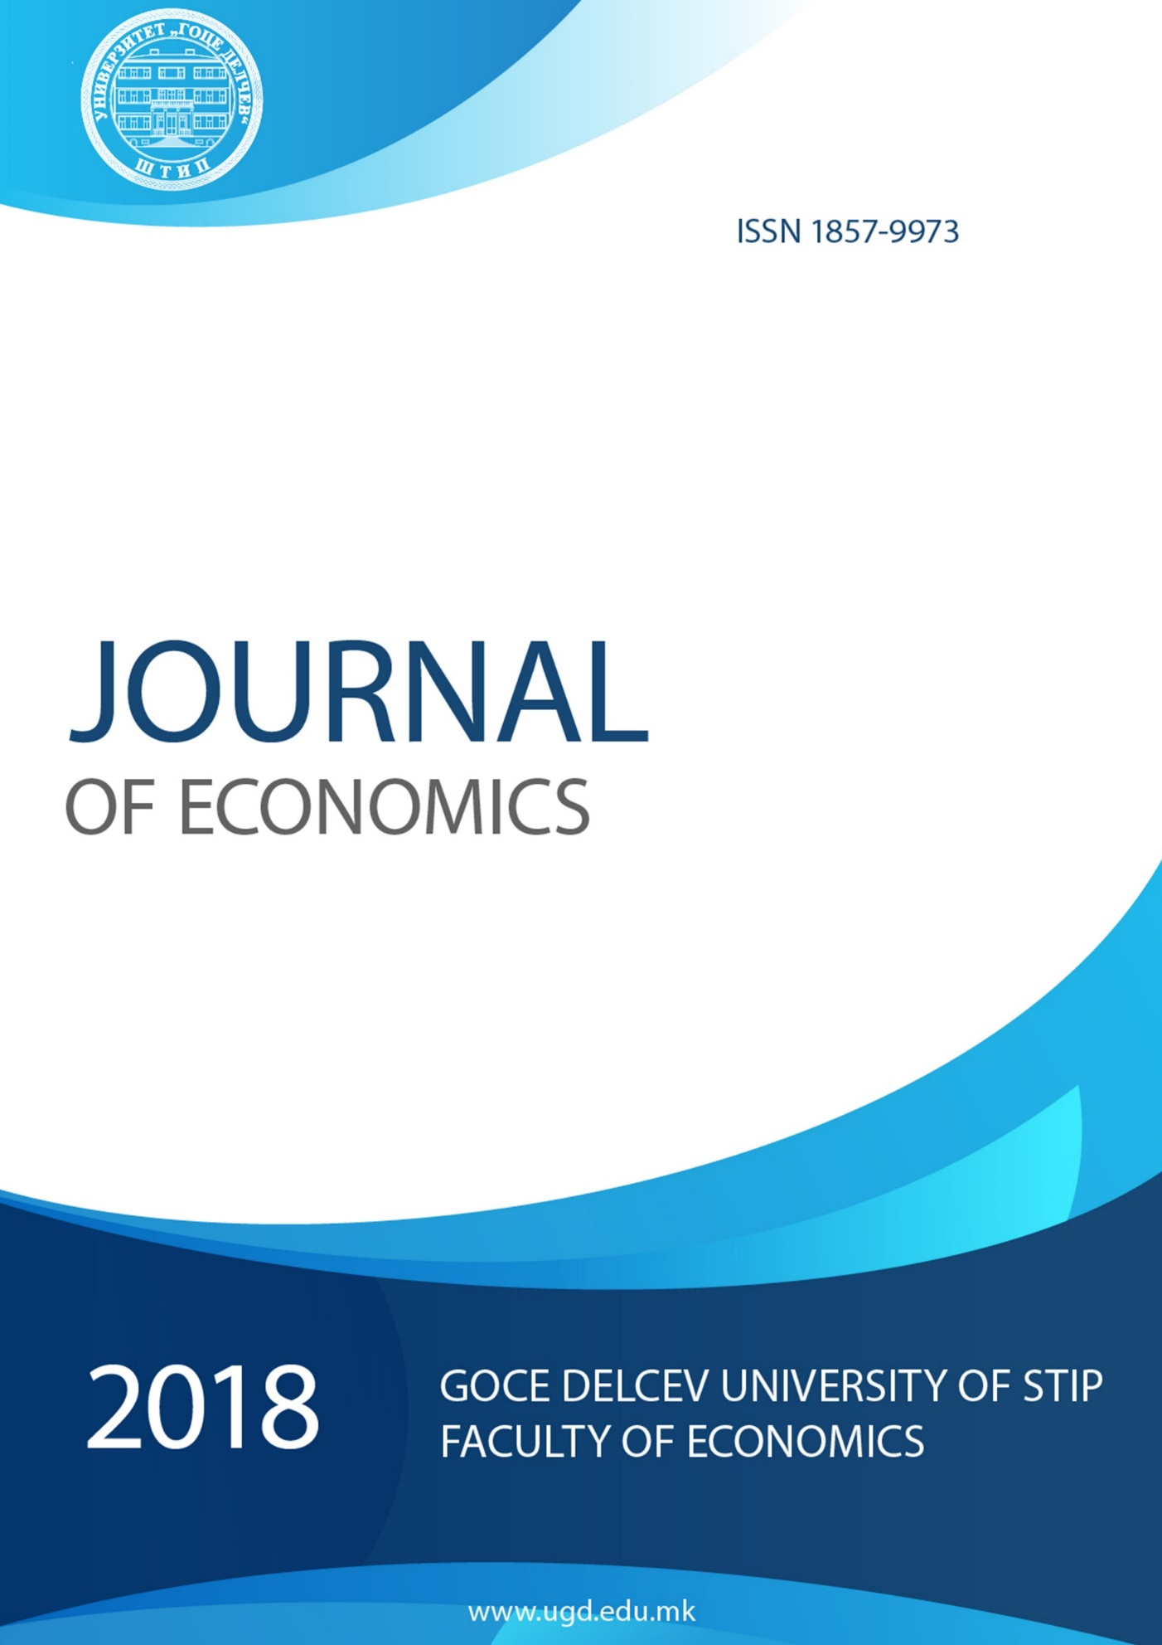
2021

The Journal of Economics ISSN 1857-9973 is an international, open access, peer reviewed, online journal. The journal focuses on the following areas of publication: Economics (Microeconomics, Macroeconomics, International Economics), Banking and Finance, Accounting and Auditing, Management and Business, Entrepreneurship and Marketing.
It provides an academic platform for professionals and researchers to contribute innovative work in the field. Journal of Economics carries original and full-length articles that reflect the latest research and developments in both theoretical and practical aspects of economics,finance, business and management.

Organizational Board
Riste Temjanovski, Goce Delcev University, Faculty of Economics, North Macedonia- President
Janka Dimitrova, University "Goce Delchev", Faculty of Economics, North Macedonia - Member
Elenica Sofijanova, University "Goce Delchev", Faculty of Economics, North Macedonia - Member
Olivera Gjorgieva-Trajkovska, University "Goce Delchev", Faculty of Economics, North Macedonia - Member
Tamara Jovanov-Apasieva, University "Goce Delchev", Faculty of Economics, North Macedonia - Member
Mila Mitreva, University "Goce Delchev", Faculty of Economics, North Macedonia - Member

International Editorial Board
Dr Suzana Stefanovic, University of Nis, Faculty of Economics, Nis, Serbia, Serbia and Montenegro
Dr Jovo Ateljevic, University of Banja Luka, Faculty of Economics, Republika Srpska, Bosnia and Herzegovina, Bosnia and Herzegovina
Dr Hristo Georgiev Sirashky, Academia "Dimitar Acenov" Faculty of management and marketing -Svishtov, R.Bulgaria, Bulgaria
Dr Alexander Petrov Ganchev, Dimitar A. Tsenov Academy of Economics, Svishtov, Bulgaria
Dr Nikolas Hourvouliades, The American College of Thessaloniki, Greece, Greece
Dr Milenko Popovic, Mediterranean University, Serbia and Montenegro
Dr Mehmet Huseyin Bilgin, Istanbul Medeniyet University, Turkey
Dr Riste Temjanovski, "Goce Delcev" University – Stip, North Macedonia
Dr Janka Dimitrova, University "Goce Delchev", Faculty of Economics, North Macedonia
Dr Elenica Sofijanova, University "Goce Delchev", Faculty of Economics, North Macedonia

Principal Contact
Riste Temjanovski, PhD
"Goce Delcev" University
Phone +38932550335
riste.temjanovski@ugd.edu.mk

Support Contact
Janka Dimitrova, PhD
Phone +38932550332
janka.dimitrova@ugd.edu.mk

Journal of Economics, 6 (1) 2021 ISSN 1857-9973

Contents

 | Title | Page
1 | Financial Contagion and Volatility Spillover: an exploration into Bitcoin Future and FOREX Future Markets  UDC 336.746:004.91.056.55]:336.76}:303.725.3(100)”2017/2019”  Konstantinos Tsiaras | 1-12
2 | The Impact and the Potential Disruption of the Blockchain Technology on Marketing  UDC 658.8:004.031.4  Zlatko Bezovski¹, Tamara Jovanov Apasieva², Riste Temjanovski³ | 13-22
3 | Cloud computing in logistic and Supply Chain Management environment  UDC 004.75:004.455]:658.86/.87  Riste Temjanovski,¹ Zlatko Bezovski,² Tamara Jovanov Apasieva³ | 23-32
4 | Benefits of using CRM (Customer Relationship Management) by Accounting Services Providers  UDC 005.42:658.89]:657:658.64  Dushko Kocev | 33-44
5 | Economic Aspects of Public Debt  UDC 336.27.01  330.34/.35:336.27  Stevan Gaber¹, Ilija Gruevski² | 45-53
6 | Spc technigues in the non – manufacturing areas  UDC 005.6:303.71]:658.5/.7  Elenica Sofijanova,¹ Goran Mitev² | 54-64
7 | Multilevel Perspective of Human Capital Resources: Recent Debates on Construct Clarification and its Measurement  UDC 331.101.262.01  Vesna Zabijakin Chatleska¹ | 65-75
8 | Basic Time Series Models in Financial Forecasting  UDC 658.14/.17-021.57:303.733.3  Ilija Gruevski¹, Stevan Gaber² | 76-89
9 | The effects of the globalization process on developing countries  UDC 339.5/.9-027.511(100-773)  Vlatko Paceskoski¹ , Krume Nikoloski ² | 90-97

