OVERVIEW OF THE FINANCIAL SYSTEM IN NORTH MACEDONIA
Mila Mitreva
Faculty of Economics, Goce Delcev University, Stip, North Macedonia, mila.mitreva@ugd.edu.mk
Ljupco Davcev
Faculty of Economics, Goce Delcev University, Stip, North Macedonia, ljupco.davcev@ugd.edu.mk
Marija Gogova Samonikov
Faculty of Economics, Goce Delcev University, Stip, North Macedonia, marija.gogova@ugd.edu.mk

Abstract
The financial sector in N. Macedonia is composed of deposit and non-deposit financial institutions. The banking sector is dominant in the financial system, while the participation of the other institutions is relatively lower. Although the total assets of the deposit institutions were 86.4% in 2022, these institutions faced declining trend in their assets throughout the past several years. In 2022 the total assets of the non-deposit institutions were 20.8%, however, with an increasing trend in the past several years. The obligatory pension funds have contributed mostly to the total growth of the assets of the non-deposit financial institutions. Therefore, considering the current dominant role of the banks and the upcoming importance of the non-deposit financial institutions, the aim of this paper is to deeply analyze the structure оf the total assets of separate deposit and non-deposit financial institutions in the financial sector of N. Macedonia.
Key words: financial system, financial institutions, banks, institutional investors

Introduction
The stability of the financial systems is very important for the economic development of the countries. Schumpeter (1912) is among the first researchers who analyzed the relationship between the financial system development and the economic growth and determined that the banking system plays crucial role for the economic growth. When it comes to the financial system in N. Macedonia, it is worth mentioning that it is composed of deposit and non-deposit financial institutions. Banks, as the largest deposit institutions constitute the largest segment of the domestic financial system. Therefore, the stability of the financial system is mainly determined by the stability of the banks. Nevertheless, the non-deposit financial institutions (insurance companies, pension funds, investment funds, financial companies, brokerage companies etc.) are also present, but their participation in the financial system is much lower (NBRM, 2024). Hence, the N. Macedonian financial system is relatively simple, with underdeveloped financial markets. (Cvetkoska and Fotova Cikovic, 2020). Although the banking system operates in traditional fashion it is strictly regulated by the Central Bank, National Bank of Republic of North Macedonia. The main activities of the banks include gathering deposits and issuing loans (Golitsis, et al, 2022). In this context, the National Bank of Republic of Macedonia is the main institution that regulates the financial stability and defines the requirements for proper operation of all participant in the financial system (Petrovska and Mihajlovska, 2013). Nevertheless, all of the others participant in the financial system in N. Macedonia are also regulated and controlled by various other institutions. Hence, Agency for Supervision of Fully Funded Pension Insurance regulates the pension funds, Insurance Supervision Agency regulates the insurance companies, Ministry of Finance regulates the financial companies and the Securities Commission is the main supervisor of the participants in the securities market (NBRM, 2024). Undoubtedly, the financial system is composed of different kind of institutions whose operations are highly supervised and regulated. Thus, the aim of this paper is to provide an overview of the financial system in N. Macedonia and to better understand the role that the banking and non-banking financial institutions have.

Literature review
The literature that focuses on analyzing the importance of the financial systems is vast. Well-functioning financial systems contribute to better allocation of resources in high-productivity investments that result with high return activities (Stiglitz, 1998). Therefore, Prochniak and Wasiak (2017) in their paper analyzed the impact of the financial system on economic growth in 28 European countries and 34 OECD countries for the period 1993-2013. In their analysis, domestic credit, non-performing loans, capital-asset ratio and market capitalization were used as independent variables, while gross domestic product was used as dependent variable. The results showed a positive and significant relationship between the banking sector and economic growth. Levine and Zervos (1996) in their paper found that the capital markets are very important source for funding of the companies. Pagano, et al. (2014) found that the financial structure has significant effects on real long-term growth per capita. Alda (2017) found that investment of pension funds in shares contributes to the development of the stock market, while Vucetich (2014) determined that insurance industry plays an important role in supporting investment and innovation, which is important for economic development. Additionally, Zacek, J., et al. (2019) analyzed the impact of European structural and investment funds on economic growth in the Czech Republic for the period 2004-2015 and found that they have positive effect on the economic growth.
Despite the literature that provides an overview of how different financial institutions affect the financial systems, there is also literature that analyses the financial system in N. Macedonia. Shabani (2022) in his paper analyzed the banking-activity participation in the financial system of the N. Macedonia. As stated in his paper, in the period 2015-2020, banks managed to comply with the new regulatory requirements and maintained their liquidity with liquid assets of one third of total assets. Tome, et al. (2012) in their paper highlight the expected increase in competition between the banking and non-banking financial institutions in N. Macedonia. This competition requires innovations in the traditional banking operations. Changes in the operation and the financial products offered are needed in order banks to keep their position as market leaders. Additionally, Popovska (2014) in her paper constructed a simple index of financial stability of the Macedonian banking sector. The methodological procedures included several methods, descriptive statistics, analysis of the correlation matrix, principle component analysis with oblique rotation, Construction of sub-indices for each individual dimension etc. The results showed a decrease during the financial crisis of 2007/2008. In the aftermath of the crisis, stabilization was evident, mainly due to the measures taken by the National Bank. Although most of the literature considers the banking institutions in N. Macedonia, there are several papers that focus on the non-banking institutions, such as the institutional investors. Mrsik and Jolevska (2014) analyzed the support of the institutional investors in developing stock markets in small economies, such as N. Macedonia. As stated in the paper, nowadays both banking and non-banking financial institutions are characterized by universalization of financial services and there should be tendency of changing the financial legal framework. Additionally, Jolevska and Andovski (2017) in their paper assessed the level of financial inclusion in N. Macedonia in which that they determined that the level of financial inclusion is on satisfactory level. As stated in the paper, financial inclusion is important because it can contribute to reduction of poverty, can have positive impact on macroeconomic development and it is important for other social policies.

Analysis of the financial system
As stated before, banks have dominant role in the financial system in N. Macedonia. However, the aim is to determine whether their participation in the financial system has changed through the years. Therefore in Graph 1 is presented the structure of the total assets in the financial system of the Republic of North Macedonia. It is evident that the deposit financial institutions have dominant role, compared to the non-deposit financial institutions. However, interesting finding is that their total assets have been decreasing throughout the years, from 91.7% in 2007 to 79.2% in 2022. The assets of the non-deposit financial institutions although are much lower, still there is an increasing trend in the period 2007-2022. Their assets in 2007 were 8.3%, reaching an amount of 20.8% in 2022. Additionally, in Graph 2 is presented the aggregate percentage growth of the assets of the individual segments of the financial system, for the last five years. The values shown show significant information about the potential importance of the other financial institutions for the financial system in N. Macedonia. For the period 2018-2022, financial companies have the highest aggregate potential growth of 275.5%. Although they are fastest growing, it is worth mentioning that their main activities include approval of quick loans with relatively small amounts with high cost. Therefore, this growth imposes a need for greater regulation and supervision. Comparing the banks with the institutional investors, the banks have grown 48%, while the insurance companies 51.7%, the pension funds 100.8% and the investment funds 105.5%. Hence, pension funds and insurance companies have grown twice compared to the banks. This growth suggests that institutional investors are starting to have important role for the N. Macedonian financial system. Regarding the institutional investors, pension funds are largest. As mentioned in the paper of Meng and Pfau (2010), an important prerequisite for pension fund assets to contribute to the development of capital markets is the level of financial development. Therefore, changes are needed in N. Macedonian financial system in order to create better opportunities for the activities of the institutional investors.
Graph 1: Structure of total assets in the financial system of the Republic of North Macedonia, in percentage
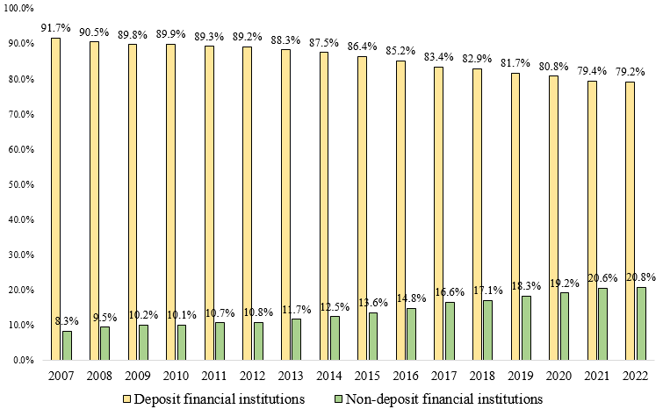
Source: National Bank of Republic of North Macedonia (2023)
Graph 2: Aggregate percentage growth of the assets of the individual segments of the financial system, for the last five years, in percentage
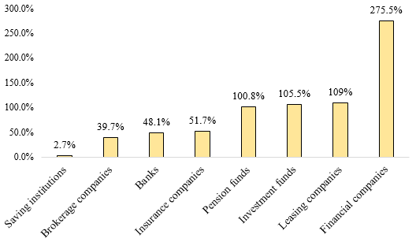
Source: National Bank of Republic of North Macedonia (2023)
As it was stated above, the financial system in N. Macedonia is bank-based, however, with an increasing importance of the institutional investors. In this context, it is important to understand the ownership structure of the financial institutions in order to detect the potential advantages, disadvantages and the possible risks. In Graph 3 are presented these results. Some of the factors important for understanding the ownership structure include transparency and accountability, risk management, regulatory compliance, market dynamics and financial stability. Therefore, financial companies, leasing companies, brokerage companies have mostly domestic ownership with 57.2%, 83.8% and 88.8%. Saving institutions are fully domestic owned (100%). Investment fund management companies, pension funds management companies, insurance companies and banks have mostly foreign ownership. The main advantages of foreign ownership is the access to capital and diversification of risk. Because of the foreign ownership, these companies can be less vulnerable to various negative economic condition in the country. Despite these advantages, foreign ownership increases the sensitivity to various foreign economic conditions, which can be easily transferred in the daily operations of these companies. Considering that banks have the dominant role and they have mostly foreign ownership they can be exposed to foreign economic conditions. Therefore, for all these institutions strict regulation is needed in order to avoid occurrence of risks that may negatively affect their activities.
Graph 3: Ownership structure of individual financial institutions in 2022, in percentage

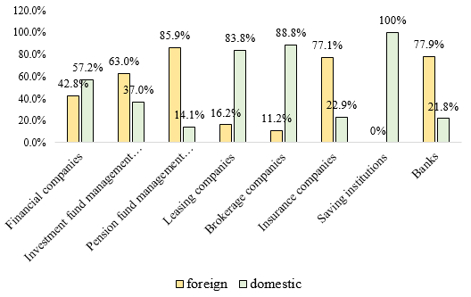
Source: National Bank of Republic of North Macedonia (2023)
Conclusion
The financial system in N. Macedonia is composed of banking and non-banking financial institutions. Banks remain the largest institutions through which the stability of the financial system is maintained. Although they have the largest part in the financial system, other segments, such as the institutional investors are starting to increase their participation and role. In the last few years, their role has been increasing more and more, which creates pressure for the introduction of new government policies and regulatory reforms. There are studies that confirm the positive role that the institutional investors have, but their impact depends on several factors, such as the degree of the development of the country. Institutional investors are very important for the financial system development because of the capital allocation process. They allocate their funds in different asset categories, resulting into productive investments that have positive effect on the economy. Considering that the banking sector is the main source of funding in N. Macedonia, with the development of the institutional investors it is expected that they will also play this role. The financial gap that exists for funding various activities, such as infrastructure can be filled through these institutions. Therefore, proper economic conditions are needed in order to further stimulate their growth and inclusion in the financial markets. With the right mechanisms, both deposit and non-deposit institutions can improve their performance. In this context, these institutions can become competitive not only in our country, but in the region as well.

References
Alda, M. (2017), “The relationship between pension funds and the stock market: Does the aging population of Europe affect it?” International Review of Financial Analysis. Vol. 49, pp. 83-97.
Cvetkoska, V. and Fotova Cikovic, K. (2020), Assessing the relative efficiency of commercial banks in the Republic of North Macedonia: DEA window analysis. Croatian Operational Research Review. Vol. 11, p. 217-227.
Golitsis, P., et al. (2022) Determinants of non-performing loans in North Macedonia. Cogent Business and Management. Vol. 9, No. 1.
Jolevska, E. D. and Andovski, I. (2017), Financial inclusion: The case of Republic of Macedonia. Economica. Vol. 63, p. 51-62.
Levine, R. and Zervos, S. (1996), “Stock Market Development and Long-Run Growth”. The World Bank Economic Review. Vol. 10, pp. 323-339.
Mrsik, J. and Jolevska, E. D. (2014), Institutional investors and their impact on the local stock markets in small developing economies. Horizons Series. Vol. 13, No. 10.
NBRM (2024), Financial system in Republic of North Macedonia. National Bank of Republic of North Macedonia. Retrieved from: https://www.nbrm.mk/finansiskiot-sistem-vo-republika-severna-makedonija.nspx
Pagano, M., et al. (2014), “Is Europe Overbanked?” Reports of the Advisory Scientific Committee, No. 4.
Petrovska, M. and Mihajlovska, E. M. (2013), Measures of Financial Stability in Macedonia. Journal of Central Banking Theory and Practice. No. 3, p. 85-110.
Popovska, J. (2014), Modeling financial stability: The case of the banking sector in Macedonia. Journal of Applied Economics and Business. Vol. 2, No. 1, p. 68-91.
Prochniak, M. and Wasiak, K. (2017), “The impact of the financial system on economic growth in the context of the global crisis: empirical evidence for the EU and OECD countries”. Empricia. Vol 44, pp: 295–337.
Schumpeter, J. (1912), The Theory of Economic Development: An Inquiry Into Profits, Capital, Credit, Interest, and the Business Cycle. Reprint, Harvard University Press, Cambridge, 1934.
Shabani, F. (2022), Banking activity-Participation in the financial system of the Republic of North Macedonia. Economic vision. Vol. 9, No. 17/18.
Stiglitz, J. (1998), . Fourth Annual Bank Conference on Development in Latin America and the Caribbean (LAC ABCDE).
Tome, N., et al. (2012), The impact of the banking system from the accession of Macedonia in the EU. MPRA Paper No. 42254.
Vucetich, A., et al. (2014), “The insurance sector and economic stability”. Reserve Bank of New Zealand. Vol. 77, No. 3.
Zacek, J., et al. (2019), “The Impact of EU Funds on Regional Economic Growth of the Czech Republic”. Finance a Uver. Vol. 69, No. 1, pp. 76-94.
National Bank of Republic of North Macedonia (2023), Report on financial stability in the Republic of North Macedonia in 2022. National Bank website. Retrieved from: https://www.nbrm.mk/content/FSR_2022_MKD.pdf

