**APPLICATION OF THE AGGLOMERATIVE CLUSTERING PROCEDURE FOR ASSESSING THE CIRCULARITY OF THE EUROPEAN UNION COUNTRIES**

Žarko Rađenović1, Tatjana Boshkov2

1Research Associate, University of Niš, Innovation Center, Serbia, [z_radjenovic89@outlook.com](mailto:z_radjenovic89@outlook.com)

2Professor, Goce Delcev University of Stip, Faculty of tourism and business

logistics, R.North Macedonia, e-mail: [tatjana.dzaleva@ugd.edu.mk](mailto:tatjana.dzaleva@ugd.edu.mk); ORCID: 0000-0001-8821-9223

**Abstract**

The circular economy represents a regenerative concept of the functioning of the economy and society, which aims at a more efficient allocation of resources and their use with the application of the principles of recycling and reducing the rate of waste generation to protect the environment. At the same time, the circular economy transforms and absorbs the existing industrial waste generation to create energy that encourages the further sustainable development of industrial ecosystems by directing processes to improve general business conditions. The primary methodological framework of this research is based on the selection of circular economy indicators and their performance at the level of the European Union for the five years 2017-2021, based on the latest available data from the Eurostat Database. By analyzing the five-year average values of circular economy indicators, using hierarchical cluster analysis using the agglomerative procedure, the European Union members are grouped by similarity into six clusters. Descriptive statistics within a cluster can determine the dominance of a particular cluster and progress in the area of the circular economy. Based on the results obtained, the most significant progress in circular performance was achieved by Croatia, Estonia and Latvia.

**Key words:** *Circular economy, European Union, Cluster analysis, Agglomerative procedure, Indicators*

**JEL Classification: C38, Q57**

**INTRODUCTION**

At the macroeconomic level, the circular economy implies the separation of economic growth from the use of natural resources and inputs. Ideally, the rate of resource extraction should remain below the rate of resource consumption, and the rate of waste production should be below the ability of the environment to absorb and transform waste. A circular economy can also be seen as a regenerative system where resource input and waste, emissions, and energy leakage are minimized through long-term design, maintenance, repair, reuse, sharing, remanufacturing, refurbishment, and recycling activities. The traditional model of industrial activity in which individual production processes take raw materials and produce products for sale plus waste to be disposed of should be transformed into a more integrated model ie. an industrial ecosystem. In such a system, the consumption of energy and materials is optimized, the generation of waste is reduced to a minimum, and the effluents of one process serve as raw materials for another process (Vranjanac, Ž. et al., 2023). The circular economy, an inspiring concept that is gaining enormous attention worldwide, deals with the effective scaling of sustainable economic models within planetary boundaries. The principle of extending the life cycle of materials, to keep the value of products and materials as long as possible, is central to this vision, as well as the transition to renewable energy, respect for biodiversity, social balance, and social inclusion. Working on a circular economy means working on the most sustainable development goals, not as a cost item, but as a business model. In some parts of the world, action is taking place within the framework of sustainable development goals, in other countries, climate issues are the dominant driver of action. Some focus on measures that create economically sustainable cities, while there are also regions that have started the transition to a circular economy (Vranjanac, Ž., & Rađenović, Ž., 2022). Innovative models based on a closer relationship with customers, mass personalization, the sharing and collaboration economy, and digital technologies such as the Internet, big data, blockchains, and artificial intelligence will accelerate the transition to a circular economy, dematerialization of the economy and the reduction of Europe's dependence on primary raw materials. The circular economy will bring citizens high-quality, functional, and safe products that are efficient and affordable, last longer, and can be reused, repaired, and recycled with high quality. A whole range of new sustainable services, product-as-a-service models, and digital solutions will increase the quality of life of citizens, create innovative jobs, and modernize knowledge and skills.The circular economy has become an attractive and challenging concept in the wide debate on public policy, yet the actual implementation of this concept is still debatable (Ren, Q., & Albrecht, J., 2023). Similar to sustainable development, the circular economy is a fluid concept that is still evolving (Velenturf, A. P., & Purnell, P., 2021).

The concept of the circular economy (CE) has become very popular since it was introduced by policymakers from China and the European Union as a solution that will enable countries, businesses, and consumers to reduce environmental damage and close the loop of the product life cycle (Prieto-Sandoval, V., Jaca, C., & Ormazabal, M., 2018). In a linear economy, natural resources are used to produce new products. Consumers buy products, use them for a while, and then dispose of them. However, as the ecological and economic drawbacks of this system become increasingly apparent, there is a growing need for a new and more sustainable approach (Alberich, J. P. et al., 2023). The central idea of the circular economy concept is to align economic and environmental benefits while reducing dependence on natural resources, achieved through material circulation in the business environment (Geissdoerfer, M. et al., 2020.) In a planned circular cycle, governments centrally guide the transition of the economy, using strong coercive measures such as command and control regulations on production and consumption, introducing taxes, strict limitations, and bans on certain activities (Boonman, H. et al., 2023). Circular consumption places consumers in difficult choices and compromises, while the fundamental technological orientation of the circular economy approach and its ecological modernist idea of gradually adapting the existing production system to the constraints of material resources tend to sideline temporality and spatiality in consumption. According to the principles of the circular economy, energy incineration should be the penultimate option, while landfill disposal should be the last option. In this way, the value chain of products and the life cycle retain the highest possible value and quality for as long as possible, while also being as energy-efficient as possible (Korhonen, J. et al., 2018). When raw material is extracted, refined, and produced at customary costs, it economically and business-wise makes sense for the produced value to be used for as long as possible, to keep the product/service function and utility value in economic circulation for as long as possible. Waste generation is one of the consequences of the traditional linear production process that has been observed in recent decades. The pattern of extraction of primary materials, production, consumption, and disposal, accelerated by economic development, has increased the amount of generated waste (Neves, S. A., & Marques, A. C., 2022). The circular economy (CE) is based on a transdisciplinary discussion aimed at achieving circularity in the management of natural resources. Understanding the cycle of material flow reversal is a potential competitive advantage for businesses, while CE also opens up employment opportunities, developing expertise in legal, mechanical, operational, or cross-sectoral challenges. Circular economy methods are highly scalable, therefore, CE is capable of stimulating growth and attracting investment capital. The circular economy is regenerative by design, in which economic activity builds and restores the overall health of the system (Nunes, A. M. M. et al., 2023) The concept of the circular economy recognizes the importance of an economy that should operate efficiently at all levels, for large and small enterprises, for organizations and individuals, globally and locally.

**MATERIAL AND METHODS**

The methodology applied in this research is mainly based on cluster analysis. The application of cluster analysis aims to group the EU member states based on selected indicators for the circular economy. Grouping the EU member states based on indicator values should contribute to understanding the similarities among countries in specific clusters regarding the implementation of circular economy policies. Additionally, by determining descriptive statistics for each cluster individually, the cluster with the best conditions for implementing the circular economy is identified, guiding for other member countries to progress in this area. In this regard, the authors use the indicator values for the EU27 from the last available five-year period (2017-2021), the Eurostat dataset for CE indicators (Circular Economy), as follows (Figure 1):

* Municipal waste generation per capita (C1) - The indicator measures waste collected on behalf of municipal authorities and disposed of through the waste management system. It largely consists of waste generated by households, although similar waste from sources such as trade, offices, and public institutions may also be included (Eurostat, cei_pc031).
* Packaging waste generation per capita (C2) - "Packaging" in this context refers to all products made from any material of any nature used for containment, protection, handling, delivery, and presentation of goods, from raw materials to processed goods, from producers to users or consumers. 'Single-use' items used for the same purposes will also be considered packaging. "Packaging waste" refers to any packaging or packaging material covered by the waste definition in the Waste Framework Directive 2008/98/EC, excluding production residues (Eurostat, cei_pc040).
* Recycling rate of materials (C3) - The indicator measures the proportion of materials that are recycled and returned to the economy - saving the extraction of primary raw materials - in the total material use. Circular material use, also known as the circularity rate, is defined as the ratio of circular material use (recycling) to total material use (Eurostat, cei_srm030).
* Recycling rate of packaging waste by type of packaging (C4) - The indicator is defined as the proportion of recycled packaging waste in the total generated packaging waste. Packaging waste includes waste material used for containment, protection, handling, delivery, and presentation of goods, from raw materials to processed goods, from producers to users or consumers, excluding production residues (Eurostat, cei_wm020).
* Patents related to waste management and recycling (C5) - The indicator measures the number of patents related to recycling and secondary raw materials (Eurostat, cie_cie020).
* Recycling rate of e-waste (C6) - Waste electrical and electronic equipment, also known as e-waste, such as computers, televisions, refrigerators, and mobile phones, is one of the fastest-growing waste streams in the EU. The indicator is calculated by multiplying the 'collection rate' as stated in the Directive with the 'reuse and recycling rate' established in the Directive (Eurostat, cei_wm050).
* Bio-waste recycling rate (C7) - The indicator is indirectly measured as the ratio of composted/methanized municipal waste (in mass units) to the total population (in number). The ratio is expressed in kg per capita (Eurostat, cei_pc040).
* Municipal waste recycling rate (C8) - The indicator measures the proportion of recycled municipal waste in the total municipal waste production (Eurostat, cei_wm011).

Figure 1. Average indicators values for the EU27 from the last available five-year period (2017-2021)

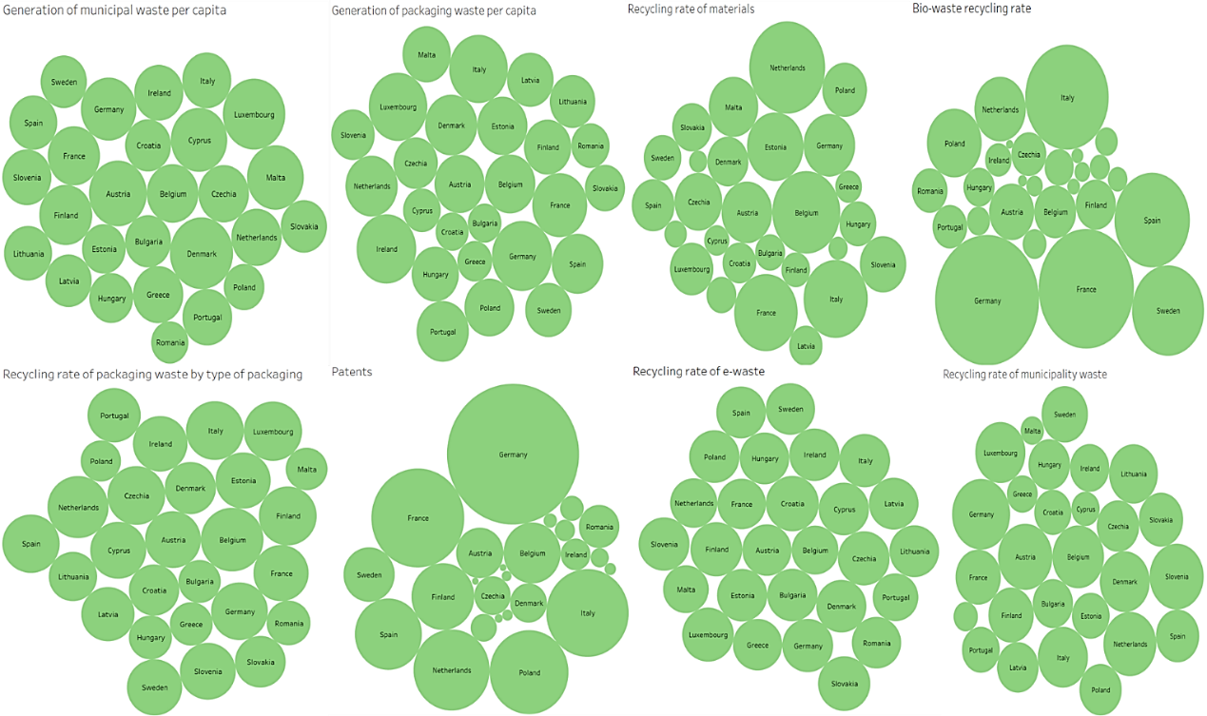

Source: Authors’ calculation based on the Eurostat Database

The cluster analysis methodology used in the conducted research is based on a hierarchical agglomeration scheme that, after several iterative steps, shows the last smallest change in the value of the Euclidean distance square, which defines the number of clusters using the proximity matrix. The agglomerative approach first involves a "bottom-up" analysis and then combines objects and groups until each of them is in a group or cluster. The Ward method was applied to form the agglomeration scheme to identify groups of countries that are similar to each other but different from other groups of countries. Specifically, by using this approach, the last significant change in the coefficient of cluster combination determines the total number of clusters (Table 1).

Table 1. Agglomeration schedule coefficients of cluster combination

|  |  |  |  |  |
| --- | --- | --- | --- | --- |
| **Stage** | **Cluster Combined** | | **Coefficients** | **Next Stage** |
| Cluster 1 | Cluster 2 |
| **1** | 10 | 26 | .012 | 4 |
| **2** | 11 | 27 | .037 | 5 |
| **3** | 13 | 18 | .075 | 10 |
| **4** | 7 | 10 | .120 | 6 |
| **5** | 9 | 11 | .179 | 6 |
| **6** | 7 | 9 | .245 | 10 |
| **7** | 4 | 16 | .351 | 12 |
| **8** | 2 | 24 | .463 | 15 |
| **9** | 6 | 25 | .582 | 18 |
| **10** | 7 | 13 | .747 | 13 |
| **11** | 1 | 14 | .935 | 19 |
| **12** | 4 | 8 | 1.205 | 22 |
| **13** | 7 | 22 | 1.520 | 15 |
| **14** | 20 | 21 | 1.866 | 20 |
| **15** | 2 | 7 | 2.228 | 19 |
| **16** | 3 | 12 | 2.728 | 21 |
| **17** | 15 | 23 | 3.410 | 23 |
| **18** | 6 | 17 | 4.450 | 23 |
| **19** | 1 | 2 | 6.109 | 22 |
| **20** | 5 | 20 | 8.105 | 21 |
| **21** | 3 | 5 | **10.534** | 25 |
| **22** | 1 | 4 | **13.530** | 24 |
| **23** | 6 | 15 | **16.881** | 24 |
| **24** | 1 | 6 | **22.703** | 26 |
| **25** | 3 | 19 | **31.743** | 26 |
| **26** | 1 | 3 | **45.452** | 0 |

Source: Authors’ calculation using statistical software IBM SPSS 26.0

The Ward method applied in the agglomerative process is based on the analysis of variance to estimate the distance between clusters and thus differs from others. The Ward procedure means that for each cluster, the average value for each variable (cluster center) is calculated, and then the Euclidean distance square from the cluster center is calculated for each object, after which the distance for the objects is summed (Fanelli, 2018). In this way, cluster analysis attempts to find similarities between the analyzed objects, which in this case are represented in the form of EU member states (Simović et al., 2020). The last significant changes in agglomeration schedule stages are depicted in Figure 2.

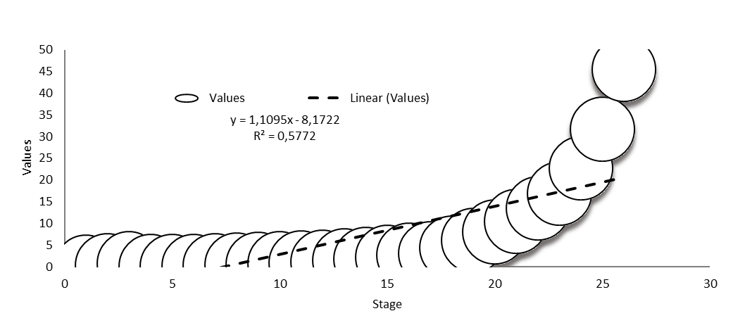

Figure 2. The last six changes in agglomeration schedule

Source: Authors’ elaboration based on agglomeration procedure results

The changes that occurred in the agglomeration arrangement after the class recomposition could be followed through a dendogram - the result of cluster analysis in the form of a tree representing the number of clusters on its lower "branches". In this way, it was possible to see how the country moved from one price group of public utility systems to another. The number of horizontal lines at lower tree heights intersected by a vertical line (dashed line) closer to the initial dendogram shows the actual number of clusters. A dendogram divides objects into a certain number of groups in vertical sections at a certain height, with one possible solution for grouping (Figure 3).

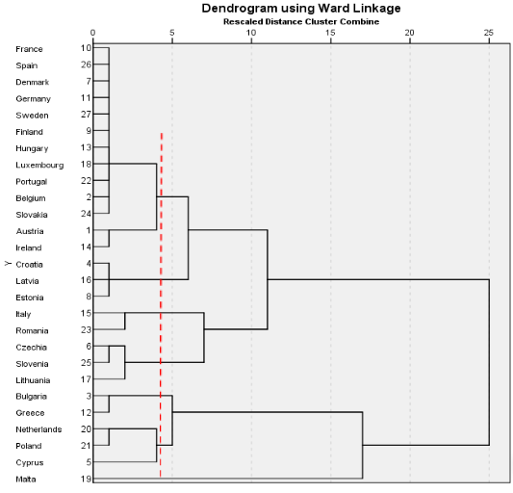

Figure 3. Dendogram using Ward’s linkage

Source: Authors’ elaboration based on agglomeration procedure results

**RESULTS AND DISCUSSION**

The hierarchical agglomerative approach as well as the descriptive statistics between existing clusters show that based on the analyzed indicators of the circular economy, six clusters of countries have been identified. Table 2 shows descriptive statistics for the analyzed indicators with their mean value within each cluster, where it can be seen that cluster number three is dominant in terms of indicators C4, C6, C7, and C8. Cluster number has dominance in recycling rate of materials. On the other hand, cluster number four has the highest results for the circular economy in terms of indicators C1 and C5, while cluster number five has the highest value for the circular economy indicator C2.

Table 2.Descriptive statistics for the indicators within six analyzed clusters

|  |  |  |  |  |  |  |  |  |  |
| --- | --- | --- | --- | --- | --- | --- | --- | --- | --- |
| Cluster | N | Mean | | | | | | | |
| C1 | C2 | C3 | C4 | C5 | C6 | C7 | C8 |
| 1 | 13 | 2.987 | 2.994 | 3.785 | 3.725 | 2.938 | 3.047 | 3.051 | 2.934 |
| 2 | 5 | 2.714 | 2.542 | **3.832** | 2.496 | 2.168 | 3.024 | 2.693 | 2.785 |
| 3 | 3 | 3.031 | 3.046 | 3.766 | **3.884** | 1.899 | **3.283** | **3.168** | **3.161** |
| 4 | 3 | **3.048** | 3.050 | 3.779 | 3.680 | **4.239** | 2.961 | 3.016 | 3.041 |
| 5 | 2 | 2.778 | **3.143** | 3.723 | 3.569 | 3.147 | 1.797 | 2.79 | 2.727 |
| 6 | 1 | 2.958 | 2.99 | 4.059 | 3.82 | 1.000 | 2.751 | 0.001 | 3.085 |

*C1- Municipal waste generation per capita, C2- Packaging waste generation per capita, C3- Recycling rate of materials, C4- Recycling rate of packaging waste by type of packaging, C5- Patents related to waste management and recycling, C6- Recycling rate of e-waste, C7- Bio-waste recycling rate, C8- Municipal waste recycling rate

**N- number of analyzed countries in the particular cluster

Source: Authors’ calculation using statistical software IBM SPSS 26.0

Based on the mentioned descriptive statistics and membership in specific clusters, where the first cluster consists of thirteen countries, the second cluster contains five member states, the third and fourth clusters have three countries each, the fifth cluster consists of two countries, and the sixth cluster comprises a single-country cluster (Malta), a map of circular economy clusters based on circular business model indicators for EU27 was created (Figure 4). These clusters consist of the following countries:

* Cluster 1: Austria, Belgium, Denmark, Finland, France, Germany, Hungary, Ireland, Luxembourg, Portugal, Slovenia, Spain, and Sweden.
* Cluster 2: Bulgaria, Cyprus, Greece, Netherlands, and Poland.
* Cluster 3: Croatia, Estonia, and Latvia.
* Cluster 4: Czech Republic, Lithuania, and Slovakia.
* Cluster 5: Italy and Romania.
* Cluster 6: Malta.

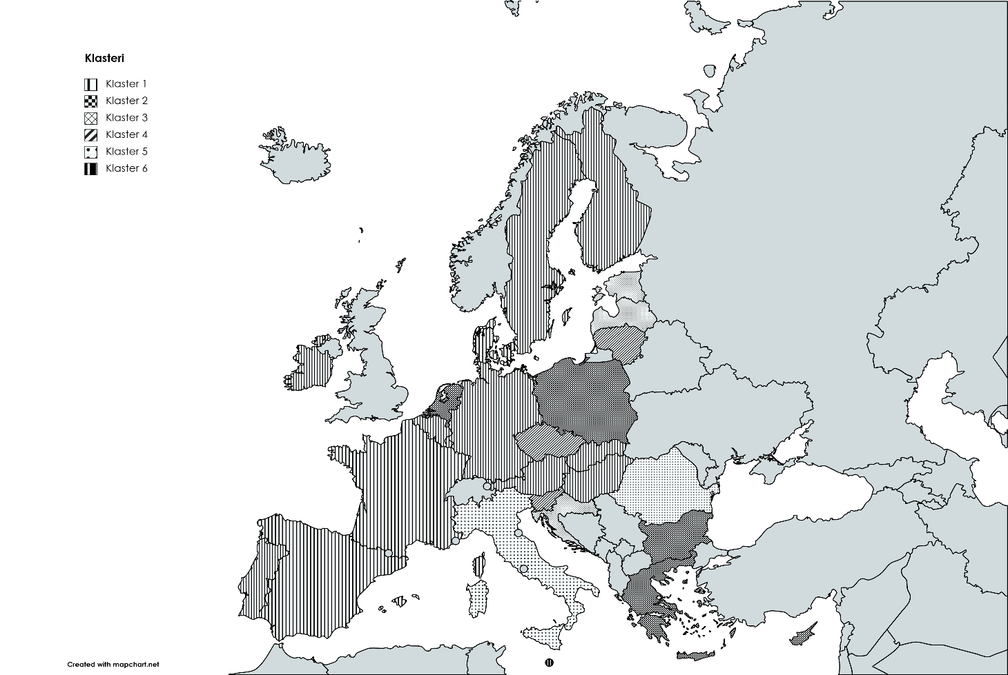

Figure 4.EU27 map chart based on cluster membership and descriptive statistics among clusters

Source: Author’s calculation using statistical software IBM SPSS 26.0

To validate the hierarchical grouping, the authors used Levene's statistic. The Levene test is one of the most commonly used tests, which starts from the null hypothesis that the variance is the same in all samples if P > 0.05. If P > 0.05, the null hypothesis is accepted, and the alternative is rejected, implying that the variance is equal for at least one pair of samples (Rađenović et al., 2022). Testing showed that statistically significant differences do not exist between the variations of the given sample, as recorded in Table 3. The results further indicate that the null hypothesis was accepted, meaning that the variance is homogeneous for the given variable across groups.

Table 3. Levene statistics and ANOVA procedure

|  |  |  |  |  |  |  |
| --- | --- | --- | --- | --- | --- | --- |
| Indicators | Levene Statistic | Sig. | Decision | Mean Square | Sig. | Decision |
| C1 | 4.463 | .090 | Approved | .079 | .038 | Approved |
| C2 | .736 | .578 | Approved | .197 | .000 | Approved |
| C3 | .659 | .628 | Approved | .018 | .013 | Approved |
| C4 | 11.671 | .050 | Approved | 1.271 | .000 | Approved |
| C5 | 3.429 | .056 | Approved | 2.869 | .000 | Approved |
| C6 | 1.436 | .257 | Approved | .636 | .000 | Approved |
| C7 | 2.974 | .053 | Approved | 1.832 | .000 | Approved |
| C8 | 1.245 | .322 | Approved | .081 | .037 | Approved |

*The level of significance is taken at 0.05.

Source: Author’s calculation using statistical software IBM SPSS 26.0

The authors used ANOVA procedure to examine the statistical significance of differences in average indicator values among clusters. Based on the conducted ANOVA procedure (Table 3), statistically significant differences in average indicator values can be noted, as seen in the Sig. column where P < 0.05 for all CE indicators.

**CONCLUDING REMARKS**

The cluster comprising of Croatia, Estonia, and Latvia exhibits the best performance in the area of circular economy for indicators like the recycling rate of packaging waste by type of packaging, patents related to waste management and recycling, the recycling rate of e-waste, the recycling rate of bio-waste, and the recycling rate of municipal waste, as can be clearly seen from the results of the mean values of the indicators among the clusters. Specifically, four growth directions are defined under the Croatian National growth Strategy 2030 (NDS 2030): balanced regional development, green and digital transformation, enhancing crisis resilience, and sustainable economy and society. In this sense, by guaranteeing a just and inclusive transition to climate neutrality, Croatia will be among the leaders in Europe in transforming environmental and climate-related issues into possibilities. A defined circular economy strategy and action plan have been established by Latvia for the 2020–2027 transition period. The Action Plan's main goal is to offer a framework for policymaking that will enable the nation to move towards a more environmentally friendly economy and help realise the Sustainable Development Goals (SDGs) and the European Green Deal. It is intended to make sure that the CE is applied wisely in Latvia's economy and society, to encourage more deliberate, accountable, and sustainable resource production and consumption, and to incorporate these fundamental ideas into all sectoral policies concerning resource flows and lifecycle stages. In terms of the EU Circular Economy Monitoring Framework metrics, Estonia has made inconsistent progress thus far, with no notable shifts in recent times. Positive developments include increasing the usage of circular materials and decreasing trash creation. However, increasing recycling rates continues to present challenges. The primary obstacles Estonia has in advancing a circular economy include poor environmental consciousness and societal knowledge of the CE, a lack of collaboration across stakeholders, and the diluting of duties. The creation of garbage has grown in Malta (country-cluster) due to significant increases in tourism, GDP, and overall population between 2010 and 2020. Malta's industrial sector depends heavily on imported goods for both raw materials and finished goods. Italy and Romania have the highest packaging waste generation per capita according to cluster descriptive statistics which is conversely expanding of their circular rate. To enhance circular economy practices, stakeholders should collaborate on aligning national strategies with EU directives. Investments in research and innovation are most important for developing circular solutions and waste management infrastructure. Promoting circular design principles and product lifecycle assessments can drive sustainable production. Capacity-building programs should equip stakeholders with the skills needed for a circular transition. Monitoring frameworks must be established to track progress and assess the effectiveness of circular initiatives. These measures vary between countries and clusters, highlighting the need to dynamically seek optimal solutions for enhancing circularity in today's and future's evolving conditions.

**ACKNOWLEDGEMENT**

This research was financially supported by the Ministry of Science, Technological Development and Innovation of the Republic of Serbia *(*Evidence number: *451-03-66/2024-03/ 200371*)

**REFERENCES**

Alberich, J. P., Pansera, M., & Hartley, S. (2023). Understanding the EU's circular economy policies through futures of circularity. Journal of Cleaner Production, pp. 385

Boonman, H., Verstraten, P., & van der Weijde, A. H. (2023). Macroeconomic and environmental impacts of circular economy innovation policy. Sustainable Production and Consumption, 35, pp.216-228.

Eurostat (2024, February, cei_srm030). Circular material use rate.

https://ec.europa.eu/eurostat/cache/metadata/en/cei_srm030_esmsip2.htm

Eurostat (2024, February, cei_pc031). Generation of municipal waste per capita.

https://ec.europa.eu/eurostat/cache/metadata/en/cei_pc031_esmsip2.htm

Eurostat (2024, February, cei_pc040). Generation of packaging waste per capita.

https://ec.europa.eu/eurostat/cache/metadata/en/cei_pc040_esmsip2.htm

Eurostat (2024, February, cei_pc040). Recycling bio-waste. https://datahub.digicirc.eu/dataset/recycling-of-biowaste/resource/7f590b4f-a9f0-4bf8-98c3-71d809657085?view_id=804f0b78-a78a-482e-85e5-30cc4dd030c6

Eurostat (2024, February, cei_wm050). Recycling rate of e-waste.

https://ec.europa.eu/eurostat/databrowser/view/cei_wm050/default/table?lang=en

Eurostat (2024, February, cei_wm011). Recycling rate of municipal waste.

https://ec.europa.eu/eurostat/cache/metadata/en/cei_wm011_esmsip2.htm

Eurostat (2024, February, cei_wm020). Recycling rate of packaging waste by type of packaging.

https://ec.europa.eu/eurostat/cache/metadata/en/cei_wm020_esmsip2.htm

Eurostat (2024, February, cie_cie020). Patents related to waste management and recycling.

https://ec.europa.eu/eurostat/cache/metadata/en/cei_cie020_esmsip2.htm

Fanelli, R.M. (2018) The (Un)Sustainability of the Land Use Practices and Agricultural Production in EU Countries“, International Journal of Environmental Studies, 76(2), pp. 273–294., https://doi.org/10.1080/00207233.2018.1560761

Geissdoerfer, M., Pieroni, M. P., Pigosso, D. C., & Soufani, K. (2020). Circular business models: A review. Journal of cleaner production, 277, pp.1-15

Korhonen, J., Nuur, C., Feldmann, A., & Birkie, S. E. (2018). Circular economy as an essentially contested concept. Journal of cleaner production, 175, pp.544-552.

Neves, S. A., & Marques, A. C. (2022). Drivers and barriers in the transition from a linear economy to a circular economy. Journal of Cleaner Production, 341

Nunes, A. M. M., Coelho Junior, L. M., Abrahão, R., Santos Júnior, E. P., Simioni, F. J., Rotella Junior, P., & Rocha, L. C. S. (2023). Public Policies for Renewable Energy: A Review of the Perspectives for a Circular Economy. Energies, 16(1), pp.485.

Prieto-Sandoval, V., Jaca, C., & Ormazabal, M. (2018). Towards a consensus on the circular economy. Journal of cleaner production, 179, pp.605-615.

Rađenović, Ž., Krstić, B., & Marković, M., (2022) Economic Performance of Agriculture in the European Union Countries, Problems of Agricultural Economics, 370(1), pp.5-21, https://doi.org/10.30858/zer/145686

Reiff, M., Ivanicova, Z., & Surmanova, K., (2018) Cluster analysis of selected world development indicators in the fields of agriculture and the food industry in European Union countries. Agric. Econ. – Czech, 64, pp. 197–205., https://doi.org/10.17221/198/2016-AGRICECON

Ren, Q., & Albrecht, J. (2023). Toward circular economy: The impact of policy instruments on circular economy innovation for European small medium enterprises, Ecological Economics, 207, pp.107-761.

Simović, O., Rađenović, Ž., Perović, D., & Vujačić, V. (2020) Tourism in the Digital Age: E-Booking Perspective. ENTRENOVA – ENTerprise REsearch InNOVation, 6(1), pp. 616-627., https://hrcak.srce.hr/ojs/index.php/entrenova/ article/view/13515/6766

Velenturf, A. P., & Purnell, P. (2021). Principles for a sustainable circular economy. Sustainable Production and Consumption, 27, pp.1437-1457.

Vranjanac, Ž., Rađenović, Ž., Rađenović, T., Živković, S. (2023). Modeling circular economy innovation and performance indicators in European Union countries. Environmental Science and Pollution Research, 30 (34), pp. 81573-81584., https://link.springer.com/article/10.1007/s11356-023-26431-5

Vranjanac, Ž., & Rađenović, Ž. (2022). EU Countries' Hierarchical Clustering Towards Circular Economy Performance Indicators. Facta Universitatis, Series: Working and Living Environmental Protection, 19 (3), pp. 149-155., https://doi.org/10.22190/FUWLEP2203149V