Optimal taxation without state-contingent debt, the Ramsey allocation for a given multiplier, and tax smoothing of consumption and taxes in complete and incomplete markets
Dushko Josheski∗ Natasha Miteva∗ Tatjana Boshkov∗
Faculty of Tourism and Business Logistics, Goce Delcev University, Stip, North Macedonia
Abstract
This paper illustrates optimal fiscal and monetary policies without state-contingent debt as in Aiyagari, Marcet, Sargent, and Seppälä (2002) and the issue of competitive equilibrium with distorting taxes, tax smoothing as in Barro (1979) but without state-contingent debt, and Ramsey problem without state-contingent debt. Numerical model od optimal taxation without state-contingent debt proves that the total resources available to the government (from taxes) are entirely used for consumption purposes, possibly reflecting a scenario where government spending equals tax revenue, and there is no debt accumulation. Optimal taxation without state-contingent debt shows that the contact between tax rate and debt is of 0th-order: The curves touch at a point but don't necessarily have the same tangent or curvature at that point. The tax rate curve is convex (minimum),debt curve is concave (maximum).
Keywords: AMSS model, without state-contingent debt, tax smoothing, complete markets, incomplete markets
JEL codes:H21, H63

Introduction
Our main reference paper is that by Aiyagari, Marcet, Sargent, and Seppälä (2002) (hereafter, AMSS) studied optimal taxation in a model without state-contingent debt. In order to recover a version of Barro’s random walk tax-smoothing outcome model, AMSS modify economy of Lucas,Stokey (1983) to permit-only risk free debt. Barro (1979) embraced an analogy with a permanent income model of consumption to conjecture that debt and taxes should follow random walks, regardless of the serial correlations of government expenditures, see Hansen, Roberds, and Sargent (1991). Barro (1979), has formalized the idea that taxes should be smooth by saying that they should be a martingale, regardless of the stochastic process for government expenditures, see Sargent,Velde (1998). Barro (1979) model is about government that borrows and lends to help it minimize an intertemporal measure of distortions caused by taxes. The consumption model that inspired Barro (1979) assumes consumer in incomplete markets setting and adjusting by holding of aa risk-free asset to smooth consumption across time and states. By assuming complete markets,Lucas,Stokey (1983) disrupted Barro(1979) analogy. This paper will investigate optimal taxation problems in an incomplete market setting. By permitting only risk-free government borrowing, we revitalize parts of Barro’s consumption-smoothing analogy, same as in Aiyagari, Marcet, Sargent, and Seppälä (2002). Optimal taxation is the study of how a government can design a tax system to achieve certain objectives, such as maximizing social welfare or minimizing economic distortions. State-contingent debt refers to government debt whose repayment depends on the state of the economy (e.g., GDP-linked bonds). When such debt is unavailable, the government must design tax policies that are robust to various economic conditions. Research on optimal taxation includes: optimal income taxation theories are subject of investigation following the classic paper in public finance by Mirrlees (1971), and the models of Sadka (1976), Seade,(1977), Akerlof (1978),Stiglitz (1982), Diamond (1998), and Saez (2001) , Piketty-Saez-Stantcheva (2014), all related to the classic paper by Mirrlees (1971). The government chooses a tax policy that equates the marginal utility of consumption to the marginal cost of raising public funds (given by the Lagrange multiplier). First-Best vs. Second-Best: In a first-best world with lump-sum taxes, the optimal policy would avoid any distortions. In the second-best world, where lump-sum taxes are not available, the government must balance the trade-off between efficiency and equity. In the context of Barro 1979), tax smoothing refers to the idea that governments should adjust tax rates gradually to smooth out fluctuations in government spending over time, rather than making frequent changes in tax policy in response to short-term fluctuations in revenue or expenditure. According to the tax-smoothing hypothesis, the government sets the budget surplus equal to expected changes in government expenditure, see Adler (2006) , and Josheski, D. ,Miteva, N. ; Boskov, T. (2024) . Tax smoothing is the concept that governments should minimize the variability of tax rates over time to reduce economic distortions. The idea is to spread tax burdens evenly over time rather than imposing high taxes during economic downturns and low taxes during booms. In Complete Markets: All future risks can be hedged with financial instruments. The government can fully smooth taxes over time by issuing state-contingent debt. While in Incomplete Markets: Some risks cannot be hedged, leading to potential tax volatility. The government must find a balance between current and future taxation. In the tradition of neoclassical economics on optimal fiscal policy of Ramsey (1927), Barro (1979), and Lucas and Stokey (1983),it has been emphasized that, when taxation is distortionary, societal welfare is being maximized if the government smoothes taxes across different period of time and different realizations of uncertainty. Tax Smoothing in Complete Markets: The government can maintain a relatively stable tax rate over time by issuing state-contingent debt, allowing for consumption smoothing across different economic states. Tax Smoothing in Incomplete Markets: The absence of state-contingent debt means the government may need to adjust tax rates more frequently to respond to economic conditions, leading to less smoothing of consumption and potentially higher welfare losses. How these concepts can be implemented? Barro’s Tax Smoothing Hypothesis: The government should aim to keep tax rates constant over time, adjusting borrowing and spending instead of changing tax rates frequently. This minimizes the distortions caused by fluctuating tax rates. Consumption Smoothing: In a tax-smoothing scenario, households’ consumption paths are relatively stable, as the government adjusts other fiscal instruments to absorb shocks. This paper will explore these issues and will provide numerical examples for optimal taxation without state-contingent debt followed by some meaningful conclusions. The primal approach to optimal taxation should follow Ramsey (1927) tradition, who thinks of optimal tax problem in economy with representative agent only when distortionary taxes are available. The general equilibrium traditions stems from : Cass (1965),Koopmans (1965), Kydland,Prescott (1982), Lucas and Stokey (1983), see also Chari,Kehoe (1991). So, in summary about optimal taxation without State-Contingent Debt: The government aims to design a tax policy that is robust to economic fluctuations, minimizing distortions while maintaining budget balance without the flexibility offered by state-contingent debt. And as for the tax smoothing: it aims to keep tax rates stable over time to reduce economic distortions. In complete markets, this is more feasible due to the availability of state-contingent debt, while in incomplete markets, the government faces greater challenges in maintaining stable tax rates. Distortionary taxes create wedge between marginal rates of transformation and marginal rates of substitution,and government policy becomes a source of frictions. The monetary stabilization literature considers environments where frictions are present even without government policy. These frictions are due to nominal rigidities and imperfect competition in product or labor market. The corresponding wedges reduce the level of economic activity and may be subject to stochastic fluctuations, known as cost-push shocks.First, we will explain competitive equilibrium with distorting taxes, followed by Ramsey problem without state-contingent debt, and risk-free one period debt only, and this paper later will provide numerical examples.

Barro's Tax Smoothing Hypothesis without state-contingent debt
Barro's Tax Smoothing Hypothesis suggests that governments should aim to keep tax rates stable over time, using borrowing and debt repayment to manage fluctuations in expenditure. This approach minimizes economic distortions caused by volatile tax rates, providing a more predictable environment for economic agents.The objective function in this economy is given as:
equation 1
$$L=\sum_{t=0}^{T}{β^{t}\left(\frac{{\left(τ_{t}-{\overline{τ}}_{t}\right)}^{2}}{2}\right)}$$
Where $β$ is a discount factor and ${\overline{τ}}_{t}$ is smoothed tax. To smooth taxes, the government should ideally keep the tax rate constant over time. Thus, we set$τ_{t}={\overline{τ}}_{t},∀τ$.The government budget constraint is:$b_{t+1}=\left(1+r\right)b_{t}+g_{t}-τ_{t}$.Where $τ_{t}=τ_{t}∙y_{t}$ , $y_{t}$ is output of the economy. The government’s budget constraint implies that:
equation 2
$$τ_{t}=g_{t}+\frac{b_{t+1}-\left(1+r\right)b_{t}}{1}$$
For tax smoothing, we equate the average tax rate to the average expenditure. Assuming debt is repaid smoothly over time, the government’s intertemporal budget constraint can be simplified:$\sum_{t=0}^{T}{τ_{t}=\sum_{t=0}^{T}{g_{t}}}$.The optimal tax rate $\overline{τ}$ can be written as:$\overline{τ}=\frac{\sum_{t=0}^{T}{g_{t}}}{T}$Barro’s Tax Smoothing Hypothesis (Barro (1979)) suggests that in the absence of state-contingent debt, the optimal strategy for the government is to keep the tax rate constant over time. This approach minimizes the distortionary impact of taxes by avoiding large fluctuations in tax rates, which can cause inefficiencies and reduce economic welfare. The simulation is plotted below.
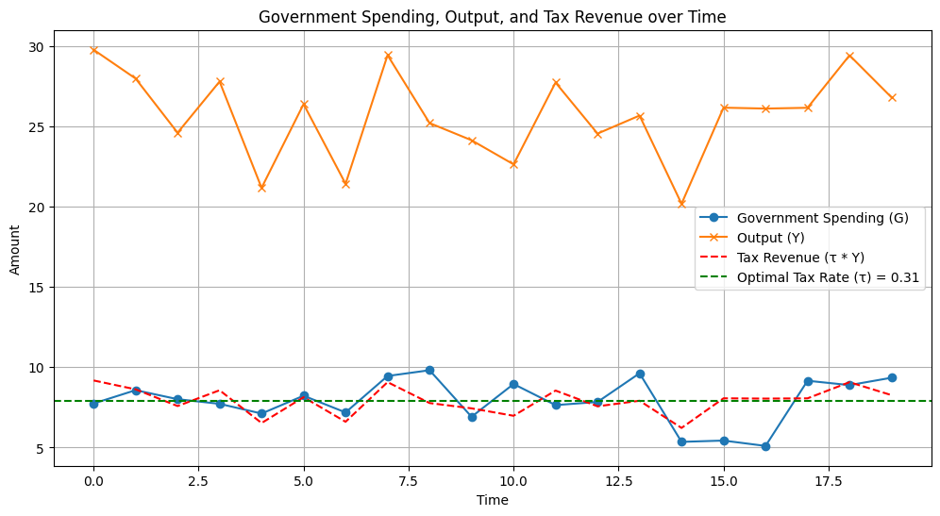
Figure 1 Barro’s tax smoothing hypothesis

Competitive equilibrium with distorting taxes
First here we will describe economy (in much similar) such as in Lucas and Stokey (1983).Now, things that are identical are:
equation 3
$$s^{t}=\left[s_{t},s_{t-1},….,s_{0}\right] ,t≥0$$
Government purchases $g\left(s\right)$ are and exact-time invariant function of $s$.Now let, $c_{t}\left(s^{t}\right),l_{t}\left(s^{t}\right),n_{t}(s^{t})$ denote consumption, leisure, and labor supply, at history $s^{t}$ at time $t$.Each period representative household is endowed with one unit of time that can be divided between leisure $l_{t}$ and labor $n_{t}$:
equation 4
$$n_{t}\left(s^{t}\right)+l_{t}\left(s^{t}\right)=1$$
Output equals $n_{t}(s^{t})$ and can be divided between consumption$c_{t}\left(s^{t}\right)$ and $g(s_{t})$:
equation 5
$$c_{t}\left(s^{t}\right)+g\left(s^{t}\right)=n_{t}\left(s^{t}\right)$$
A representative household preference ${\left\{c_{t}\left(s^{t}\right),l_{t}\left(s^{t}\right)\right\}}_{t=0}^{∞}$ are ordered by:
equation 6
$$\sum_{t=0}^{∞}{\sum_{s^{t}}{β^{t}π_{t}\left(s^{t}\right)u\left[c_{t}\left(s^{t}\right),l_{t}(s^{t})\right]}}$$
Where $π_{t}\left(s^{t}\right)$ is a joint PDF over a sequence $s^{t}$,the utility function $u≫0$ is increasing, strictly concave, and three times continuously differentiable in both arguments. Government now imposes a flat tax rate $τ_{t}\left(s^{t}\right)$ on labor income at time $t$ and history $s^{t}$ . Lucas and Stokey (1983) assumed that there are complete markets with one period securities. At this point Aiyagari, S Rao, Marcet,A. Sargent,T.J. Seppälä,J.(2002) (AMSS),modify this economy. AMSS allow government to issue only one period risk-free debt each period. In this way ruling out complete markets is a step-in direction of making total tax collections behave more like those prescribed in Barro (1979).

Risk-free One-Period Debt Only
In time history $t,s^{t}$ let there be:
- $b_{t+1}\left(s^{t}\right)$ be the amount of time $t+1$ consumption good that at time $t$ the government promised to pay.
- $R_{t}\left(s^{t}\right)$ is the gross interest rate on risk-free one period debt between periods $t→t+1$
$T_{t}\left(s^{t}\right)>0$ is a non-negative lump sum transfer to the representative household. That $b_{t+1}\left(s^{t-1}\right)$ is the same for all realizations of $s_{t+1}$ and captures its risk-free character. The market value at time $t$ of government debt maturing at time $t+1$ equals $\frac{b_{t+1}\left(s^{t}\right)}{R_{t}\left(s^{t}\right)}$. The government budget constraint in period $t$ at history $s^{t}$ is:
equation 7
$$b_{t}\left(s^{t-1}\right)=τ_{t}^{n}\left(s^{t}\right)n_{t}\left(s^{t}\right)-g_{t}\left(s_{t}\right)-T_{t}\left(s^{t}\right)+\frac{b_{t+1}\left(s^{t}\right)}{R_{t}\left(s^{t}\right)}≡z\left(s^{t}\right)+\frac{b_{t+1}\left(s^{t}\right)}{R_{t}\left(s^{t}\right)}$$
The government imposes a flat tax rate $τ_{t}\left(s^{t}\right)$ on labor income at time $t$,history $s^{t}$ .Where in previous $z(s^{t})$ is the net of interest government surplus. To rule out Ponzi scheme we assume natural debt limit , the consumption Euler equation for a representative household able to trade only one-period risk-free debt with one-period gross interest rate is :
equation 8
$$\frac{1}{R_{t}\left(s^{t}\right)}=\sum_{\left(s^{t+1} | s^{t}\right)}{βπ_{t+1}\left(s^{t+1} | s^{t}\right)\frac{u_{c}\left(s^{t+1}\right)}{u_{c}\left(s^{t}\right)}}$$
Substituting this expression in government budget constraint $b_{t}\left(s^{t-1}\right)=τ_{t}^{n}\left(s^{t}\right)n_{t}\left(s^{t}\right)-g_{t}\left(s_{t}\right)-T_{t}\left(s^{t}\right)+\frac{b_{t+1}\left(s^{t}\right)}{R_{t}\left(s^{t}\right)}≡z\left(s^{t}\right)+\frac{b_{t+1}\left(s^{t}\right)}{R_{t}\left(s^{t}\right)}$ we get:
equation 9
$$b_{t}\left(s^{t-1}\right)=z\left(s^{t}\right)n_{t}\left(s^{t}\right)+β\sum_{\left(s^{t+1} | s^{t}\right)}{π_{t+1}\left(s^{t+1} | s^{t}\right)\frac{u_{c}\left(s^{t+1}\right)}{u_{c}\left(s^{t}\right)}}b_{t+1}\left(s^{t}\right)$$
Now the components $z\left(s^{t}\right)$ on the right side depends on $s^{t}$, but the eft side is required to depend on $s^{t-1}$ only. This is what it means for one period debt to be risk free. Now if we replace $b_{t+1}\left(s^{t}\right)$ on the right side of previous equation by the right side of next period’s budget constraint (associated with a particular realization $s_{t}$) we get:
equation 10
$$b_{t}\left(s^{t-1}\right)=z\left(s^{t}\right)+\sum_{\left(s^{t+1} | s^{t}\right)}{βπ_{t+1}\left(s^{t+1} | s^{t}\right)\frac{u_{c}\left(s^{t+1}\right)}{u_{c}\left(s^{t}\right)}}\left[z\left(s^{t+1}\right)+\frac{b_{t+2}\left(s^{t+1}\right)}{R_{t+1}\left(s^{t+1}\right)}\right]$$
Now, after making repeated substitutions for all future occurrences of government indebtedness and by invoking natural debt limit we get at:

equation 11
$$b_{t}\left(s^{t-1}\right)=\sum_{j=0}^{∞}{\sum_{\left(s^{t+j} | s^{t}\right)}{β^{j}π_{t+j}\left(s^{t+j} | s^{t}\right)\frac{u_{c}\left(s^{t+j}\right)}{u_{c}\left(s^{t}\right)}z\left(s^{t+j}\right)}}$$
Now let’s substitute the resource constraint into the net-of -interest government surplus and we are using the household FOC :
equation 12
$$1-τ_{t}^{n}\left(s^{t}\right)=\frac{u_{l}\left(s^{t}\right)}{u_{c}\left(s^{t}\right)}$$
So that now we can express the net of interest government surplus $z\left(s^{t}\right)$ as:
equation 13
$$z(s^{t})=\left[1-\frac{u_{l}\left(s^{t}\right)}{u_{c}\left(s^{t}\right)} \right]\left[c_{t}\left(s^{t}\right)+g_{t}\left(s_{t}\right)\right]-g_{t}(s_{t})-T_{t}( s^{t})$$
If we substitute $z\left(s^{t+j}\right)$ from previous equation in $b_{t}\left(s^{t-1}\right)=\sum_{j=0}^{∞}{\sum_{\left(s^{t+j} | s^{t}\right)}{β^{j}π_{t+j}\left(s^{t+j} | s^{t}\right)\frac{u_{c}\left(s^{t+j}\right)}{u_{c}\left(s^{t}\right)}z\left(s^{t+j}\right)}}$ we obtain a sequence of implementability constraints on a Ramsey allocation in an AMSS economy:
equation 14
$$b_{0}\left(s^{-1}\right)=E_{0}\sum_{j=0}^{∞}{β^{j}\frac{u_{c}\left(s^{j}\right)}{u_{c}\left(s^{0}\right)}z\left(s^{j}\right)}$$
But now we have a large number of to the implementability constraints :
equation 15
$$b_{t}\left(s^{t-1}\right)=E_{0}\sum_{j=0}^{∞}{β^{j}\frac{u_{c}\left(s^{t+j}\right)}{u_{c}\left(s^{t}\right)}z\left(s^{t+j}\right)}$$

Ramsey Problem Without State-contingent Debt

Ramsey problem as in Ramsey (1927), after we have substituted resource constraint in utility function we can express Ramsey problem as:
equation 16
$$\max_{c_{t}\left(s^{t}\right),b_{t+1}\left(s^{t}\right)}{E_{0}\sum_{t=0}^{∞}{β^{t}u\left(c_{t}\left(s^{t}\right),1-c_{t}\left(s^{t}\right)-g_{t}\left(s_{t}\right)\right)}}$$
Subject to:
equation 17
$$E_{t}\sum_{j=0}^{∞}{β^{j}}\frac{u_{c}\left(s^{j}\right)}{u_{c}\left(s^{0}\right)}z\left(s^{t+j}\right)≥b_{0} \left(s^{t-1}\right), ∀s'$$
Now let $γ_{0}\left(s^{0}\right)$ be a Lagrangian multiplier nonnegative on constraint $\max_{c_{t}\left(s^{t}\right),b_{t+1}\left(s^{t}\right)}{E_{0}\sum_{t=0}^{∞}{β^{t}u\left(c_{t}\left(s^{t}\right),1-c_{t}\left(s^{t}\right)-g_{t}\left(s_{t}\right)\right)}}$. As in the Lucas-Stokey economy Lucas and Stokey (1983), this multiplier is strictly positive when the government must resort to distortionary taxation; otherwise it equals zero. A consequence of the assumption that there are no markets in state-contingent securities and that a market exists only in a risk-free security is that we have to attach stochastic processes ${\left\{γ_{t}\left(s^{t}\right)\right\}}_{t=1}^{∞}$ of LR multipliers to the implementability constraint $E_{t}\sum_{j=0}^{∞}{β^{j}}\frac{u_{c}\left(s^{j}\right)}{u_{c}\left(s^{0}\right)}z\left(s^{t+j}\right)≥b_{0} \left(s^{t-1}\right), ∀s'$.
equation 18
$$\begin{matrix}γ_{t}\left(s^{t}\right)≥\left(≤\right)0 \\ E_{t}\sum_{j=0}^{∞}{β^{j}}\frac{u_{c}\left(s^{j}\right)}{u_{c}\left(s^{0}\right)}z\left(s^{t+j}\right)≥≤b_{0} \left(s^{t-1}\right), ∀s'\end{matrix}$$
The Lagrangian of Ramsey problem now can be represented as:
equation 19
$$L=E_{0}\sum_{t=0}^{∞}{β^{t}\left\{u\left(c_{t}\left(s^{t}\right),1-c_{t}\left(s^{t}\right)-g_{t}\left(s_{t}\right)\right)\right\}}+γ_{t}\left(s^{t}\right)\left[E_{t}\sum_{j=0}^{∞}{β^{j}}u_{c}\left(s^{t+j}\right)z\left(s^{t+j}\right)-u\left(c_{t}\left(s^{t}\right)b_{t}\left(s^{t-1}\right)\right)\right]=E_{0}\sum_{t=0}^{∞}{β^{t}\left\{u\left(c_{t}\left(s^{t}\right),1-c_{t}\left(s^{t}\right)-g_{t}\left(s_{t}\right)\right)\right\}}+Ψ_{t}\left(s^{t}\right)u_{c}\left(s^{t}\right)z\left(s^{t}\right)-γ_{t}\left(s^{t}\right)u_{c}\left(s^{t}\right)b_{t}\left(s^{t-1}\right)$$
Where in previous:
equation 20
$$\begin{matrix}Ψ_{t}\left(s^{t}\right)=Ψ_{t-1}\left(s^{t-1}\right)+γ_{t}\left(s^{t}\right) \\ Ψ_{-1}\left(s^{-1}\right)=0\end{matrix}$$

Abel summation formula
In the Lagrangian previous the second part uses the Abel summation formula, also known as Abel's identity or Abel's transformation, is a technique used in mathematical analysis to sum certain infinite series by introducing an additional parameter and integrating or differentiating the series term by term. This technique is particularly useful when dealing with series that do not converge in the usual sense but converge under Abel summation.
Let's consider a series $\sum_{n=0}^{∞}{a_{n}}$, where $a_{n}$​ is a sequence of real or complex numbers. The Abel summation formula states:
equation 21
$$\sum_{n=0}^{∞}{a_{n}}=\lim_{\left(x→1\right)}{\sum_{n=0}^{∞}{a_{n}}x^{n}}$$
This formula is valid under certain conditions, typically when the series $\sum_{n=0}^{∞}{a_{n}}$​ converges absolutely or conditionally. The key idea behind Abel summation is to introduce a parameter $x$ and consider the series $\sum_{n=0}^{∞}{a_{n}}x^{n}$, which might be easier to handle or evaluate. Then, we take the limit of this expression as $x→1$ from below.To derive the Abel formula we start with power series :
equation 22
$$f\left(x\right)=\sum_{n=0}^{∞}{a_{n}x^{n}}$$
Then we integrate both sides with respect to$x 0→t$:
equation 23
$$\int_{0}^{t}{f\left(x\right)dx=\int_{0}^{t}{\left(\sum_{n=0}^{∞}{a_{n}x^{n}}\right)dx}}$$
By exchanging the integral and the sum which is justified under certain convergence conditions we get :
equation 24
$$\int_{0}^{t}{f\left(x\right)dx=\sum_{n=0}^{∞}{\left(\int_{0}^{t}{a_{n}x^{n}dx}\right)}}$$
Now we can evaluate the integral term by term:
equation 25
$$\int_{0}^{t}{a_{n}x^{n}dx=\frac{a_{n}}{n+1}}x^{n+1}{\left.​\right|}_{0}^{t}=\frac{a_{n}}{n+1}t^{n+1}$$
Substituting this back into series yields:
equation 26
$$\int_{0}^{t}{f\left(x\right)dx=\sum_{n=0}^{∞}{\frac{a_{n}}{n+1}t^{n+1}}}$$
Now we can take the limit on both sides as $t→1$:
equation 27
$$\lim_{t→1}{\int_{0}^{t}{f\left(x\right)dx=\lim_{t→1}{\sum_{n=0}^{∞}{\frac{a_{n}}{n+1}t^{n+1}=\sum_{n=0}^{∞}{a_{n}\lim_{t→1}{\frac{t^{n+1}}{n+1}}}}}}}=\sum_{n=0}^{∞}{a_{m}\lim_{t→1}{\frac{t^{n+1}}{n+1}=\sum_{n=0}^{∞}{a_{n}}}}$$

Back to Ramsey Problem Without State-contingent Debt
Now, where we left, we want to maximize Lagrangian with respect to $c_{t}\left(s^{t}\right);b_{t}\left(s^{t-1}\right)$, and partial derivative of $L$ with respect to $c_{t}\left(s^{t}\right)$ is set to zero:
equation 28
$$\frac{∂L}{∂c_{t}\left(s^{t}\right)}=E_{0}β^{t}u_{c}(c_{t}\left(s^{t}\right),1-c_{t}\left(s^{t}\right)-g_{t}\left(s_{t}\right)-γ_{t}\left(s^{t}\right)u_{c}\left(c_{t}\left(s^{t}\right),b_{t}\left(s^{t-1}\right)\right)=0$$

partial derivative of $L$ with respect to $b_{t}\left(s^{t-1}\right)$ is set to zero:
equation 29
$$\frac{∂L}{∂b_{t}\left(s^{t-1}\right) }=-γ\left(s^{t}\right)u_{c}(c_{t}\left(s^{t}\right),b_{t}\left(s^{t-1}\right)=0$$
With solving this equation, we will get solutions for $c_{t}\left(s^{t}\right);b_{t}\left(s^{t-1}\right)$ :
equation 30
$E_{0}β^{t}u_{c}\left(c_{t}\left(s^{t}\right),1-c_{t}\left(s^{t}\right)-g_{t}\left(s_{t}\right)\right)=γ_{t}\left(s^{t}\right)u_{c}(c_{t}\left(s^{t}\right),b_{t}\left(s^{t-1}\right)⇒E_{0}β^{t}\left(1-c_{t}\left(s^{t}\right)-g_{t}\left(s_{t}\right)\right)=γ_{t}(s^{t})b_{t}\left(s^{t-1}\right)$-from the 1st equation
From the second equation we get:
equation 31
$$γ_{t}\left(s^{t}\right)u_{c}(c_{t}\left(s^{t}\right),b_{t}\left(s^{t-1}\right)=0;γ_{t}\left(s^{t}\right)=≠0;b_{t}\left(s^{t-1}\right)=≠0$$

Numerical example

The government's objective is to minimize the social loss function:
equation 32
$$\min{\sum_{t=0}^{∞}{β^{t}\left(a(c_{t}-c^{*}\right)+b{\left(τ-τ^{*}\right)}^{2}) }}$$
The government aims to minimize previous distortions from taxation while financing a given stream of public expenditures $g_{t}$ using a non-state contingent debt $b_{t}$ and taxes $τ_{t}$.Subject to following constraint:
equation 33
$$b_{t+1}=\left(1+r\right)b_{t}+g_{t}-τ_{t}$$
Where $c_{t}$ is consumption at time $t$, $c^{*}$ is a steady-state consumption,$τ_{t}$ is tax revenue at time $t$, while $τ^{*}$ is the steady-state tax revenue. And $β$ is the discount factor. Where $r$ is the real interest rate. We use the method of Lagrange multiplier to solve this problem where $λ_{t}$ is the Lagrange multiplier associated with the budget constraint. The Lagrangian here is given by:
equation 34
$$L=\sum_{t=0}^{∞}{β^{t}\left(a{\left(c_{t}-c^{*}\right)}^{2}+b{\left(τ_{t}-τ^{*}\right)}^{2}+λ_{t}\left(b_{t+1}-\left(1+r\right)b_{t}-g_{t}+τ_{t}\right)\right)}$$
FOC’s are:
- For $c_{t}$:
equation 35
$$\frac{∂L}{∂c_{t}}=2aβ^{t}\left(c_{t}-c^{*}\right)=0⇒c_{t}=c^{*}$$
- For $τ_{t}$:
equation 36
$$\frac{∂L}{∂τ_{t}}=2bβ^{t}\left(τ_{t}-τ^{*}\right)+β^{t}λ_{t}=0⇒τ_{t}=τ^{*}=-\frac{λ}{2b}$$
- For $b_{t}$:
equation 37
$$\frac{∂L}{∂b_{t}}=-β^{t}λ_{t}\left(1+r\right)+β^{t-1}λ_{t-1}=0⇒λ_{t}=\frac{λ_{t-1}}{1+r}$$
Ramsey allocation for a given multiplier is :
equation 38
$$\sum_{t=0}^{∞}{β^{t}\left(a(c_{t}-c^{*}\right)+b{\left(τ-τ^{*}\right)}^{2}) }$$
Previous is objective function, subject to:
equation 39
$$\sum_{t=0}^{∞}{β^{t}(b_{t+1}-\left(1+r\right)b_{t}-g_{t}+τ_{t}) }$$
Lagrangian is given as:
equation 40
$$L=\sum_{t=0}^{∞}{β^{t}\left[{\left(c_{t}-c^{*}\right)}^{2}+b{\left(τ_{t}-τ^{*}\right)}^{2}+λ_{t}(b_{t+1}-\left(1+r\right)b_{T}-g_{t}+τ_{T}\right]+μ\sum_{t=0}^{∞}{β^{T}\left(b_{t+1}-\left(1+r\right)b_{T}-g_{t}+τ_{t}\right)} }$$
FOC’s are given as:
- For $c_{t}: \frac{∂L}{∂c_{t}}=2αβ^{t}\left(c_{t}-c^{*}\right)=0⇒c_{t}=c^{*}$
- For $τ_{t}$ : $\frac{∂L}{∂τ_{t}}=2bβ^{t}\left(τ_{T}-τ^{*}\right)+β^{t}λ_{t}⇒τ_{t}-τ^{*}=-\frac{λ_{t}}{2b}$
- For $b_{t}$: $\frac{∂L}{∂b_{t}}=-β^{t}λ_{t}\left(1+r\right)+β^{t-1}λ_{t-1}=0⇒λ_{T}=\frac{λ_{t-1}}{1+r}$
As for tax smoothing in complete and incomplete markets the result is the same there is difference in the Lagrangian multiplier with stochastic element in incomplete markets this function is given as:
equation 41
$$L=\sum_{t=0}^{∞}{β^{t}\left(a{\left(c_{t}-c^{*}\right)}^{2}+b{\left(τ_{t}-τ^{*}\right)}^{2}+λ_{t}\left(b_{t+1}-\left(1+r\right)b_{t}-g_{t}+τ_{t}+ε_{t}\right)\right)}$$
FOC’s are given as:
- For $c_{t}: \frac{∂L}{∂c_{t}}=2αβ^{t}\left(c_{t}-c^{*}\right)=0⇒c_{t}=c^{*}$
- For $τ_{t}$ : $\frac{∂L}{∂τ_{t}}=2bβ^{t}\left(τ_{T}-τ^{*}\right)+β^{t}λ_{t}⇒τ_{t}-τ^{*}=-\frac{λ_{t}}{2b}$
- For $b_{t}$: $\frac{∂L}{∂b_{t}}=-β^{t}λ_{t}\left(1+r\right)+β^{t-1}λ_{t-1}=0⇒λ_{T}=\frac{λ_{t-1}}{1+r}$
For complete markets results are identical there is difference in objective function
equation 42
$$L=\sum_{t=0}^{∞}{β^{t}\left(a{\left(c_{t}-c^{*}\right)}^{2}+b{\left(τ_{t}-τ^{*}\right)}^{2}+λ_{t}\left(b_{t+1}-\left(1+r\right)\left(b_{t}+ε_{t}\right)-g_{t}+τ_{t}\right)\right)}$$
The optimal taxation problem, the Ramsey allocation, and tax smoothing in complete and incomplete markets share similar structures, but the presence of stochastic elements and the ability to use state-contingent debt introduce differences in the solutions. The FOCs provide the necessary conditions to determine the optimal paths for consumption, taxes, and debt.
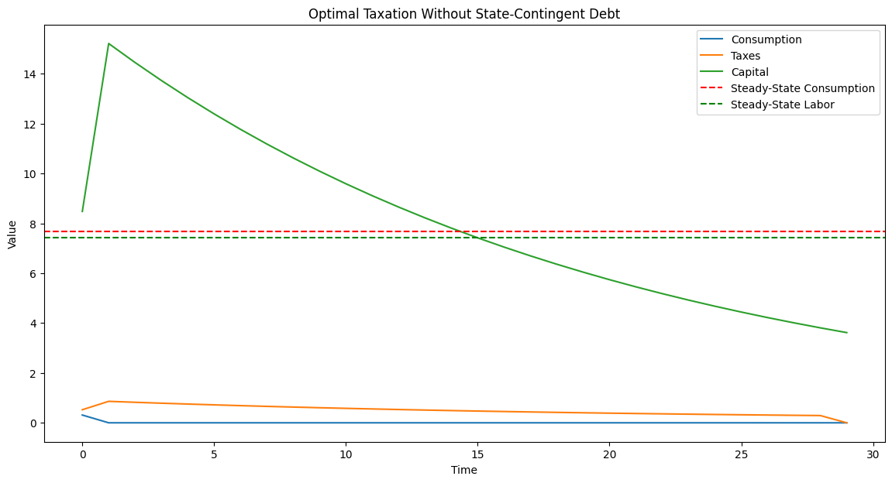
Figure 2 optimal taxation without state-contingent debt; Source: authors’ own calculation

Еxample: Anticipated One-Period War

The government budget constraint, without state-contingent debt, is:
equation 43
$g_{t}+r_{t}b_{t-1}=τ_{t}+b_{t}$​
$r_{t}b_{t-1}$ is the interest payment on the past debt. In the Ramsey problem, the government chooses taxes, debt, and spending to maximize the representative agent’s utility subject to the constraints: Household budget constraint, Government budget constraint, Resource constraint:
equation 44
$$c_{t}+I_{t}+g_{t}=y_{t}$$
Output equals: investment plus government spending + consumption. Tax smoothing in Complete Markets: In a complete market, the government can issue contingent debt to smooth taxes over time. The tax rate is smoothed according to:$τ_{t}=\frac{1}{β}E_{t}\left[τ_{t+1}\right]$.Representative household maximizes:
equation 45
$$\max_{\left\{c_{t},l_{t}\right\}}{\sum_{t=0}^{∞}{β^{t}\left(u\left(c_{t}\right)-v\left(l_{t}\right)\right)}}$$
$v\left(l_{t}\right)$ represents disutility of labor. Assume the government needs to finance an unexpected one-period increase in spending due to war. The spending increase is $∆G_{w}$,which lasts for one period. The government can finance this either by increasing debt, increasing taxes, or a combination of both. Government budget constraint here is:
equation 46
$$g_{w}+r_{t}b_{t-1}=τ_{t}+b_{t}$$
Where $g_{w}=g_{t}+∆g_{w}$ . Tax Rate $τ_{t} :$Approximated as the ratio of taxes to output, showing how the government adjusts taxation to finance the war. Next, plots are showing how the economy evolves over time with and without the war shock.

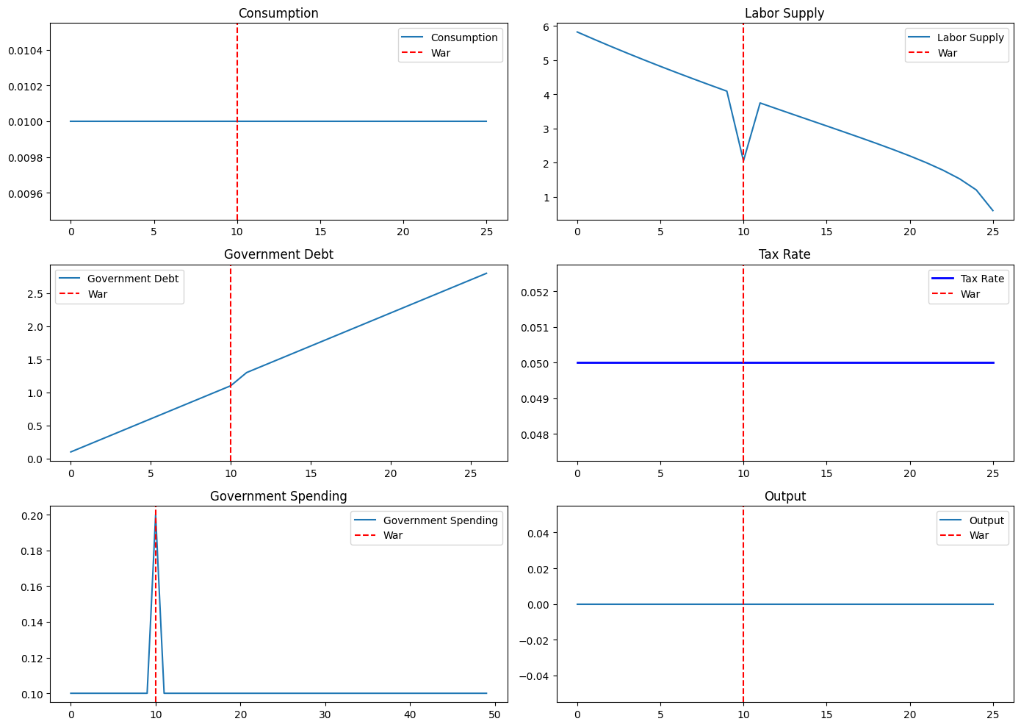
Figure 3 anticipated one period war ; Source: authors’ own calculation

Еxample: Anticipated Two-Period War

Representative agent problem here is:
equation 47
$$max⁡\sum_{\left(t=0\right)}^{T-1}{β^{t}\left[\log\left(c_{t}\right)-\frac{L_{t}^{1+η}}{1+η}\right]}$$
where $η$ is disutility of labor. Household budget constraint and production function are given respectively :
equation 48
$$c_{t}+k_{t+1}-\left(1-δ\right)k_{t}=y_{t}-τ_{t}$$
$δ$ is depreciation rate, $τ_{t}$ are total taxes at time $t$. Production function is Cobb-Douglas type:
equation 49
$$y_{t}=k_{t}^{α}+l_{t}^{1-α}$$
$α$ is capital share in production. Total taxes function is given as:
equation 50
$$τ_{t}=τ\left(y_{t}\right)∙y_{t}=\left(τ_{0}+τ_{1}y_{t}+τ_{2}y_{t}^{2}\right)∙y_{t}$$
Budget constraint is given as: $c_{t}+k_{t+1}+\left(1-δ\right)k_{t}=y_{t}-k_{t}$. About labor supply we have:
equation 51
$$\begin{matrix}\frac{∂u}{∂l_{t}}=λ_{t}∙\frac{∂y}{∂l_{t}} \\ \frac{l_{t}^{η}}{c_{t}}=λ_{t}∙\left(1-α\right)∙\frac{k_{t}^{α}}{l_{t}^{α}}\end{matrix}$$
Government budget constraints re given as:
equation 52
$$\begin{matrix}τ_{t}=g_{t}+b_{\left(t-1\right)}-b_{t} \\ b_{t+1}=b_{t}+g_{t}-τ_{t}\end{matrix}$$
Key equations for consumption and labor supply are given respectively as:
equation 53
$$\begin{matrix}c_{t}=y_{t}-g_{t}-τ_{t} \\ \frac{l_{t}^{η}}{c_{t}}=\frac{\left(1-α\right)∙k_{t}^{α}}{l_{t}^{α}}\end{matrix}$$
About taxes:
$$\begin{matrix}τ\left(y_{t}\right)=τ_{0}+τ_{1}y_{t}+τ_{2}y_{t}^{2}-progressive tax rate \\ τ_{t}=\left(τ_{0}+τ_{1}y_{t}+τ_{2}y_{t}^{2}\right)∙y_{t}-total taxes \end{matrix}$$
In this setup:
- The representative agent maximizes utility over time, considering a progressive tax rate and government budget constraints.
- Government spending spikes during the two-period war.
- The consumption and tax rates are dynamically adjusted based on the economic conditions and government budget requirements.
In this python code for this simulation parameters are as follows:
$β=0.96$, $α=0.36$ ,$δ=0.05$, $g_{steady}=0.1$ ,$g_{war}=0.5$ (steady-state and war government spending respectively, $r=0.04$,$T=50$ this is the time horizon. Base tax rate is $τ_{0}=0.05,$ linear component $τ_{1}=0.01$and quadratic component${ τ}_{2}=0.05$.The results are shown plotted one next page.
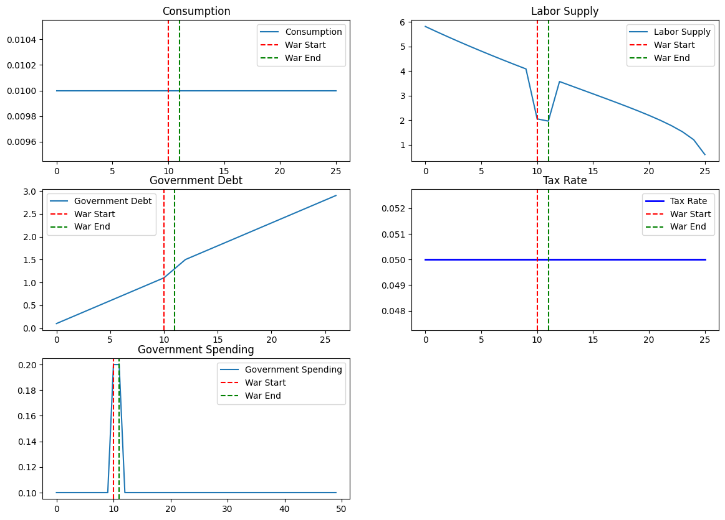
Figure 4 anticipated two period war; Source: authors’ own calculation

Еxample: Anticipated Four-Period War
In complete markets, the government can issue contingent claims. The optimal tax policy minimizes the distortions from taxation over time, leading to a smooth tax rate:

equation 54
$$\min{τ_{t}: \sum_{t=0}^{∞}{\frac{g_{t}}{{\left(1+r\right)}^{t}}=\sum_{t=0}^{∞}{\frac{τ_{t}}{{\left(1+r\right)}^{t}}} }}$$
In incomplete markets, the government cannot fully insure against shocks. The optimal taxation problem then becomes one of balancing the trade-off between intertemporal smoothing and the inability to issue state-contingent debt:
equation 55
$$\min{\sum_{t=0}^{∞}{β^{t}\left[τ_{t}\frac{c_{t}^{-γ}}{1-γ}\right]}}$$
subject to the government’s intertemporal budget constraint. Assume the government needs to finance a war for 4 periods. During these periods, government spending $G_{t}$​ increases sharply. The optimal policy will involve higher taxes and/or increased debt issuance during the war, followed by post-war fiscal adjustments. The FOCs for the Ramsey problem, including optimal taxation and consumption, are derived by setting up the Lagrangian:
equation 56
$$L=\sum_{t=0}^{∞}{β^{t}\left[\log\left(c_{t}\right)-\frac{l_{t}^{1+η}}{1+η }+λ_{t}(F\left(k_{t},l_{t}\right)-c_{t}-g_{t}-I_{t}\right]}$$
The production function is $y_{t}=f\left(k_{t},l_{t}\right)=k_{t}^{α}l_{t}^{1-α}$ FOCs are given as:
- The derivative of the Lagrangian with respect to consumption $c_{t}$ is given as:
equation 57
$$\frac{∂L}{∂c_{t}}=\frac{1}{c_{t}}-λ_{t}=0⇒λ_{t}=\frac{1}{c_{t}}$$
This equation tells us that the Lagrange multiplier $λ_{t}$​ is the marginal utility of consumption.
- The derivative of the Lagrangian with respect to labor $l_{t}$ is given as:
equation 58
$$\frac{∂L}{∂l_{t}}=-l_{t}^{-η}+λ_{t}\frac{∂f\left(k_{t},l_{t}\right)}{∂l_{t}}=0$$
Now, since $\frac{∂f\left(k_{t},l_{t}\right)}{∂l_{t}}=\left(1-α\right)k_{t}^{α}l_{t}^{-α}$ we can substitute $λ_{t}$​ from previous FOC:
equation 59
$$-l_{t}^{-η}+\frac{\left(1-α\right)k_{t}^{α}l_{t}^{-α}}{c_{t}}=0$$
Simplifying we get :
equation 60
$$l_{t}^{η+α}=\frac{\left(1-α\right)k_{t}^{α}}{c_{t}}$$
Or rearranging:
equation 61
$$l_{t}={\left(\frac{\left(1-α\right)k_{t}^{α}}{c_{t}}\right)}^{\frac{1}{η+α}}$$
- Derivative of the Lagrangian with respect to capital $k_{t+1}$:
equation 62
$$\frac{∂L}{∂k_{t+1}}=β^{t+1}λ_{t+1}\left(\frac{∂f\left(k_{t+1},l_{t+1}\right)}{∂l_{t+1}}+1-δ\right)-λ_{t}=0$$

Sunstituting $λ_{t}=\frac{1}{c_{t}}$ ,and $\frac{∂f\left(k_{t+1},l_{t+1}\right)}{∂l_{t+1}}=αk_{t+1}^{α-1}l_{t+1}^{1-α}$ we get:

equation 63
$$β\frac{1}{c_{t+1}}\left(αk_{t+1}^{α-1}l_{t+1}^{1-α}+1-δ\right)=\frac{1}{c_{t}}$$

This is the Euler equation for capital :
equation 64
$$\frac{1}{c_{t}}=β\frac{1}{c_{t+1}}\left( α \frac{k_{t+1}^{α-1}l_{t+1}^{1-α}}{1-δ}\right)$$
The derivative with respect to government debt $b_{t}$ involves the government budget constraint. Without state-contingent debt:
equation 65
$$\frac{∂L}{∂b_{t}}=β^{t+1}λ_{t+1}-λ_{t}\left(1+r\right)=0$$
By using $λ_{t}=\frac{1}{c_{t}}$,we get :
equation 66
$$\frac{1}{c_{t+1}}=β\left(1+r\right)\frac{1}{c_{t}}$$

This is the intertemporal budget constraint faced by the government, implying tax smoothing over time. About the interpretation of the results, it can be stated as follows:

- The FOCs show how the optimal consumption, labor supply, capital accumulation, and tax policies are determined in the Ramsey framework.
- The optimal tax policy aims to smooth the marginal utility of consumption over time, which is consistent with tax smoothing.
- The labor supply equation indicates how labor responds to changes in consumption and the marginal productivity of labor.

Next we will show plotted results for following parameters: $β = 0.96, α = 0.36, δ = 0.05 ,r = 0.03 , η = 1.0, G_{steady} = 0.1, G_{war} = 0.3, T = 100 , war_{periods} = \left[10, 11, 12, 13\right],initial_{debt} = 0.1$ .
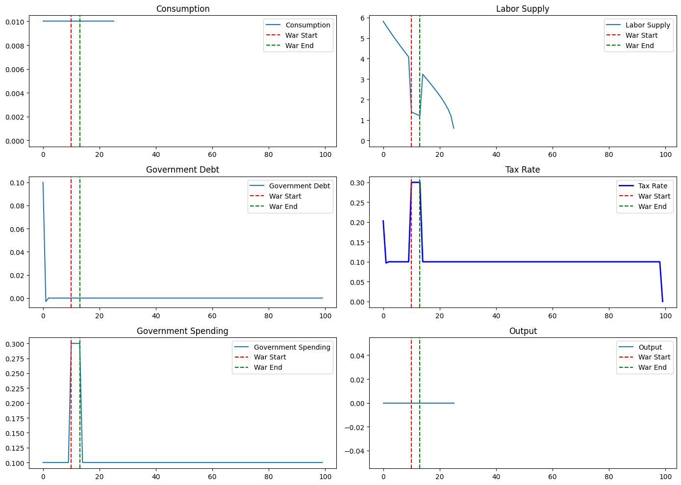
Figure 5 anticipated four period war; Source: authors’ own calculation

Example: Optimal taxation without state-contingent debt in LQ economy
Here government needs to finance exogenous government spending $G_{t}$ over time $t$ .The government can use taxation $τ_{t}$ on output and issue debt $b_{t}$,which accumulates at interest rate $r$.Government budget constraint is:
equation 67
$$b_{t+1}=\left(1+r\right)b_{t}+g_{t}-τ_{t}y_{t}$$
The government aims to minimize distortions caused by taxation. The objective function is quadratic in tax rates, which is common in LQ framework:
equation 68
$$\min{\sum_{t=0}^{∞}{β^{t}\frac{1}{2}τ_{t}^{2}}}$$
Where $β$ is a discount factor usually $β=0.96$. The government minimizes above objective function subject to budget constraint by setting Lagrangian:
equation 69
$$L=\sum_{t=0}^{∞}{β^{t}\left(\frac{1}{2}τ_{t}^{2}+λ_{t}\left[\left(1+r\right)b_{t}+g_{t}-τ_{t}y_{t}-b_{t+1}\right]\right)}$$
Taking the FOCs with respect to $τ_{t},b_{t+1},λ_{t}$, we obtain:
- FOC for $τ_{t}$:
equation 70
$$τ_{t}=λ_{t}y_{t}$$
- FOC for $b_{t+1}$ :
equation 71
$$λ_{t}=β\left(1+r\right)λ_{t+1}$$

- FOC for $λ_{t}$:
equation 72
$$b_{t+1}=\left(1+r\right)b_{t}+g_{t}-τ_{T}y_{t}$$
Recursive formulation of this problem (solution) by given FOCs, the optimal tax rate $τ_{t}$ is determined by the marginal value of relaxing the budget constraint $λ_{t}$:
equation 73
$$τ_{t}=λ_{t}y_{t}$$
By substituting the value of $λ_{t}$ we get:
equation 74
$$τ_{t}=\frac{β^{t}y_{t}}{1-β\left(1+r\right)}$$
The evolution of debt is given by:
equation 75
$$b_{t+1}=\left(1+r\right)b_{t}+g_{t}-τ_{t}y_{t}$$
In the next plots we will show this theoretical section. To code and plot optimal taxation in a Linear-Quadratic (LQ) economy without state-contingent debt, we need to set up the problem where the government seeks to minimize the distortions caused by taxation over time while ensuring that debt is serviced. The main objective is to minimize the welfare loss subject to the government's budget constraint. Objective Function (Welfare Loss):
equation 76
$$\min{\sum_{t=0}^{∞}{β^{t}\left(\frac{1}{2} τ_{t}^{2}\right)}}$$
Government Budget Constraint:

equation 77
$$b_{t+1}=Rb_{t}+g_{t}-τ_{t}y_{t}$$

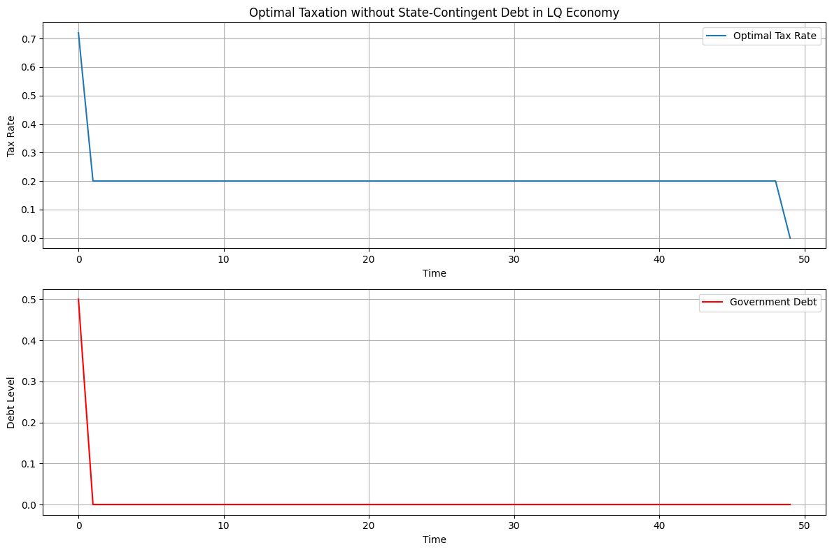
Figure 6 Optimal taxation with state-contingent debt in LQ economy (1)
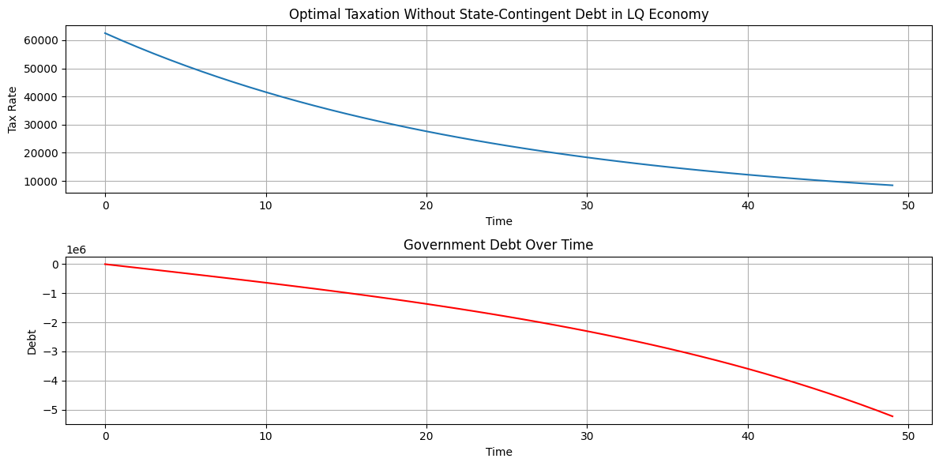
Figure 7 Optimal taxation with state-contingent debt in LQ economy (2)

Conclusion(s) or explanations
In the simulation for Barro tax smoothing hypothesis: the optimal tax rate $τ$ is set to ensure that the total present value of government spending matches the total present value of tax revenue. This minimizes the distortions and fluctuations in the tax rate over time. Competitive equilibrium in our economy is modified by allowing government to issue only one period risk-free debt each period. In this way ruling out complete markets is a step-in direction of making total tax collections behave more like those prescribed in Barro (1979).In the numerical example for optimal taxation without state contingent debt: Value of taxes is way below that of steady-state consumption and steady-state labor and after 15 periods value of capital equals and then falls below the value of steady-state consumption and steady-state labor. Value of consumption and taxes equals after 30 periods. If the value of consumption and taxes equals in a model, this implies that the total resources available to the government (from taxes) are entirely used for consumption purposes, possibly reflecting a scenario where government spending equals tax revenue, and there is no debt accumulation. In the examples for one, two and four period financing, those codes simulate and plot consumption, labor supply, government debt, tax rate, government spending, and output over time with a 1,2, 4-period war. The tax smoothing is implemented implicitly by adjusting taxes to meet the government's intertemporal budget constraint.In the one and two year war tax is unaffected i.e. flat, in 4 year war there is a sharp increase in taxes and after the war taxes return to previous value and after many periods they fall below the equilibrium value, same goes for government consumption, while debt is unaffected after initial shock increase. Government debt increases slightly in 1 or 2 period war. In the simulation for optimal taxation without state-contingent debt in LQ economy: The tax rate ( $τ$ ) is initially higher to service the initial debt and stabilize the economy. Over time, as the debt level stabilizes, the tax rate gradually declines. Government debt starts from an initial level and evolves over time based on the government's budget constraint and the chosen tax policy.

References

- Adler, J. (2006). The Tax-smoothing Hypothesis: Evidence from Sweden, 1952-1999. Scandinavian Journal of Economics, 108(1), 81–95. doi:10.1111/j.1467-9442.2006.00442.x
- Aiyagari, S Rao, Marcet,A. Sargent,T.J. Seppälä,J.(2002). Optimal taxation without state-contingent debt. Journal of Political Economy, 110(6),pp.1220–1254.
- Akerlof, G. (1978). The Economics of Tagging as Applied to the Optimal Income Tax,Welfare Programs, and Manpower Planning, American Economic Review, Vol. 68, 1978, 8-19. (web)
- Barro, R. J. (1979), On the Determination of the Public Debt, Journal of Political Economy 87 (5),pp.940–971.
- Cass, David, (1965), Optimum Growth in an Aggregative Model of Capital Accumulation, The Review of Economic Studies, 32, issue 3, p. 233-240.
- Chari, V. V., Christiano,L. ,Kehoe.P. (1991). Optimal fiscal and monetary policy: Some recent results. Journal of Money, Credit, and Banking23:pp. 519-539
- Diamond, P.(1998).Optimal Income Taxation: An Example with a U-Shaped Pattern of Optimal Marginal Tax Rates, American Economic Review, 88, 83–95.
- Hansen, L. P.; Roberds, W. T.; Sargent, T. J. (1991) “Time Series Implications of Present Value Budget Balance and of Martingale Models of Consumption and Taxes.” In Rational Expectations Econometrics, edited by Lars Peter Hansen and Thomas J. Sargent. Boulder, Colo.: Westview, 1991.
- Josheski, Dushko and Miteva, Natasha and Boskov, Tatjana (2024) Optimal taxation policy, monetary policy and state-contingent debt, time inconsistency in Ramsey problem, tax smoothing, non-CRRA preferences and taxation in LQ economy. International Journal of Economics, Management and Tourism, 4 (1). pp. 24-51. ISSN 2671-3810
- Koopmans, T.C. (1965) On the Concept of Optimal Economic Growth. In: Johansen, J., Ed., The Econometric Approach to Development Planning, North Holland, Amsterdam.
- Kydland, F. E., Prescott, E. C. (1982). Time to Build and Aggregate Fluctuations. Econometrica, 50(6), 1345–1370. https://doi.org/10.2307/1913386
- Lucas, Robert Jr., Stokey, Nancy L., (1983). Optimal fiscal and monetary policy in an economy without capital, Journal of Monetary Economics, Elsevier, vol. 12(1), pages 55-93.
- Mirrlees, J. A. (1971). An Exploration in the Theory of Optimum Income Taxation. The Review of Economic Studies. 38 (2): 175–208. doi:10.2307/2296779. JSTOR 2296779
- Piketty,T., Saez,E., Stantcheva,S.( 2014). Optimal Taxation of Top Labor Incomes: A Tale of Three Elasticities, American Economic Journal: Economic Policy, American Economic Association, vol. 6(1), pages 230-71
- Ramsey, F. P. (1927). A Contribution to the Theory of Taxation. The Economic Journal, 37(145),pp. 47–61. https://doi.org/10.2307/2222721
- Roy, René (1947). La Distribution du Revenu Entre Les Divers Biens. Econometrica. 15 (3): 205–225. JSTOR 1905479
- Sadka,E.(1976), On Income Distribution, Incentive Effects and Optimal Income Taxation ,The Review of Economic Studies, Vol. 43, No. 2, (Jun., 1976), pp. 261-267
- Saez,E.(2001).Using elasticities to derive optimal income tax rates, The Review of Economic Studies, 68(1), pp.205- 229.
- Seade, J. K., (1977), On the shape of optimal tax schedules, Journal of Public Economics, 7, issue 2, p. 203-235.
- Staum, J. (2007). Chapter 12 Incomplete Markets. Handbooks in Operations Research and Management Science, 511–563. doi:10.1016/s0927-0507(07)15012-x
- Stiglitz, J.(1982) .Self-Selection and Pareto Efficient Taxation, Journal of Public Economics, 1982,17, 213–240.

∗ Dushko Josheski, Associate professor Faculty of Tourism and Business Logistics, Goce Delcev University, Stip, North Macedonia, dusko.josevski@ugd.edu.mk ; ORCID: 0000-0002-7771-7910
∗ Natasha Miteva, Associate professor, Faculty of Tourism and Business Logistics, Goce Delcev University, Stip, North Macedonia, natasa.miteva@ugd.edu.mk
∗ Tatjana Boshkov, Professor, Faculty of Tourism and Business Logistics, Goce Delcev University, Stip, North Macedonia, tatjana.boskov@ugd.edu.mk
Lucas and Stokey (1983) found that taxes should be smooth, not by being random walks, but in having a smaller variance than a balanced budget would imply.
Risk-free debt is deeply embedded in financial markets as short-hand for high-quality liquid debt that typically retains its value over time. Also, it's referred to as debt that has a zero chance of defaulting.
Barro’s 1979 model looks a lot like a consumption-smoothing model
Incomplete markets are those in which perfect risk transfer is not possible. Despite the ever-increasing sophistication of financial and insurance markets, markets remain significantly incomplete, with important consequences for their participants: workers and homeowners remain exposed to risks involving labor income, property value, and taxes, investors and portfolio managers have limited choices, and traders of derivative securities must bear residual risks, see Staum(2007).
When expenditure is expected to increase, the government runs a budget surplus, and when expenditure is expected to fall, the government runs a budget deficit
In Ramsey (1927), utility function is given of type:$u=f(p_{1},p_{2},p_{3},…..,w)$, $p_{1},p_{2},p_{3},…..$ are prices and $w$ is income. This result is known as Roy’s identity, Roy (1947) is:$\frac{∂u}{∂p_{i}}=-f_{i}\frac{∂u}{∂w}$ . The lemma relates the ordinary (Marshallian) demand function to the derivatives of the indirect utility function. With the optimal tax structure, this identity must holds:$\frac{t_{2}}{p_{2}}ε_{u}^{2}-\frac{t_{1}}{p_{1}}ε_{u}^{1}=0$, for the linear demand curve results is :$\frac{t}{p}=\frac{kQ}{bp}=\frac{k}{ε_{u}^{d}}$.
$p_{x},p_{y}$ are prices before taxation $τ$ is tax rate. Now $p_{x\left(aftertax\right)}=\left(1+τ\right)p_{x}$ , slope of budget constraint after tax is:$slope of budget constraint=-\frac{p_{x\left(aftertax\right)}}{p_{y}}=-\frac{\left(1+τ\right)p_{x}}{p_{y}}. MRT=\frac{MC_{x}}{MC_{y}};MC_{aftertax}=\frac{MC_{aftertax}}{MC_{y}}=\frac{\left(1+τ\right)MC_{x}}{MC_{y}}$.Now the wedge is :$tax wedge=\frac{M{RT}_{aftertax}}{MRS}=\frac{\frac{\left(1+τ\right)MC_{x}}{MC_{y}}}{unchanged MRS }$
Present value of government spending matches the total present value of tax revenue$PV\left(G\right)=\sum_{t=0}^{T}{\frac{g_{t}}{{\left(1+r\right)}^{t}};PV\left(G\right)=\sum_{t=0}^{T}{\frac{y_{t}}{{\left(1+r\right)}^{t}}; } }τ=\frac{PV\left(g\right)}{PV\left(y\right)}$ . Representative agent utility function is given as:$U=\sum_{t=0}^{T}{\frac{c_{t}^{1-σ}}{1-σ} β^{t}}$. The government has to balance its budget with constant tax revenues and cannot use state-contingent debt. The budget constraint over $T: \sum_{t=0}^{T}{\frac{g_{t}}{{\left(1+r\right)}^{t}}=\sum_{t=0}^{T}{\frac{T_{t}}{{\left(1+r\right)}^{t}}; } }$where $T=τ∙y_{t}$.
In control theory, a time-invariant system has a time-dependent system function that is not a direct function of time. Such systems are regarded as a class of systems in the field of system analysis. The time-dependent system function is a function of the time-dependent input function.Or mathematically:$y\left(t\right)=f(x\left(t),t\right)=f\left(x\left(t\right)\right)$, where $y(t)$ is time dependent output function, and time-independent function$x\left(t\right)$,the system is considered time invariant if a time-delay in input $x\left(t+δ\right)=y\left(t+δ\right)$ equates to a time-delay of output.
Asset growth equation is:$A_{t+1}=A_{t}\left(1+r\right)$ ; Liability growth equation: $L_{t+1}=L_{t}\left(1+r\right)$; Debt limit constraint:$D≥L_{t}$ In this system, the liabilities represent the total amount owed to investors. The debt limit $D$ ensures that the scheme doesn't accumulate unsustainable levels of debt.Now, to ensure that it's a no-Ponzi scheme, we need to guarantee that investors can realize returns without requiring new investors to join. This implies that the assets must be sufficient to cover the liabilities:$A_{t}≥L_{t}$

