**INSTRUCTIONS FOR AUTHORS**

The journal is publishing original research papers, review papers, short communications, professional papers, book reviews and other types of text of interest in the field of agriculture and plant sciences.

**Category of paper**

**Original research papers** report original research results. The material should not have been previously published elsewhere, except in a preliminary form. The scientific information presented in the original research paper shall be processed and presented in the way that the experiment is reproducible, and the truthfulness of experimental analyses, results and conclusions shall be provable.

**Review papers** provide a comprehensive analysis of a specific problem/s or research area, based on an extensive collection of published materials. They synthesize, analyze, and discuss the gathered information, drawing upon a wide range of literature that is closely related to the research field.

**Short communications** are concise reports presenting preliminary results of significant research, pilot study, or internationally relevant projects that require urgent publication. Although these papers provide a limited analysis of the results, they introduce new or improved research methodologies or modifications to existing techniques.

**Professional papers** serve as valuable contributions to professional practice, without necessarily being tied to original research. Their primary goal is to apply existing research knowledge and adapt it to practical needs. Unlike research papers, professional papers do not require statistical analysis of the results.

**Book reviews** provide critical assessments of significant academic publications and books. These formal papers aim to describe, analyze, and evaluate a specific source, offering detailed evidence to support the analysis and evaluation.

**Other types of papers** as case study, methodology or method, comment or opinion can be published prior personal communication between author/s and JAPS Editorial Office. JAPS Editorial Office decides if proposed other type of paper is in JAPS scope of interest to be published.

Manuscript layout shall be A4, normal margins (2.54 cm top, bottom, left, right), in single-column format. All text in the manuscript shall be written in Arial 11, single line space with 0 pt spacing before and after paragraph, justify text alignment.

Each paragraph shall start with tab indent. there are no enter or spacing between paragraphs.

**Submission of a manuscript**

**Authors must strictly follow** [**JAPS Manuscript template**](https://js.ugd.edu.mk/public/dokumenti/dok/zemjodelski/Manuscript%20template_JAPS.docx) **for preparation of a manuscript before it is submitted to JAPS. Manuscripts will be rejected before the peer review process if they do not comply with the journal scope and/or JAPS Manuscript template.**

Manuscripts should be submitted exclusively through the online submission system of the journal. The online submission system guides the authors stepwise through the process of entering manuscript details and uploading manuscript files. Please follow this [link](https://js.ugd.edu.mk/index.php/YFA/about/submissions) to submit your paper.

In the step 3. Metadata in step-by-step online submission system only fields marked with * (Asterisk) shall be completed. All authors shall be added as paper contributors with click on ‘Add contributor’ button. Only field marked with * (Asterisk) shall be completed when contributor is added.

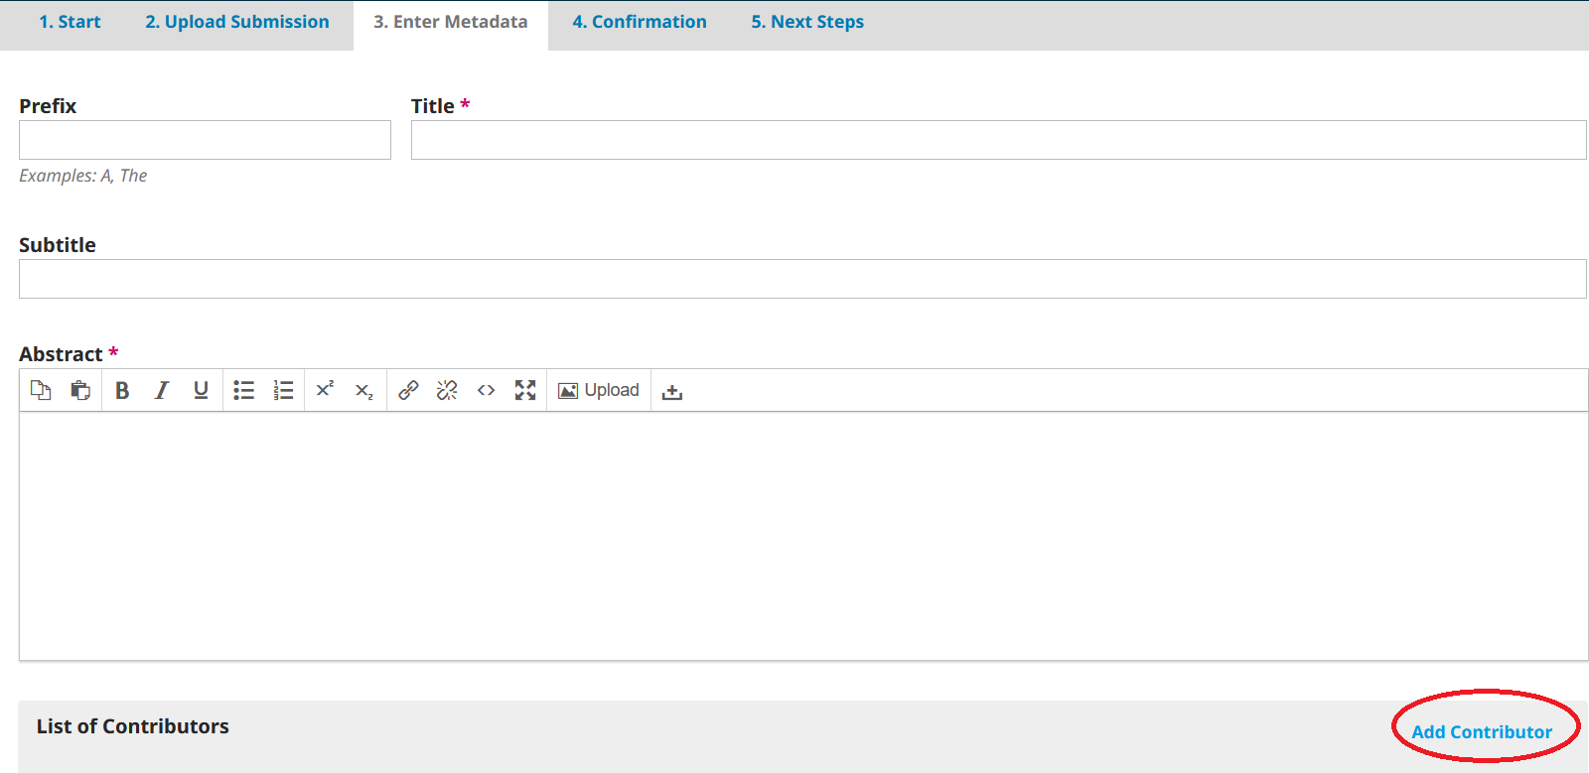

**Responsibility of the author/s**

Submission of a manuscript implies that:

* the material presented in the paper has not been published before, except in the form of an abstract, part of a lecture, conference or thesis;
* it is not under consideration for publication anywhere;
* it has been approved by all co-authors, if any.

Publication has been approved as well as by the responsible authorities of the institution where the work has been carried out.

Any legal responsibility in case of claims for compensation and reimbursement of authors’ rights is responsibility of the authors.

**Manuscripts check for plagiarism / self-plagiarism**

Submission of a manuscript implies that the work described has not been published elsewhere. The publisher will not be held legally responsible if there will be any claims for compensation. Upon receiving of manuscripts, the Editorial Board of JAPS checks each received manuscript for plagiarism or self-plagiarism. The check is performed on the platform for checking the plagiarism / self-plagiarism and artificial intelligence before submitting the manuscript for review on the link [https://my.plag.mk/](https://my.plag.mk/login).

**Peer review process**

All the manuscripts are subject to an anonymized double-blind peer review process before publication. All contributions will be initially assessed by the Editors for suitability of the journal. Papers that are in the scope of the journal will be sent to two independent reviewers to evaluate the scientific quality of the paper. The manuscript is sent to reviewers without the personal information of the author/s along with the Review form. Each reviewer independently fills out the Review form. Additionally, the reviewers can give comments/suggestions directly in the manuscript file. After the final edition and approval by the Editors, the manuscript will be accepted for publication. The Editors reserve the right to make editorial changes. The Editors make the final decision for publication.

**After acceptance of paper for publication**

After receiving the final decision that the paper is accepted for publication in JAPS, the authors shall sign the [Author/s statement](https://js.ugd.edu.mk/public/dokumenti/dok/zemjodelski/JAPS%20-%20Authors%20statement%20&%20copyright%20notice%20-2023.docx) and send it to JAPS Editorial Office.

Once the specific volume number is prepared for publication the corresponding author will receive the paper for its proof reading within a given deadline. The purpose of proofreading is to check the typesetting, editing, completeness, and correctness of paper text, tables, and figures. Significant changes to the paper at the proofing reading stage will only be considered with the approval of the journal editor.

JAPS Editorial Office

Journal of Agriculture and Plant Sciences

Faculty of Agriculture, Goce Delcev University – Stip