Filled in by Editorial office of JAPS

Manuscript received: Journal of Agriculture and Plant Sciences, JAPS

Accepted: Vol --, No. -, pp. -- - -- (202-)

In print: ISSN 2545-4447

On line: ISSN 2545-4455

Paper type classification is done by the Editorial Office

Manuscript layout shall be A4, normal margines (2.54 cm top, bottom, left, right), in single-column format. All text in the manuscript shall be written in Arial 11, single line space with 0 pt spacing before and after paragraph, justify text alignment.

Each paragraph shall start with tab indent. there are no enter or spacing between paragraphs.

**PAPER TITLE** **(Arial 11, CENTER)**

**MICROPROPAGATION OF ORNAMENTAL SPECIES *Brassica oleracea* cv. Kyoto Red Given AND *Ageratum* sp.**

**Name and surname1*, Name and surname2 of author/s, (Arial 11, CENTER)**

*1Author/s address, (the address of more authors from different institutions to be noted with superscript)* **(Arial, italic 10, center)**

*2Author/s address, (the address of more authors from different institutions to be noted with superscript)* **(Arial italic 10, center)**

*\*Corresponding author: email address* **(Arial italic 10, left alignment)**

**Abstract** **(Arial 11, justify) Max 250 words**

Text, text, text, text, text, text, text, text, text, text, text, text, text, text, text, text, text, text, text, text, text, text, text, text, text, text......

**Key words:** *3-7 words that are not included in the title* **(Arial italic 11, left alignment)**

**INTRODUCTION**

Text, text, text, text, text, text, text, text, text, text, text, text, text, text, text, text, text, text, text, text, text, text, text, text, text, text...... **(Arial 11, JUSTFY)**

**MATERIAL AND METHODS**

**Subtitle** (Optional, if there are subtitles, they shall not be numerated)

Text, text, text, text, text, text, text, text, text, text, text, text, text, text, text, text, text, text, text, text, text, text, text, text, text, text...... **(Arial 11, JUSTFY)**

**RESULTS AND DISCUSSION**

**Subtitle** (Optional, if there are subtitles, they shall not be numerated)

Text, text, text, text, text, text, text, text, text, text, text, text, text, text, text, text, text, text, text, text, text, text, text, text, text, text...... **(Arial 11, JUSTFY)**

**Table formatting and citation in manuscript body text**

Place tables next to the relevant text or on a separate page(s) at the end of the manuscript. Table titleshall be always above the table, font Ariel, letter size 11, without space between the table and the table title. If ‘table footnotes’ are included, use font size 9, without space. No additional table formatting (different colors, shades, bold/italic letters…) is required.

Tables are mentioned in the manuscript body mandatory. Examples of table citating in manuscript body:

Example 1: In Table 1 are presented the results from….

Example 2: Table 1 shows the results from ….

Example 2: The results from….. (Table 1).

**Table example**

Table 1. Initial cultivation of meristem buds and cotyledons from ornamental red cabbage (*Brassica oleracea* cv. Kyoto red given) on MS medium supplemented with different combination and concentrations of growth regulators.

|  |  |  |  |  |  |  |
| --- | --- | --- | --- | --- | --- | --- |
| Medium + growth regulators | Number of meristem buds | Width (mm) | Height (mm) | Number of cotyledons | Width (mm) | Length (mm) |
| А | 40.0 | 3.5a | 8.8a | 48.0 | 1.2b | 2.5a |
| B | 40.0 | 4.7b | 9.2a | 55.0 | 1.9b | 2.1ab |
| C | 31.0 | 1.15c | 3.8b | 47.0 | 3.2a | 1.4b |
| D | 50.0 | 2.8a | 9.5a | 50.0 | 1.0c | 2.4a |

Means within each column having different letters are significantly different according to Duncan’s test at *p*<0,05.

**Figures formatting and citation in manuscript body text**

Place figures next to the relevant text or on a separate page(s) at the end of the manuscript. Figures are graphics, photos, diagrams, charts, pies, histograms, drawings, schemes, etc. All figures are given in the manuscript in format and high quality that is necessary for online and print publishing. Figures generated in excel are placed in manuscript as pictures.

Figure titleshould be always placed under the figure, font Ariel, letter size 11, without space between the table and the table title.

The figures are mentioned in the manuscript body mandatory. Example of figure citating in manuscript body:

Example 1: In Figure 1 are presented shoot regenerants as result….

Example 2: Figure 1 shows shoot regenerants as result….

Example 3: The shoot regenerants as result ….. (Figure 1).

**Figure example**

a.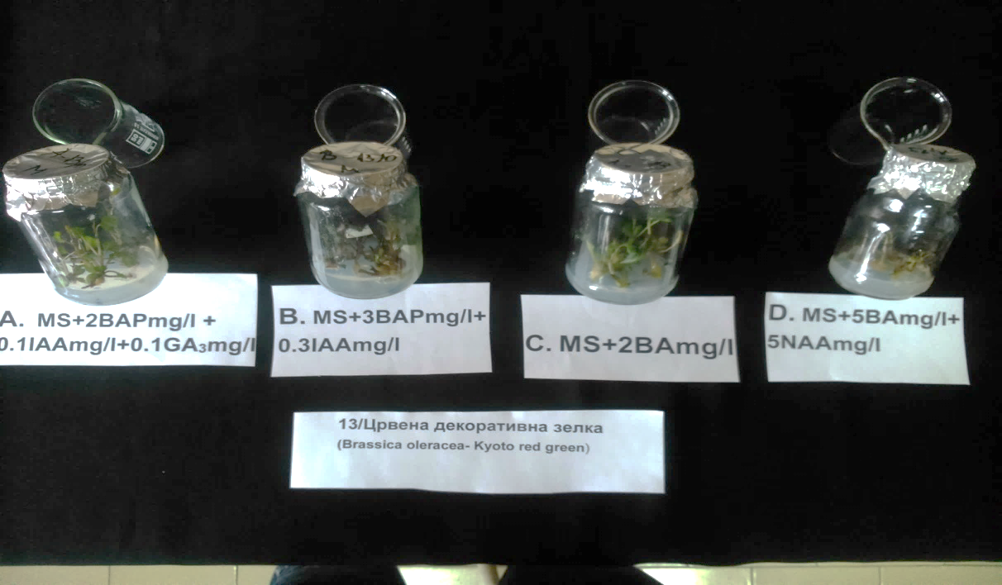 b 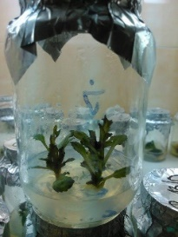

Figure 2. a. Shoot regenerants as result of the effect of MS medium and different growth regulators on ornamental red cabbage, b. Shoot regeneration meristem buds of ornamental red cabbage one month after the initial cultivation.

**Reference citations within manuscript text**

In manuscript text, the references should be cited as:

1. **Reference with one author:**

* According to Trajkova (2024) text, text, text.
* Text, text, text (Trajkova, 2024).

1. **Reference with 2 authors:**

* Koleva Gudeva & Trajkova (2024)
* Text, text, text (Koleva Gudeva & Trajkova, 2024).

1. **Reference with at least 3 authors:**

* Koleva Gudeva et al. (2024)
* Text, text, text (Koleva Gudeva et al., 2024)

1. **More than one reference from the same author(s) in the same year must be identified by the letters 'a', 'b', 'c', etc., placed after the year of publication.**

* Text, text, text (Koleva Gudeva et al., 2024a).
* Text, text, text (Koleva Gudeva et al., 2024b).
* According to Koleva Gudeva et al. (2024c) text, text, text.

1. **Groups of references shall be listed chronologically, from the oldest to the newest:**

* Text, text, text (Koleva Gudeva et al., 2020; Koleva Gudeva & Trajkova, 2021; Trajkova, 2023)

**CONCLUDING REMARKS**

Text, text, text, text, text, text, text, text, text, text, text, text, text, text, text, text, text, text, text, text, text, text, text, text, text, text...... **(Arial 11, JUSTFY)**

**ACKNOWLEDGEMENT**

Authors must disclose any funding sources who provided financial support for the conduct of the research and/or preparation of the article. It is not necessary to include detailed descriptions on the program or type of grants, scholarships and awards.

If the funder / financer does not have specific rules for acknowledgment of financial support, the acknowledgment shall be done with the following statement: **“This work was supported by the XXXX [project/grant number xxxx].”**

If no funding has been provided for the researca and/or paper preparation, it is recommended to include the following sentence: “**This research did not receive any specific grant from funding agencies in the public, commercial, or not-for-profit sectors.”**

Any other acknowledgment, institutional and/or personal shall be included in this section **(Arial 11 bold, JUSTFY).**

**REFERENCES (Arial 11, JUSTIFY)**

The official citation style for JAPS is APA, and all references must follow this format. References should not be numbered. The references must be arranged in alphabetical order. If there are more references from the same author(s) in the same year must be identified by the letters 'a', 'b', 'c', etc., placed after the year of publication. If there are more references from the same author(s) in different years, they must be arranged chronologically, from the oldest to the newest.

Thes website references shall be listed separately under the subheading “Websites” directly after the reference list. When listing web references, as a minimum you should provide the full URL and the date when the reference was last accessed. Additional information (e.g. DOI, author names, dates or reference to a source publication) should also be provided, if known.

To generate correct APA citations easily, you can use Google Scholar. Simply search for the reference in Google Scholar, and once it appears, click on the "Cite" button below the article title. A pop-up window will display several citation styles. Select APA, copy the citation format, and paste it into your manuscript (See image below).

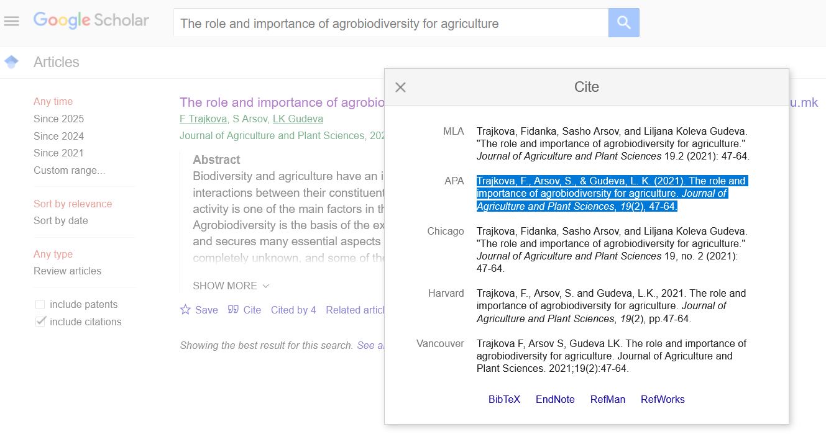

You can use automatic generation of the references, using the APA Style option from References selection in Word document, as shown in the image below.



**Examples for citation of scientific resources in APA style:**

**Journal**

Balabanova, B., Stafilov, T., Sajn, R., & Tănăselia, C. (2017). Bioindication abbility of Hypnum cupressiforme and Homolothecium lutescens for determination of arsenic distribution in environment. *Journal of Agriculture and Plant Sciences*.

Bojkov, G., Arsov, E., & Mitrev, S. (2022). Forecasting model based on cumulative degree days for incubation period of Plasmopara viticola (Berk. & MA Curtis) Berl. & De Toni. *Journal of Agriculture and and Plant Sciences*.

Markova Ruzdik, N., Mihajlov, L., Ilieva, V., Mitrev, S., Arsov, E., Kovacevik, B., ... & Todevska, D. (2024). Assessment of genetic diversity among barley varieties with different origin using simple sequence repeat (SSR) markers. *Journal of Agriculture and Plant Science*, *22*(1), 23-31.

**Book**

Garcia-Gutierrez, E., Gomez-Torres, N., & Arbulu, S. (Eds.). (2024). *Novel Approaches in Biopreservation for Food and Clinical Purposes*. CRC Press.

**Chapter in book**

Kovacevik, B., Veličkovska, S. K., Esatbeyoglu, T., Cvetkovski, A., Qamar, M., & Rocha, J. M. (2024). Biopreservation in Flours and Bread. In *Novel Approaches in Biopreservation for Food and Clinical Purposes* (pp. 130-204). CRC Press.

**Conferences**

Župunski, V., & Jevtić, R. (2023). Ramularia leaf spot-a potential threat to barley production in North Macedonia. In *Book of Abstracts, 3rd International Meeting Agriscience and Practice (ASP 2023), Stip, 19-20 April 2023* (pp. 30-30). Štip: Faculty of Agriculture of Goce Delcev University.

Pockovska, M., Trajkova, F., & Koleva Gudeva, L. (2019). Evaluation of androgenic competence of different pepper, tomato and eggplant genotypes. In *Book of Proceedings/X International Scientific Agriculture Symposium" Agrosym 2019"* (pp. 525-530). Faculty of Agriculture, East Sarajevo, Bosnia & Hercegovina.

**Website**

Statistical yearbook of the Republic of North Macedonia. Statistical Office of the Republic of Macedonia, accessed 10 October 2024, <http://www.stat.gov.mk>

Faculty of Agriculture, Goce Delcev University – Stip, accessed 25 December 2024), [https://zf.ugd.edu.mk/index.php/mk/](https://zf.ugd.edu.mk/index.php/mk/%20%20%20)

**Other resources**

Author/s might use any other resources to support their research and paper. The citation shall be in manner of APA style.

Filled in by Editorial office of JAPS for non-Macedonian speaking authors

**НАСЛОВ НА ТРУДОТ** (М**ИКРОПРОПАГАЦИЈА НА ОРНАМЕНТНИТЕ ВИДОВИ *Brassica oleracea* cv. Kyoto Red Given И *Ageratum* sp.) (Arial 11, CENTER)**

**Име и презиме1*, Име и презиме 2 на авторот/ите (Arial 11, CENTER)**

*1Адреса на авторот/ите, (адресата на автори од различни институции да се обележи со суперскрипт)* **(Arial, italic 10, center)**

*2Адреса на авторот/ите, (адресата на автори од различни институции да се обележи со суперскрипт)* **(Arial, italic 10, center)**

*\*Контакт автор: е-пошта* **(Arial, italic 10, left alignment)**

**Резиме (Arial 11, justify)**

Превод на апстракот на македонски јазик.

**Клучни зборови:** *превод на клучните зборови на македонски јазик.* **(Arial italic 11, left alignment)**

*Journal of Agriculture and Plant Sciences, JAPS, Vol. --, pp. -- - --*